rwwr

CHAPTER I

|  |
| --- |
| **Basic lab safety principles** |
| |  |  |  |  |  |  |  | | --- | --- | --- | --- | --- | --- | --- | | In the following chapters, you will be assembling a computer. The following is a list of guidelines that help create a safe, efficient work environment:   * The workspace should be large enough to accommodate the system unit, the technician’s tools, the testing equipment, and the electrostatic discharge (ESD) prevention equipment. Near the workbench, power outlets should be available to accommodate the system unit power and the power needs of other electrical devices. * The ideal level of humidity in the workspace should be between 20%-30% to reduce the likelihood of ESD. It is also important to control the temperature so the workspace does not get too hot. * The workbench should be a nonconductive surface. Additionally, it should have a flat, cleanable surface. * The workspace should be distant from areas of heavy electrical equipment or concentrations of electronics. For example, a building’s HVAC or phone system controls. * The workspace should be free of dust. Dust can contaminate the workspace, causing premature damage to computer components. The work area should have a filtered air system to reduce dust and contaminants. * Lighting should be adequate to see small details. Two different illumination forms are preferred: an adjustable lamp with a shade, and fluorescent lighting. * Extreme variations of temperature can affect computer components. Temperatures should be maintained so they are consistent with the specifications of the components. * Properly grounded AC electrical current is essential. Power outlets should be tested with an outlet tester for proper grounding.  |  | | --- | | **Tools of the trade** | | |  | | --- | | Most of the tools used in the computer assembly process are small hand tools. They are available individually or included as part of PC toolkits that can be purchased at computer stores. If a technician is working on laptops, then a small torx screwdriver will be necessary. It does not come in all PC toolkits. Figure D:\NOTES\CNAP IT Essentials I - PC Hardware and Software 2.0\images\1.gifshows a typical toolset used by a technician.    The right tools can save a technician a lot of time and help the technician avoid damage to the equipment. Tool kits range widely in size, quality and price. PC Technicians typically have the following:   * An ESD wrist strap * Straight head screwdriver (large and small) * Phillips head screwdriver (larger and small) * Tweezers or part retriever * Long-nosed pliers * Wire cutters * Chip extractor * Hex wrench set * Torx driver * Nut driver (larger and small) * Three-claw component holder * Digital multimeter * Wrap plugs * Small mirror * Small dust brush * Soft, lint-free cloth * Cable ties * Scissors * Flashlight (small) * Electric tape * Notebook-pencil or pen   Additionally, the following materials should be on hand:   * Additional screws * Expansion card inserts * Drive faceplates * Mounting kits * Extra cables   **Organizational Aids** The following are workspace organizational aids:   * A parts organizer to keep track of small parts such as screws and connectors * Adhesive or masking tape to make labels that identify parts * A small notebook to keep track of assembly and/or troubleshooting steps * A place for quick references and detailed troubleshooting guides * A clipboard for paperwork   **Diagnostic Software for System Repair and Maintenance** Once a computer system has been assembled, it is necessary to load the software that allows it to boot. If there are any problems in getting a new system to boot up, there is testing software available on floppy disk.  The following are some of the commonly used software tools in PC computing:   * **Partition Magic** – Advanced drive partitioning software * **CheckIt** – Fault isolation software * **Spinrite** – Hard drive scanning tool * **AmiDiag** – Hardware fault isolation software * **DiskSuite** – Hard drive defrag software * **SecureCRT** – Feature filled terminal software * **VNC** – Remote access software * **Norton Antivirus** – One of the industry leading virus protection software   Depending on the needs of a technician, information on each of these software tools can be readily downloaded from the respective manufacturer sites. It is always useful to find out what a particular software tool can do before purchasing it, to ensure it meets the requirements of the job. | |  |  | | --- | | **Workplace testing equipment** | | |  | | --- | | It may be necessary when assembling a computer system to test electrical signals on a motherboard or its components. In addition, testing the external power environment is often necessary. A troublesome power source can cause difficulties for the plugged in computer systems. Figure D:\NOTES\CNAP IT Essentials I - PC Hardware and Software 2.0\images\1.gifshows a Fluke 110 Multimeter, which is used to test high-voltage devices. In addition to the outlet tester and digital multimeter, wrap plugs should be part of the standard equipment kept in the workspace. These plugs are also referred to as loopback plugs, or loopback connectors.    Loopback connectors test signaling ports that are located on the back of the computer. The loopback plugs are wired so that they either loop or send the signals back on themselves. These plugs are used in conjunction with suitable test software to check the integrity of computer ports. | | | |

**Lab safety agreement**

The Lab Safety Agreement in Figure 1 details the procedures to be followed when working with computers. The classroom instructor will provide a copy to sign.

Since many classroom lab exercises do not use high voltages, electrical safety may not appear to be important. Do not become complacent about electrical safety. Electricity can injure or cause death.

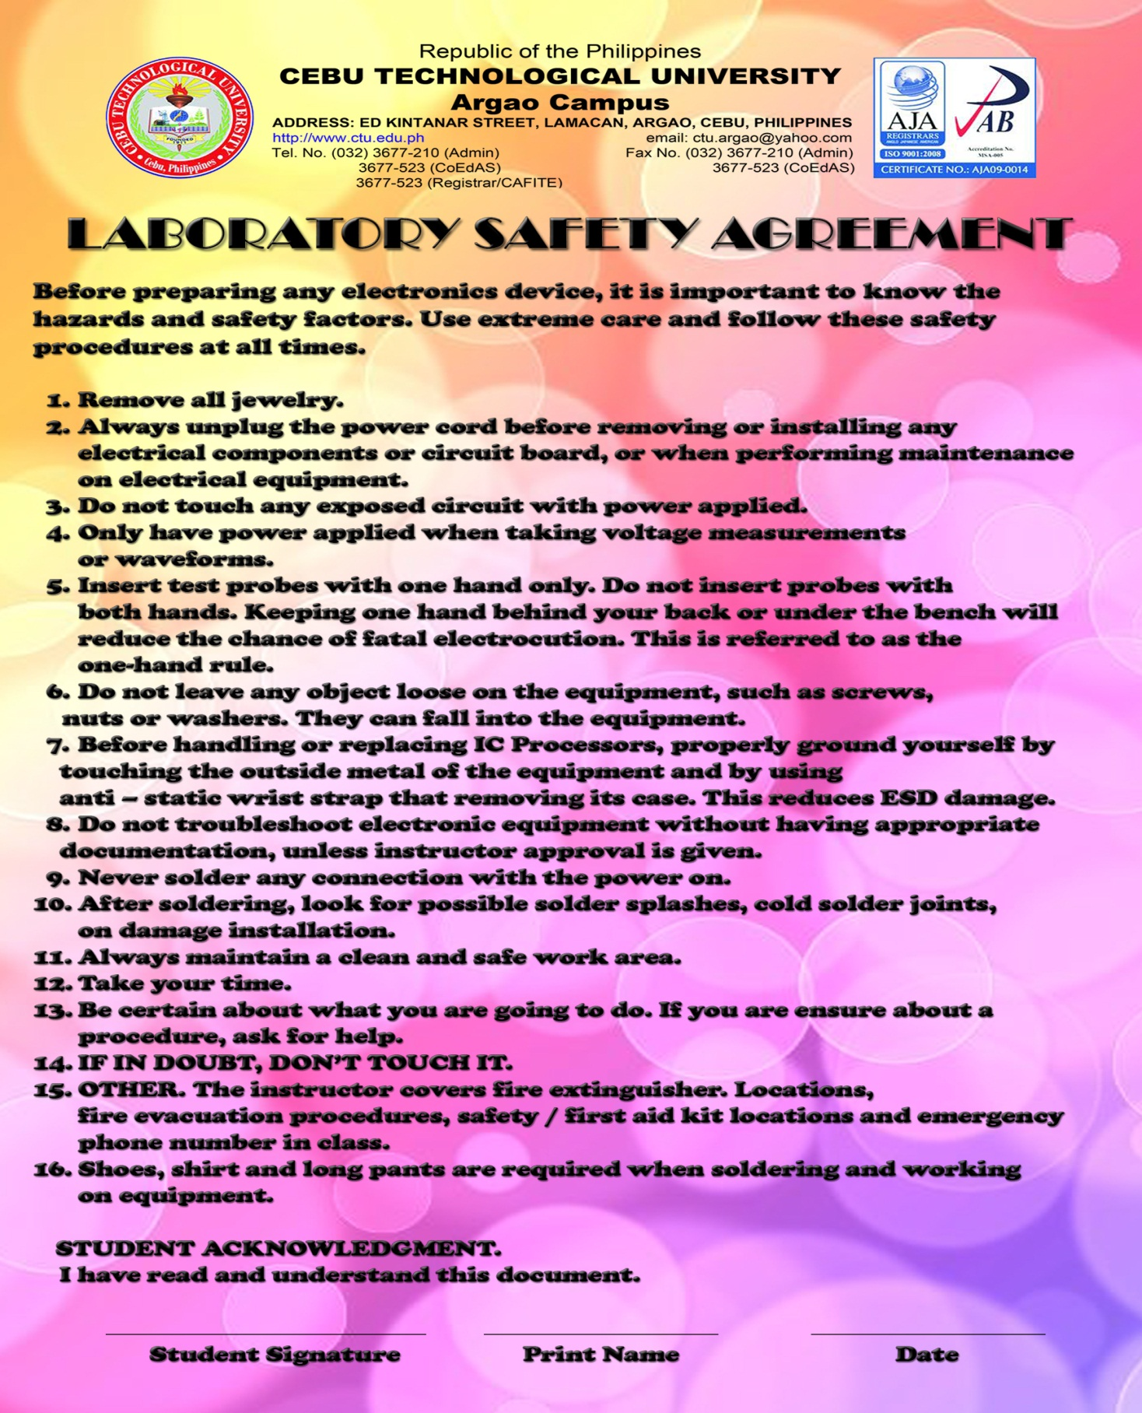

74

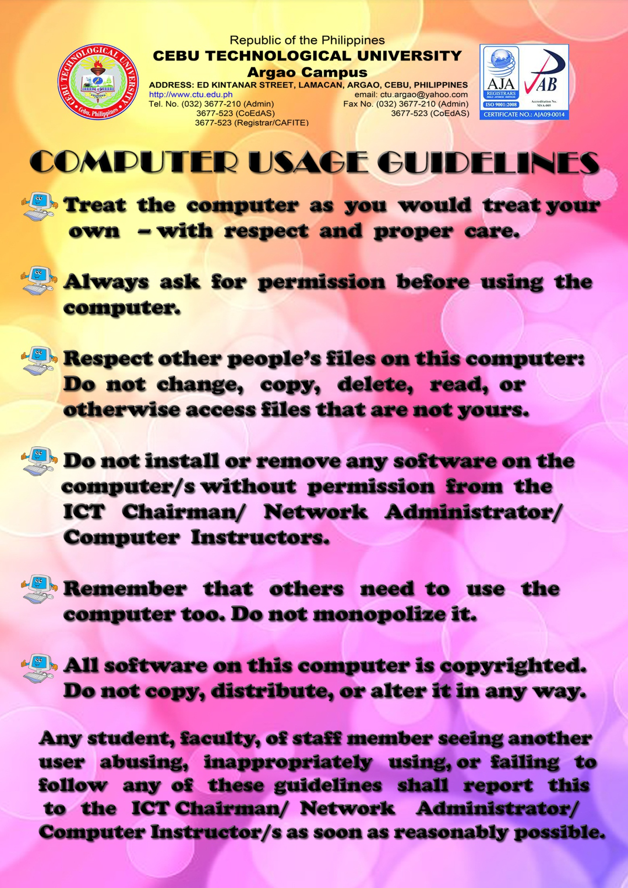

Name\_\_\_\_\_\_\_\_\_\_\_\_\_\_\_\_\_\_\_\_\_\_Year &Section\_\_\_\_\_\_\_\_Score\_\_\_\_\_\_\_\_\_\_\_\_\_\_\_\_\_\_\_

Activity # 1

Lab Safety Checklist

Fill in the blanks in the following lines:

1. The workspace for an IT technician should be large enough to accommodate the:

a. \_\_\_\_\_\_\_\_\_\_\_\_\_\_\_\_\_\_\_\_\_\_\_\_\_\_\_\_\_\_\_\_\_\_\_\_\_\_\_\_\_\_\_\_\_\_\_\_\_\_\_\_\_\_\_\_\_\_\_\_\_

b. \_\_\_\_\_\_\_\_\_\_\_\_\_\_\_\_\_\_\_\_\_\_\_\_\_\_\_\_\_\_\_\_\_\_\_\_\_\_\_\_\_\_\_\_\_\_\_\_\_\_\_\_\_\_\_\_\_\_\_\_\_

c. \_\_\_\_\_\_\_\_\_\_\_\_\_\_\_\_\_\_\_\_\_\_\_\_\_\_\_\_\_\_\_\_\_\_\_\_\_\_\_\_\_\_\_\_\_\_\_\_\_\_\_\_\_\_\_\_\_\_\_\_\_

d. \_\_\_\_\_\_\_\_\_\_\_\_\_\_\_\_\_\_\_\_\_\_\_\_\_\_\_\_\_\_\_\_\_\_\_\_\_\_\_\_\_\_\_\_\_\_\_\_\_\_\_\_\_\_\_\_\_\_\_\_\_

Near the workbench, power outlets should be available to accommodate the system unit power and the power needs of other electrical devices.

2. The workspace should maintain a humidity level of \_\_\_\_\_\_\_\_\_\_\_\_\_\_\_ percent to

reduce the likelihood of ESD.

3. The workbench should be a \_\_\_\_\_\_\_\_\_\_\_\_\_\_\_\_\_\_\_\_\_\_\_ surface. Additionally, it

should have a flat cleanable surface.

4. The workspace should be distant from areas of heavy \_\_\_\_\_\_\_\_\_\_\_\_\_\_ equipment

or concentrations of \_\_\_\_\_\_\_\_\_\_\_\_\_\_\_\_.

5. The workspace should be free of \_\_\_\_\_\_\_\_\_\_\_\_\_\_\_\_\_. \_\_\_\_\_\_\_\_\_\_\_\_\_\_\_\_\_\_   
 can contaminate the workspace, causing premature damage to computer   
 components. The work area should have a filtered air system to reduce \_\_\_\_\_\_\_\_\_   
 and contaminants.

6. Lighting should be adequate to see small details. Two different illumination forms are

preferred, such as an adjustable \_\_\_\_\_\_\_\_ with a shade and \_\_\_\_\_\_\_\_\_\_\_\_\_\_

lighting.

7. Extreme variations of \_\_\_\_\_\_\_\_\_\_\_\_\_\_\_\_\_\_\_\_ can affect a computer's

components. \_\_\_\_\_\_\_\_\_\_\_\_\_\_\_\_ should be maintained consistent with the components' specifications.

8. Properly \_\_\_\_\_\_\_\_\_\_\_ AC electrical current is essential. Power outlets should be   
 tested with an outlet tester for proper grounding.

**Chapter I Fundamentals of Computer**

**Introduction**

The term 'Computer' is derived from the Latin word   
 'Computar' which means to calculate.

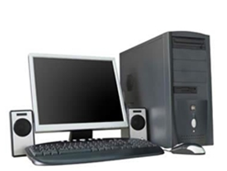▪ C = Commonly

▪ O = Oriented   
▪ M = Machine   
▪ P = Properly   
▪ U = Used for   
▪ T = Training   
▪ E = Education   
▪ R = Research

Computer is an electronic machine, that process the input data according to the   
given instruction & gives output as a result. It also saves the result for future use.

INPUT DEVICES

Keyboard

Mouse OUTPUT DEVICES

Scanner Monitor

Digital Camera Printer

Joystick Plotter

Pen drive

PROCESSING OF THE COMPUTER: (CPU)

The most essential part of the computer that perform the various operations provided. It is also called the brain of the computer. It is mainly divided into three categories:

Arithmetic & logic Unit: It performs all arithmetical as well as logical operations such as

addition, subtraction, multiplication & division. Also it performs the comparison between the entities & thus help in decision making to the computer.

Control Unit: It controls the flow of instruction within the system. CU gets the program   
instruction from memory & executes them one after another.

Memory Unit: It saves the instructions that are being executed for the future use. Each

instruction takes certain memory for its proper execution.

**Binary and Hexidecimal Conversion**

What are binary numbers? The binary number system is when only two numbers are used - 0 and 1. It is also called base 2. The computer number system is base 2. Our number system is referred to as decimal or base 10 because we use 10 digits (0 - 9) to form all of our numbers. There are many other number bases, including hexadecimal, but it's easier for computers to utilize 0s and 1s.   
  
In electronics, a 0 is off (usually 0 Volts) and 1 is on (usually 5 Volts). All computer data is composed of 1s and 0s. Each individual 1 or 0 is a bit. Four bits is a nibble. Eight bits is a byte. From there we have kilobytes, megabytes, etc. Since everything is a series of 1s and 0s, the CPU has to perform every calculation in binary. But before any operations are done, numbers have to first be converted into base 2.   
  
But before diving into the binary number system and conversions, let's first see how things work in our decimal system.   
  
Let's just pick a number...like 9345. How do we get this? Remember when I mentioned we use base 10? In math the base is a number that's raised to a power (another name for power is exponent). For example 34 is 3 raised to the 4th power, which means you multiply 3 times itself 4 times (3 \* 3 \* 3 \* 3).   
  
We have what's called a place value system. Each individual number holds a particular numerical position. We get these positions by using 10 raised to different powers. Start with the number on the right.   
  
So looking at 9345, the right-most number 5 is in the ones place (10º = 1). The 4 is in the tens place (10¹ = 10). The 3 is in the hundreds place (10² = 100), and the 9 is in the thousands place (10³ = 1000). This is true for any number. Now the larger the number the more place values (ten thousands, hundred thousands, etc.), but I'm keeping it short in this example. So we have:

http://www.learning-about-computers.com/tutorials/images/binary.jpg

If you take each number, multiply it by its place value, & add the results, you get 9345.

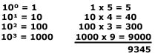

Note: any number raised to 0 = 1. Any number raised to 1 = itself.   
  
This method is used in base 2 except rather than the ones place, tens place, hundreds place, thousands place, etc. you have: ones place (2º), twos place (2¹), fours place (2²), and eights place (2³), etc.   
  
Using the base 10 example just above, the number 10112 is like this:

http://www.learning-about-computers.com/tutorials/images/binary3.jpg

It's the same process for any number system. And remember, the computer number system always uses binary. So now that you have a basic understanding of place values, it's time to start converting!   
  
**Converting From Binary To Decimal**  
Converting binary to decimal is really quite simple. All you do is apply the same technique used in the place value illustration on the intro page except this time we will be using a 2 instead of a 10.   
  
For example if we want to know what 1101000112 is in our number system (base 10) we do the following:

http://www.learning-about-computers.com/tutorials/images/binary4.jpg

We usually start on the right. With each number, you raise 2 to its power then multiply the result by the binary digit. When you're done, add all the results together and that is the number in base 10.

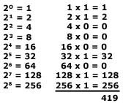

This method is used for converting any number base to decimal.   
  
**Decimal to Binary Conversion:**  
Decimal to binary conversion is not hard either, it just takes a little more work. There are two methods you can use: successive division and subtracting values using a table.   
  
Successive division requires dividing continuously by the base you're converting to until the quotient equals 0. The remainders compose the answer.   
  
As an example, let's convert 835 to binary.

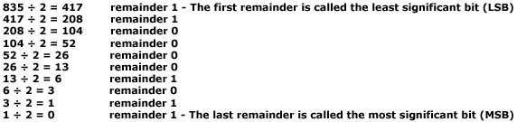

The most significant bit is the left number in the answer and the least significant bit is on the right end giving us an answer of: 11010000112   
  
Binary digits are usually grouped by 4, 8, 16, etc. so we can place a couple of 0s on the left to give us three groups of four. This does not change the answer.   
  
0011   0100   00112   
  
You can check your answer by converting back to base 10.   
  
We just looked at the successive division method of converting from decimal to binary. The other method is subtracting values. With this method you keep subtracting until you reach 0. Let's convert 165 to binary.

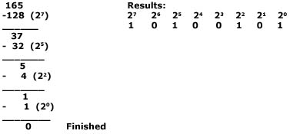

Notice a 1 is only placed under the highest value that can be subtracted from a number. Everything else is automatically a 0 giving us an answer of: 101001012.   
  
**Hexadecimal:**  
The hexadecimal (hex for short) number system uses 16 digits to form all other numbers. The purpose of using hex is for human understanding. Computers always work in binary (0s and 1s). To have a long series of binary digits gets complicated, so programmers had to come up with a more simplfied way to represent them. Hex groups binary numbers into 4 bit packages so to speak. One hex digit represents four bits (called a nibble). Hexadecimal numbers have a subscript 16 or H behind them (D316 or D3H). Because single characters must be used, the letters A, B, C, D, E, F represent 10-15. Remember, when dealing with number systems, we always start with 0. So we have 0, 1, 2, 3, 4, 5, 6, 7, 8, 9, A, B, C, D, E, F. Memory locations are listed as hex values, and many times when you get an error message, your OS (operating system) will show you the location.   
  
Example of hex and the number of bits:   
  
F6AH - 12 bits  
    BH - 4 bits  
  78H - 6 bits   
  
**Converting Hexadecimal to Decimal:**  
As was mentioned in the binary conversion section above, we use the same technique to convert to decimal (base 10) from any other base. In this case, let's convert 4B7F16 to Base 10 (decimal).

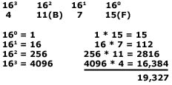

**Converting Decimal to Hexadecimal:**  
To convert from decimal to hexadecimal, we use the successive division method discussed earlier only we divide by 16 instead of 2. Let's convert 501 from decimal to hex.

http://www.learning-about-computers.com/tutorials/images/hex2.jpg

We're done since we can't divide 1 by 16 and that leaves us with a remainder of 1. When writing the answer the LSD is always on the right and the MSD on the left. The answer is: 1F516   
**Converting Hexadecimal to Binary:**  
Remember hex uses groups of four bits, so we can use the table below for conversions.

|  |  |  |
| --- | --- | --- |
| **Decimal** | **Binary** | **Hex** |
| 0 | 0000 | 0 |
| 1 | 0001 | 1 |
| 2 | 0010 | 2 |
| 3 | 0011 | 3 |
| 4 | 0100 | 4 |
| 5 | 0101 | 5 |
| 6 | 0110 | 6 |
| 7 | 0111 | 7 |
| 8 | 1000 | 8 |
| 9 | 1001 | 9 |
| 10 | 1010 | A |
| 11 | 1011 | B |
| 12 | 1100 | C |
| 13 | 1101 | D |
| 14 | 1110 | E |
| 15 | 1111 | F |

To convert D14B to binary:   
D = 1101, 1 = 0001, 4 = 0100, B = 1011   
When we put the pieces together, we get: D14B16 = 11010001010010112   
**Converting Binary to Hexadecimal:**  
To convert 11110101010011102 to base 16, we first break up the number into groups of four as shown below:   
  
1111 0101 0100 1110   
Now assign each group its corresponding hex value   
1111 = F, 0101 = 5, 0100 = 4, 1110 = 14   
When put together, we get F54E16

Name\_\_\_\_\_\_\_\_\_\_\_\_\_\_\_\_\_\_\_\_\_\_Year &Section\_\_\_\_\_\_\_\_Score\_\_\_\_\_\_\_\_\_\_\_\_\_\_\_\_\_\_\_

Activity # 1

Number System Conversion

|  |  |  |  |
| --- | --- | --- | --- |
| Decimal | Binary | Octal | Hexadecimal |
|  |  |  |  |
|  |  |  |  |
|  |  |  |  |
|  |  |  |  |
|  |  |  |  |
|  |  |  |  |
|  |  |  |  |
|  |  |  |  |
|  |  |  |  |
|  |  |  |  |
|  |  |  |  |
|  |  |  |  |
|  |  |  |  |
|  |  |  |  |
|  |  |  |  |
|  |  |  |  |
|  |  |  |  |
|  |  |  |  |
|  |  |  |  |
|  |  |  |  |
|  |  |  |  |
|  |  |  |  |
|  |  |  |  |
|  |  |  |  |
|  |  |  |  |
|  |  |  |  |
|  |  |  |  |
|  |  |  |  |
|  |  |  |  |
|  |  |  |  |

Corrected By:\_\_\_\_\_\_\_\_\_\_\_\_\_\_

Instructor Signature\_\_\_\_\_\_\_\_\_\_\_\_\_\_

Date Completed\_\_\_\_\_\_\_\_\_\_\_\_\_\_

**Components of the Computer System**

➢ Motherboard ➢ DVD/CD R-W

➢ Hard disk ➢ Floppy Drive

➢ RAM ➢ Modem

➢ ROM ➢ Graphics Card

➢ Processor ➢ Sound Card

➢ SMPS & Connecting wire   
➢ UPS

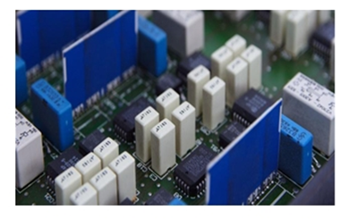





**Memory Device :Capacity Measurement**

➔ The storing capacity of computer expressed in bytes. Bytes store one character   
 of data.

0.1 1 bit

4 bits 1 nibble

8 bits 1 byte

1 byte 1 character

1024 bytes 1 Kilobyte (KB)

1024 KB 1 Megabyte (MB)

1024 MB 1 Gigabyte (GB)

1024 GB 1 Terabyte (TB)

There are mainly two types of memory:

**Primary Memory:** This is the main memory of the computer. This

memory is used frequently by the CPU for execution of the instructions. There are again two types of Primary Memory.

**▪ RAM:** RAM stands for Random Access Memory. Initially every task is stored in RAM & then   
 executed or stored in Hard disk. It is volatile, it stores data temporarily. So no data will remain   
 when the power is switched off. It ranges from 64 MB to 16 GB.

▪ **ROM:** ROM stands for Read Only Memory. It is a programming chip, where all the system

information are recorded & can't be changed. Its types are PROM, EPROM, EEPROM, etc. It is nonvolatile.

**Secondary Memory:** These are the storage devices & are used to save the   
programs files permanently. There are different types of Secondary Memory. They   
are:

▪ Hard disk (ranges from 40 GB to 1 TB)

▪ Floppy disk (1.44 MB)

▪ CD (720MB), DVD (4.7 GB, 8.5 GB)

▪ Blue ray Disc (25 GB, 40 GB)

▪ Pen Drive (ranges from 128 MB to 256 GB)

Magnetic Tapes, Zip disk, etc.

**Measurement-related terminology**

|  |
| --- |
|  |

|  |
| --- |
| When working in the computer industry, it is important to understand the terms that are used. Whether reading the specifications about a computer system, or talking with another computer technician, there is a rather large dictionary of terms that should be known. The technician needs to know the following terminology:   * **bit** – A bit is the smallest unit of data in a computer. A bit can take the value of either one or zero, and it is the binary format in which data is processed by computers. * **byte** – A byte is a unit of measure that is used to describe the size of a data file, the amount of space on a disk or other storage medium, or the amount of data being sent over a network. One byte consists of eight bits of data. * **nibble** – A nibble is half a byte or four bits. * **kilobyte (KB)** – A kilobyte is 1024 (or approximately 1000) bytes. * **kilobytes per second (kBps)** – A measurement of the amount of data transferred over a connection. For example, a network connection. kBps is a data transfer rate of approximately 1,000 bytes per second. * **kilobit (Kb)** – A kilobit is 1024 (or approximately 1000) bits. * **kilobits per second (kbps)** – kbps is a measurement of the amount of data transferred over a connection. For example, a network connection. kbps is a data transfer rate of approximately 1,000 bits per second. * **megabyte (MB)** – A megabyte is 1,048,576 bytes (or approximately 1,000,000 bytes). * **megabytes per second (MBps)** – A common measurement of the amount of data transferred over a connection. For example, a network connection. MBps is a data transfer rate of approximately 1,000,000 (106) bytes per second. * **megabits per second (Mbps)** – A common measurement of the amount of data transferred over a connection. For example, a network connection. Mbps is a data transfer rate of approximately 1,000,000 (106) bits per second.   **Note:** A common error is confusing KB with Kb and MB with Mb. Note that a capital B indicates bytes while a lower case b indicates bits. Similarly, multipliers greater than one are capitalized and multipliers less than one are lower case. For example, M=1,000,000 and m=0.001. Remember to do the proper calculations when comparing transmission speeds that are measured in KB with those measured in Kb. For example, modem software usually shows the connection speed in kilobits per second (for example, 45 kbps). However, popular browsers display file-download speeds in kilobytes per second, meaning with a 45-kbps connection, the download speed would be a maximum of 5.76-kBps.  In practice, the download speed of a dialup connection cannot reach 45 kbps because of other factors that consume bandwidth at the same time as the download. The technician needs to know the following terminology:   * **hertz (Hz)** – Hertz is a unit of measurement of frequency. It is the rate of change in the state or cycle in a sound wave, alternating current, or other cyclical waveform. Hertz is synonymous with cycles per second and it is used to describe the speed of a computer microprocessor. * **megahertz (MHz)** – One million cycles per second. This is a common measurement of the speed of a processing chip. * **gigahertz (GHz)** – One billion (1,000,000,000) cycles per second. This is a common measurement of the speed of a processing chip.   **Note:** PC processors are getting faster all the time. The microprocessors used on PCs in the 1980s typically ran under 10 MHz (the original IBM PC was 4.77 MHz). In the start of the year 2000, PC processors approached the speed of 1 GHz and approached 3.0 GHz as of the year 2002. |

Name\_\_\_\_\_\_\_\_\_\_\_\_\_\_\_\_\_\_\_\_\_\_Year &Section\_\_\_\_\_\_\_\_Score\_\_\_\_\_\_\_\_\_\_\_\_\_\_\_\_\_\_\_

Activity # 1

Measurement Related Terminology

Fill in the Left Blank space provide with the correct answer.

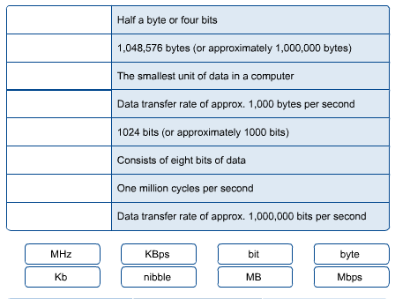

Corrected By:\_\_\_\_\_\_\_\_\_\_\_\_\_\_

Instructor Signature\_\_\_\_\_\_\_\_\_\_\_\_\_\_

Date Completed\_\_\_\_\_\_\_\_\_\_\_\_\_\_

**Types of Computers**

**ON THE BASIS OF WORKING:**

✓ Analog computer

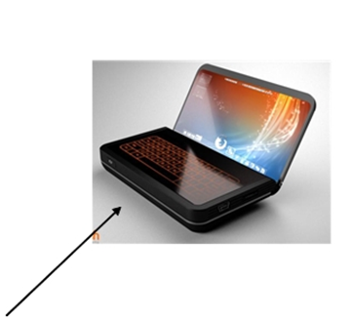✓ Digital computer

✓ Hybrid computer (Digital + Analog)

**ON THE BASIS OF SIZE:**

✓ Mainframe computer   
✓ Mini computer

✓ Super computer   
✓ Work station   
✓ Micro computer

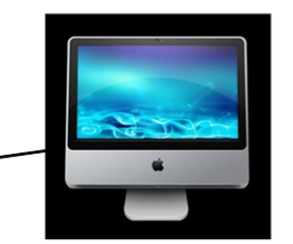▪ Desktop computer   
 ▪ Laptop computer   
 ▪ Palmtop computer   
 ✓ Network computer

**ON THE BASIS OF BRAND:**

✓ IBM PC

✓ IBM compatible   
✓ Apple/ Macintosh

**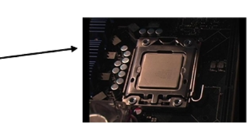ON THE BASIS OF PROCESSING**:

✓ XTI 8086 & 8088 processor   
✓ AT 286

✓ AT 386   
✓ AT 486

✓ Pentium I, II, III,IV

**Characteristics of Computer**

**➔ SPEED AND ACCURACY**

Computer performs complex calculation at a very high speed. Computer takes a few micro/nano second to execute an operation.

Fraction of a second:

1 millisecond= 1/1000 of second

1microsecond= 1/1000000 of a second

1 nanosecond= 1/000000000 of a second

1 Pico second= 1/1000000000000 of a second

Computer always gives 100% actual outputs (result), if the user provides correct

Input and Instructions .If any mistake occurs in any calculation they are due to manual error but not of computer. Since it is100% accurate, it is reliable.

**➔ STORAGE**

Computer can store a huge amount of data for the future use in auxiliary device like floppy disk, hard disk or compact disk. The storing capacity of computer is expressed in bytes. Normally one byte stores one character of data.

0.1 1 bit

4 bits 1 nibble

8 bits 1 byte

1 byte 1 character

1024 bytes 1 Kilobyte (KB)

1024 KB 1 Megabyte (MB)

1024 MB 1 Gigabyte (GB)

1024 GB 1 Terabyte (TB)

**➔ VERSITALITY:**

Computers are being used in different fields such as offices, school, hospital, etc. to perform various tasks. Versatile means ability to perform various tasks & computer can capable to do so. A computer can process any kind of data.

**➔ DILLIGENCE:**

It is a capacity of performing repeated operation without any tiredness & any mistakes. A computer is capable of performing the required tasks continuously with the same speed, accuracy & efficiency   
without any error

**HISTORY & GENERATION OF COMPUTER**

It took thousands of years for the computer to develop in to the present state. Earlier the process of

computing was done by counting with their own figures, stones & through scratches on the sand or walls. But this idea is only for the counting of small entities. So later, various types of computing devices such as ABACUS,   
Napier's bone slide rule, defiance engine, lady Augusta Ada Lovelace, etc. On the processing of previous calculating machines & continuous development on them, makes modern computer come to this stage.

**Generations of Computer**

**➔ First generation of computer (1946 to 1958)**

i. Vacuum tubes are used to electronic circuit

ii. Storage capacity was limited (1kb to 4kb)

iii. Slow processing (millisecond)

iv. High voltage needed up to 150000 volts.

v. large in size (51002 feet)

**➔ 2nd generation of computer (1959 to 1964)**

i. Transistor were used

ii. processing speed was faster

iii. Smaller in size(512 feet)

iv. Input and output device were faster

**➔ 3rd generation of computer (1965 to 1974)**

1. ICs were used in place of transistor

ii. processing speed is faster than second generation

iii. minicomputer were in produced during this generation

iv. Storage capacity in measured in mega byte.

**➔ 4th generation of computer (1975 to 1990**

i. VLSI and micro processer are used

ii. processing speed is very high Giga bytes

iii. very smaller size

iv. input and output devices were versatile

**➔ 5th generation of computer (1990 to incomplete…)**

i. Intelligent processing

ii. Easy human computing

iii. computer will understand natural language

iv. They have artificial intelligence.

The PC, history and logic

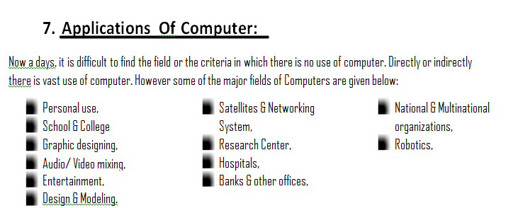The PC is a fascinating subject, and I want to take you on an illustrated, guided tour of its workings. But first I will tell you a bit about the background and history of computers. I will also have to introduce certain terms and expressions, since computer science is a subject with its own terminology. Then I will start to go through the actual PC architecture!

**The historical PC**

The PC is a microcomputer, according to the traditional division of computers based on size.

**Microcomputers**

No-one uses the expression *microcomputer* much anymore, but that is what the PC actually is. If we look at computers based on size, we find the PC at the bottom of the hierarchy.

• Mainframes and super computers are the biggest computers – million dollar machines, as big as a refrigerator or bigger. An example is the IBM model 390.

• Minicomputers are large, powerful machines which are often found at the centre of networks of “dumb” terminals and PC’s. For example, IBM’s AS/400. A definition that was used in the past, was that minicomputers cost between $10,000 and $100,000.

• Workstations are very powerful user machines. They have the capacity to execute technical/scientific programs and calculations, and typically use a UNIX variant or Windows NT as their operating system. Workstations used to be equipped with powerful RISC processors, like Digital Alpha, Sun Sparc or MIPS, but today workstations can be configured with one or more of Intel’s more powerful CPU’s.

• The PC is the baby of the family: Small, cheap, mass-produced computers which typically run Windows and which are used for standard programs which can be purchased anywhere.

The point of the story is that the baby has grown up, and has actually taken the lead! Today, PC’s are as powerful as minicomputers and mainframes were in the past. Powerful PC’s can now compete with the much more expensive workstations. How has the PC come so far?

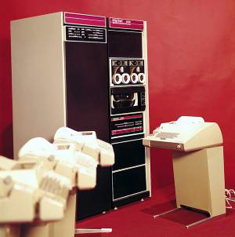

Fig.  1. Data processing in 1970. Digital PDP 11/20.

**The PC’s childhood**

Let’s take a short look at the historical background of the modern PC, which originated in 1981. In less than 20 years, the PC went through a technological development which has surpassed everything we have seen before. The PC has simply revolutionised society’s production and communication in just about every sector. And the revolution appears to be set to continue for many more years.

Today the PC is an industry standard. More than 90% of all microcomputers are based on Microsoft’s software (Windows) and standardised hardware designed primarily by Intel. This platform or design is sometimes called *Wintel*, a combination of the two product names.

But at the time that the PC was introduced by IBM, it was just one of many 16-bit microcomputers. For example, the company, Digital, sold many of their “Rainbow” machines in the middle of the 1980’s, which I have worked with myself. These other machines were *not IBM-compatible*, but they weren’t very different from IBM’s machines either, since they were all based on Intel’s 8088 CPU. There were actually a number of different types of PC in the 1980’s.

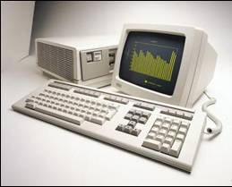

But over just a few years, late in the 1980’s, the market got behind IBM’s standards for PC architecture. Using the Intel 8086 and 8088 processors and Microsoft’s operating systems (DOS initially, later Windows), the PC revolution got seriously underway. From that time on, we talked bout IBM-*compatible* PCs, and as the years passed, the PC developed to become the triumphant industry standard.

In parallel with the IBM/Intel project, Apple developed the popular Macintosh computers, which from the very start were very user-friendly, with a graphical user interface. The Macintosh is a completely different platform from the platform of Windows-based pc’s I am describing in this guide.

The Macintosh has also been released in generation after generation, but it is not compatible with IBM/Intel/Microsoft’s PC standard.

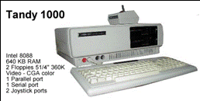

*Fig.  3. An almost IBM-compatible PC from 1984.*

In the table below you can see the development of the PC and it’s associated operating systems. The PC was actually a further development of the 8-bit microprocessors (like the Commodore 64, etc.), which were very popular until late in the 1980’s.

The computer shown in Fig. 2, is a very interesting hybrid. It marked the transition from 8 to 16-bit architecture. The computer contains two processors: an 8-bit Z80 and a 16-bit 8088. This enabled it to run several different operating systems, such as *CP/M* and MS-DOS 2. The two processors, each with their own bus, shared the 128 KB RAM. It was a particularly advanced machine.

**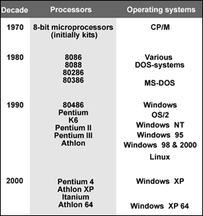**

**IBM and the PC’s success**

If we look back at the earlier PC, there are a number of factors which have contributed to its success:

• From the very beginning the PC had a *standardised* and *open* architecture.

• It was *well-documented* and had extensive *expansion options*.

• The PC was *cheap*, *simple* and *robust* (but definitely not advanced technology)

Initially, the PC was an IBM product. It was their design, built around an Intel processor (8088) and adapted to Microsoft’s simple operating system, MS-DOS.

But other companies were quick to get involved. They found that they could freely copy the important BIOS system software and the central ISA bus. None of the components were patented. That wouldn’t happen today! But precisely because of this open architecture, a whole host of companies gradually appeared, which developed and supplied IBM-compatible PC’s and parts.

**Clones**

In the late 1980’s there was a lot of talk about *clones*. A clone is a copycat machine. A machine which can do exactly the same things as an original PC (from IBM), and where the individual components (e.g. the hard disk) could be identical to the original’s. The clone just has another name, or is sold without any name.

We don’t distinguish as much today between the various PC manufacturers; but they can still be divided into two groups:

• Brand name PC’s from IBM, Compaq, Dell, Fujitsu-Siemens, etc. Companies which are large enough to develop (potentially) their own hardware components.

• Clones, which are built from standard components. Anyone can build their own clone, like the one shown in Fig.  15. The central unit contains the majority of a PC’s electronics.

The cabinet shown in **Error! Not a valid bookmark self-reference.**

|  |  |
| --- | --- |
| H:\hardware\cisco\PC Architecture. Chapter 3. A data processor_files\image008.jpg | Fig. 16. A desktop cabinet. |

Fig.17 shows a list of most of the components of the PC. Some of them are *internal*, i.e., they are inside the cabinet. Other components are *external*, they are located *outside* the cabinet.

Read through the list and think about what the words refer to. Do you know all these devices?

|  |  |  |
| --- | --- | --- |
| **Internal devices** | | **External devices** |
| Motherboard | CPU, RAM, cache, ROM circuits containing the BIOS and startup programs. Chipsets (controllers). Ports, busses and slots. EIDE interface, USB, AGP, etc. | Keyboard Mouse Joystick Screen Printer Scanner Speakers External drives Tape drive MIDI units Modem Digital camera |
| Drives | Hard disk(s), diskette drive, CD-ROM, DVD, etc. |
| Plug-in cards | Graphics card (video adapter), network card, SCSI controller. Sound card, video and TV card.  Modem and ISDN card. |

Fig.  17. The PC’s components can be divided into internal and external groups.

**Speed – the more we get, the more we want**

The PC processes data. It performs *calculations* and *moves* data between the various components. It all happens at our command, and we want it to happen fast.

It is interesting to note that current technological development is basically focusing exclusively on achieving *faster* data processing. The entire PC revolution over the last 20 years is actually just a sequence of ever increasing speed records in the area of data transfer. And there doesn’t seem to be any upper limit to how much data transfer speed we need.

This continual speed optimisation is not just occurring in one place in the PC; it’s happening everywhere that data is moved.

### The Von Neumann model

The modern microcomputer has roots going back to USA in the 1940’s. Of the many researchers, the Hungarian-born mathematician, John von Neumann (1903-57), is worthy of special mention. He developed a very basic model for computers which we are still using today.

**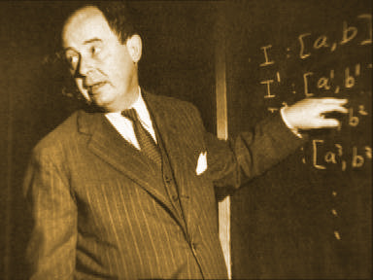**

Fig.  10. John von Neumann (1903-57). Progenitor of the modern, electronic PC.

Von Neumann divided a computer’s hardware into 5 primary groups:

• CPU

• Input

• Output

• Working storage

• Permanent storage

This division provided the actual foundation for the modern PC, as von Neumann was the first person to construct a computer which had working storage (what we today call RAM). And the amazing thing is, his model is still completely applicable today. If we apply the von Neumann model to today’s PC, it looks like this:

**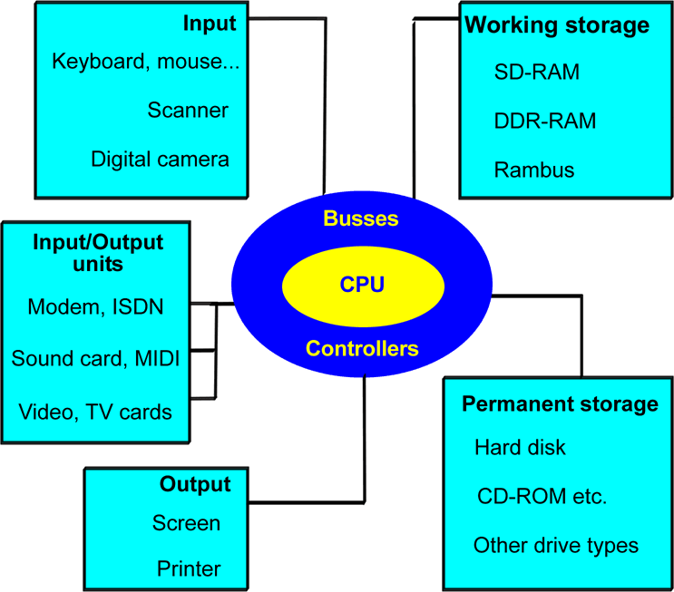**

Fig.  11. The Von Neumann model in the year 2004.

Today we talk about multimedia PC’s, which are made up of a wealth of interesting components. Note here that modems, sound cards and video cards, etc. all function as both input and output units. But this doesn’t happen simultaneously, as the model might lead you to believe. At the basic level, the von Neumann model still applies today. All the components and terms shown in **Error! Not a valid bookmark self-reference.**

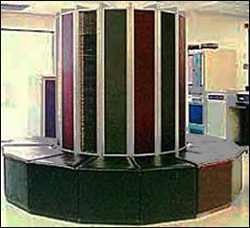

developed the world’s fastest computer. It is a huge thing (the size of four tennis courts), which can execute 35.6 billion mathematical operations per second. That’s five times as many as the previous record holder, a supercomputer from IBM.

The report from Japan shocked the Americans, who considered themselves to be the leaders in the are of computer technology. While the American super computers are used for the development of new weapons systems, the Japanese one is to be used to simulate climate models.

**The PC’s system components**

This chapter is going to introduce a number of the concepts which you have to know in order to understand the PC’s architecture. I will start with a short glossary, followed by a brief description of the components which will be the subject of the rest of this guide, and which are shown in **Error! Not a valid bookmark self-reference.**

**The necessary concepts**

I’m soon going to start throwing words around like: *interface, controller and protocol*.These aren’t arbitrary words. In order to understand the transport of data inside the PC we need to agree on various jargon terms. I have explained a handful of them below. See also the glossary in the back of the guide.

The concepts below are quite central. They will be explained in more detail later in the guide, but start by reading these brief explanations.

| **Concept** | **Explanation** |
| --- | --- |
| Binary data | Data, be it instructions, user data or something else, which has been translated into sequences of 0’s and 1’s. |
| Bus width | The size of the packet of data which is processed (e.g. moved) in each work cycle. This can be 8, 16, 32, 64, 128 or 256 bits. |
| Band width | The data transfer capacity. This is measured in, for example, kilobits/second (Kbps) or megabytes/second (MBps). |
| Cache | A temporary storage, a buffer. |
| Chipset | A collection of one or more controllers.  Many of the motherboard’s controllers are gathered together into a chipset, which is normally made up of a north bridge and a south bridge. |
| Controller | A circuit which controls one or more hardware components. The controller is often part of the interface. |
| Hubs | This expression is often used in relation to chipset design, where the two north and south bridge controllers are called hubs in modern design. |
| Interface | A system which can transfer data from one component (or subsystem) to another. An interface connects two components (e.g. a hard disk and a motherboard). Interfaces are responsible for the exchange of data between two components. At the physical level they consist of both software and hardware elements. |
| I/O units | Components like mice, keyboards, serial and parallel ports, screens, network and other cards, along with USB, firewire and SCSI controllers, etc. |
| Clock frequency | The rate at which data is transferred, which varies quite a lot between the various components of the PC.  Usually measured in MHz. |
| Clock tick (or clock cycle) | A single clock tick is the smallest measure in the working cycle. A working cycle (e.g. the transport of a portion of data) can be executed over a period of about 5 clock ticks (it “costs” 5 clock cycles). |
| Logic | An expression I use to refer to software built into chips and controllers. E.g. an EIDE controller has its own “logic”, and the motherboard’s BIOS is “logic”. |
| MHz  (Megahertz) | A ”speed” which is used to indicate clock frequency. It really means: *million cycles per second*. The more MHZ, the more data operations can be performed per second. |
| North bridge | A chip on the motherboard which serves as a controller for the data traffic close to the CPU. It interfaces with the CPU through the Front Side Bus (FSB) and with the memory through the memory bus. |
| Protocols | Electronic traffic rules which regulate the flow of data between two components or systems. Protocols form part of interfaces. |
| South bridge | A chip on the motherboard which works together with the north bridge. It looks after the data traffic which is remote from the CPU (I/O traffic). |

Fig.  13. These central concepts will be used again and again. See also the definitions on page  PAGEREF Ordforklaringer2 \h 95.

**A data processor**

The PC is a digital data processor. In practise this means that all *analogue data* (text, sound, pictures) gets translated into masses of 0’s and 1’s. These numbers (*binary values*) exist as tiny electrical charges in microscopic circuits, where a transistor can take on two states: *charged* or *not charged*. This is one picture of a *bit*, which you can say is either turned *on* or *off*.

There can be billions of these microscopic bits hidden inside a PC, and they are all managed using electronic circuits (EDP stands for *electronic data processing*). For example, the letter ”A” (like all other characters) can be represented by a particular 8-digit bit pattern. For ”A”, this 8-digit bit pattern is *01000001*.

When you type an ”A” on your keyboard, you create the digital data sequence, 01000001. To put it simply, the ”A” exists as a pattern in eight transistors, where some are “turned on” (charged) and others are not. Together these 8 transistors make up *one byte*.

The same set of data can be stored in the video card’s electronics, in RAM or even as a magnetic pattern on your hard disk:

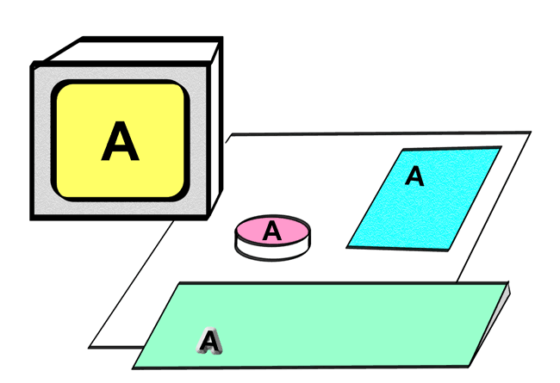

Fig.  14. The same data can be found on the screen, on the hard disk and in RAM.

The set of data can also be transferred to a printer, if you want to print out your text. The printer electronically and mechanically translates the individual bits into analogue letters and numbers which are printed on the paper. In this way, there are billions of bytes constantly circulating in your PC, while ever it is switched on. But how are these 0’s and 1’s moved around, and which components are responsible?

**The physical PC**

The PC is made up of a central unit (also called a system unit) and some external devices. The central unit is a box (a cabinet), which contains most of the computer’s electronics (the *internal* devices). The *external* devices are connected to the central unit (shown below) using cables.

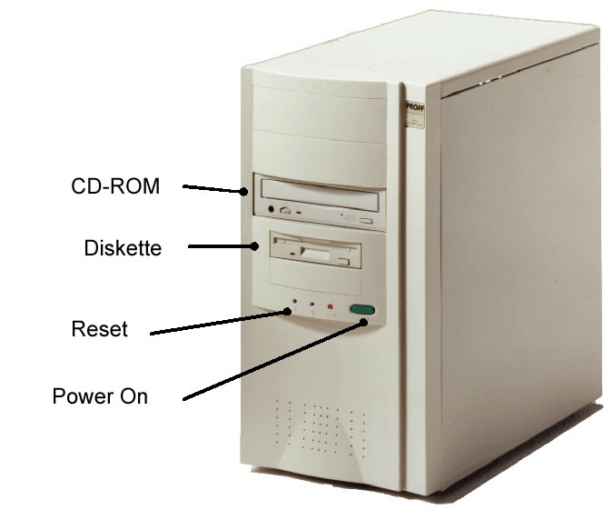

Fig.  15. The central unit contains the majority of a PC’s electronics.

The cabinet shown in **Error! Not a valid bookmark self-reference.**

|  |  |
| --- | --- |
| H:\hardware\cisco\PC Architecture. Chapter 3. A data processor_files\image008.jpg | Fig. 16. A desktop cabinet. |

Fig.17 shows a list of most of the components of the PC. Some of them are *internal*, i.e., they are inside the cabinet. Other components are *external*, they are located *outside* the cabinet.

Read through the list and think about what the words refer to. Do you know all these devices?

|  |  |  |
| --- | --- | --- |
| **Internal devices** | | **External devices** |
| Motherboard | CPU, RAM, cache, ROM circuits containing the BIOS and startup programs. Chipsets (controllers). Ports, busses and slots. EIDE interface, USB, AGP, etc. | Keyboard Mouse Joystick Screen Printer Scanner Speakers External drives Tape drive MIDI units Modem Digital camera |
| Drives | Hard disk(s), diskette drive, CD-ROM, DVD, etc. |
| Plug-in cards | Graphics card (video adapter), network card, SCSI controller. Sound card, video and TV card.  Modem and ISDN card. |

Fig.  17. The PC’s components can be divided into internal and external groups.

**Speed – the more we get, the more we want**

The PC processes data. It performs *calculations* and *moves* data between the various components. It all happens at our command, and we want it to happen fast.

It is interesting to note that current technological development is basically focusing exclusively on achieving *faster* data processing. The entire PC revolution over the last 20 years is actually just a sequence of ever increasing speed records in the area of data transfer. And there doesn’t seem to be any upper limit to how much data transfer speed we need.

This continual speed optimisation is not just occurring in one place in the PC; it’s happening everywhere that data is moved.

• The transfer from RAM to CPU – it has to be faster.

• The transfer between hard disk and motherboard – it has to be faster.

• Data to the screen – it has to be faster.

• Etc.

The PC can be viewed as a series of more or less independent subsystems, which can each be developed to permit greater capacity and higher speed. We constantly need new *standards*, because of the new, faster, interfaces, busses, protocols (which we all work out together), delivering better performance.

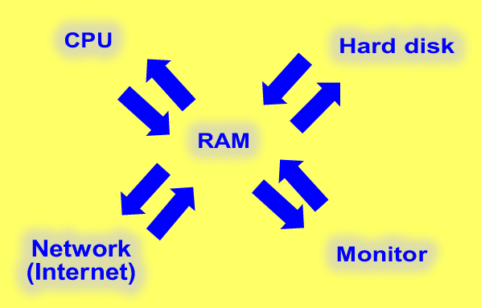

Fig. 18. Data transfer between all the components of the PC has to be fast.

**Interfaces hold it all together**

The PC is the sum of all these subsystems. At each boundary between one subsystem and another, we find an *interface*. That is, an electrical system which connects the two subsystems together and enables them to exchange data.

**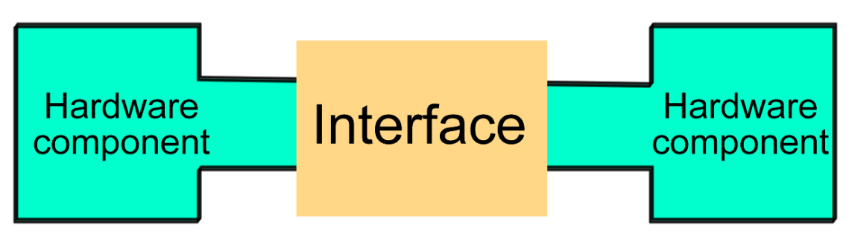**

Fig.  19. The hardware components are connected to each other via interfaces.

The concept of an interface is a little abstract, as it most accurately refers to a *standard* (a set of rules for the exchange of data). In practise, an interface can consist of, for example, two *controllers* (one at each end of the connection), a cable, and some software (protocols, etc.)  contained in the controllers.

The controllers are small electronic circuits which control the movement of data to and from the device.

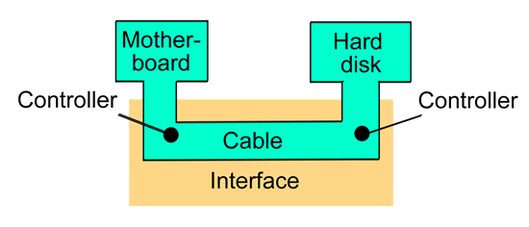

Fig. 20. An interface connects two hardware devices. An interface can consist of controllers with built-in software, cables, etc.

There are many interfaces in the PC, because there are many subsystems which have to be connected. Each interface is normally tailor-made for the job, and tuned to achieve maximum bandwidth (data transfer capacity) between the two components.

**An example of an interface**

Later in the guide I want to explore the EIDE interface in more detail, but I will use it here as a specific example of an interface. Keep your attention focused on the concept of an interface – you may not understand all the details, that doesn’t matter here.

If we want to connect a hard disk to a motherboard, this is achieved using an EIDE interface. If we look more closely at this interface, it can be divided into a series of subcomponents. The interface consists of both hardware and logic: the most important being the two EIDE controllers. One is integrated into the hard disk’s electronics, and the other is integrated into the motherboard, where it forms part of the chipset’s south bridge.

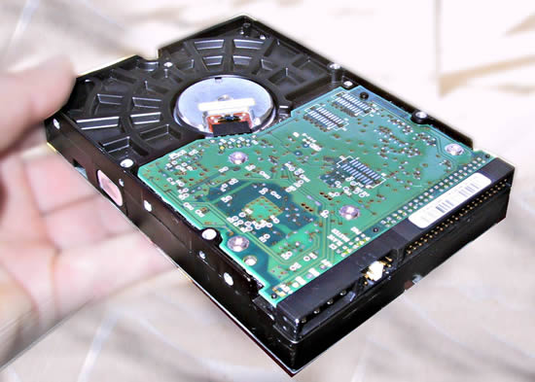

Fig.  21. Underneath the hard disk you can see a small printed circuit board. This incorporates the controller functions which work together with the corresponding controller in the PC’s motherboard.

The advantage of this system is that the hard disk can be connected directly to the motherboard with a cable. But the cable still runs from one controller to the other.

The two controllers work according to a common *standard*, which is the ATA standard. This standard includes a set of *protocols* which are continually being developed in new versions. Let’s say our specific hard disk can use the *ATA/100* protocol. That means the controller on the motherboard has to also be compatible with ATA/100, and the cable as well. When all that is in place, we have a working ATA interface.

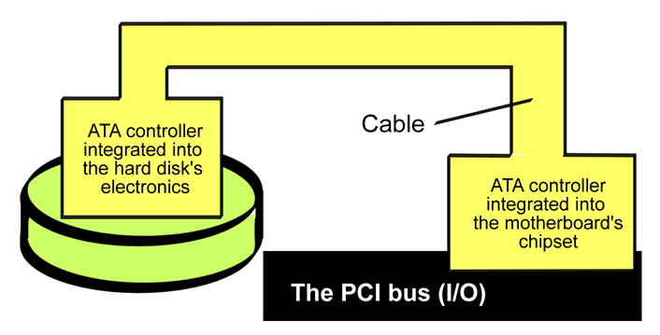

Fig.  22. A specific example of an interface.

**The CPU and the motherboard**

The heart and soul of the PC’s data processing is the CPU. But the processor is not alone in the world, it communicates with the rest of the motherboard. There will be many new terms introduced in the following sections, so remember that you can find definitions for all the abbreviations in the back of the guide.

**Busses do the transfers**

Data packets (of 8, 16, 32, 64 or more bits at a time) are constantly being moved back and forth between the CPU and all the other components (RAM, hard disk, etc.). These transfers are all done using *busses*.

The motherboard is designed around some vary powerful data *channels* (or pathways, as they are also called). It is these busses which connect all the components to each other.

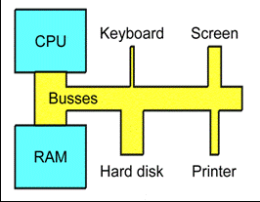

Fig.  41. The busses are the data channels which connect the PC’s components together. Some are designed for small transfers, others for large ones.

**Busses with varying capacities**

There is not just one bus on a motherboard; there are several. But they are all connected, so that data can run from one to another, and hence reach the farthest corners of the motherboard.

We can say that a bus system is subdivided into several branches. Some of the PC components work with enormous amounts of data, while others manage with much less. For example, the keyboard only sends very few bytes per second, whereas the working storage (RAM) can send and receive several gigabytes per second. So you can’t attach RAM and the keyboard to the same bus.

Two busses with different capacities (bandwidths) can be connected if we place a controller between them. Such a controller is often called a *bridge*, since it functions as a bridge between the two different traffic systems.

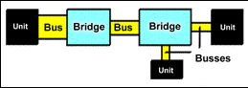

Fig.  42. Bridges connect the various busses together.

The entire bus system starts close to the CPU, where the load (traffic) is greatest. From here, the busses work outwards towards the other components. Closest to the CPU we find the working storage. RAM is the component which has the very greatest data traffic, and is therefore connected directly to the CPU by a particularly powerful bus. It is called the *front side bus* (FSB) or (in older systems) *the system bus*.

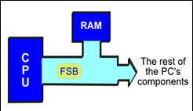

Fig.  43. The PC’s most important bus looks after the “heavy” traffic between the CPU and RAM.

The busses connecting the motherboard to the PC’s peripheral devices are called *I/O busses*. They are managed by the controllers.

**The chip set**

The motherboard’s busses are regulated by a number of controllers. These are small circuits which have been designed to look after a particular job, like moving data to and from EIDE devices (hard disks, etc.).

A number of controllers are needed on a motherboard, as there are many different types of hardware devices which all need to be able to communicate with each other. Most of these controller functions are grouped together into a couple of large chips, which together comprise the *chip set*.

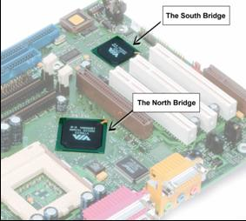

Fig.  44. The two chips which make up the chipset, and which connect the motherboard’s busses.

The most widespread chipset architecture consists of *two* chips, usually called the *north* and *south bridges*.This division applies to the most popular chipsets from VIA and Intel. The north bridge and south bridge are connected by a powerful bus, which sometimes is called a *link channel*:

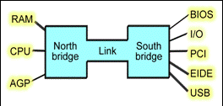

Fig.  45. The north bridge and south bridge share the work of managing the data traffic on the motherboard.

**The north bridge**

The north bridge is a controller which controls the flow of data between the CPU and RAM, and to the AGP port.

In Fig.  46. The north bridge and its immediate surroundings. A lot of traffic runs through the north bridge, hence the heat sink.

The AGP is actually an I/O port. It is used for the video card. In contrast to the other I/O devices, the AGP port is connected directly to the north bridge, because it has to be as close to the RAM as possible. The same goes for the PCI Express x16 port, which is the replacement of AGP in new motherboards. But more on that later.

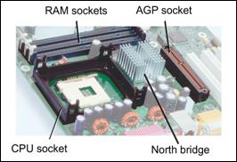

Fig.  46. The north bridge and its immediate surroundings. A lot of traffic runs through the north bridge, hence the heat sink.

The AGP is actually an I/O port. It is used for the video card. In contrast to the other I/O devices, the AGP port is connected directly to the north bridge, because it has to be as close to the RAM as possible. The same goes for the PCI Express x16 port, which is the replacement of AGP in new motherboards. But more on that later.

**Chapter II Parts of the Computer System**

**Computer Case**

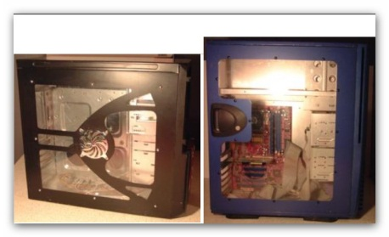Computer cases (or chassis) protect the internal components of a PC from the outside environment and come in two varieties-desktop and tower. Desktop computer cases lie on a desk with the monitor sitting on top. These were the first type of PCs and there are a few that exist today. Towers stand upright. However, the term desktop is now used to describe any system that is not a laptop. Towers are the most popular and there are three types: mini, mid, and full. The front of the case is called the bezel. Each one is designed for a certain motherboard form factor. The mini case can also be a slim tower or a HTPC. HTPC stands for Home Theater PC. As the name implies, HTPC cases are specifically designed to match your audio/video system equipment. Most lie flat like a desktop and support a micro ATX or ITX board. The mid tower and full tower support micro as well as regular ATX. When choosing tower computer cases, consider these factors:   
  
**Space** - Don't have much room to spare? You may want a mini tower case. These computer cases take up very little space and can be tucked away nicely. However, at some point you may want to fix or add components to your PC. If so, then a mid or full tower case is better because they provide more space inside to work.   
  
**Number of Drive Bays** - Drive bays are where you insert hard drives and CD/DVD drives. Full tower computer cases usually contain far more external and internal bays than mid or mini. Make sure you purchase a case with enough bays for present and future needs.   
  
**Number of Ports & Slots** - Cases come equipped with a number of front panel audio, USB, and Firewire ports as well as slots in the back for expansion cards. Just like above, get the one that's suitable for your needs.   
  
**Number of Fans & Vents** - Make sure the case has sufficient air flow. The more fans the better and many cases have additional vents on the side.   
  
**Case Material** - Most cases are made of aluminum, steel, or both. Sometimes the bezel is plastic.   
  
**Power Supply** - Many cases come with a power supply already installed. This can be a money saver instead of buying them separately.   
  
Besides providing protection for parts, computer cases come in a multitude of stylish designs and colors. Many have a clear side and LED lighting so you can see inside. Remember to keep upgrading in mind. If you're thinking about adding extra drives or cards later, buy a case with plenty of space that supports those extra components.7654’

|  |
| --- |
| **Computer Motherboard** |

|  |  |  |
| --- | --- | --- |
| Computer Motherboard |  | This tutorial discusses the various motherboard components and features. For information on installing a motherboard, read [**this tutorial**](http://www.learning-about-computers.com/tutorials/install_a_motherboard.shtml).   The motherboard (mobo for short) is the most important part of a computer and is the main circuit board. Everything connects directly or indirectly to it.   To become familiar with motherboards, you need to know and understand their parts. PC motherboard components differ depending on the manufacturer and model. However, all have the following primary features:   * BIOS Chip * Battery * Form Factor * Type of Processor They Support * Chipset * Type of Bus & Bus Speed * Expansion Slots * Memory Slots |

**BIOS Chip:**  
Every motherboard has a BIOS (Basic Input Output System). This chip contains a small amount of code that is responsible for booting up your system. It reads the CMOS settings, performs the POST (Power On Self Test), checks for devices, and then reads the master boot record on the hard drive so the operating system can load. Phoenix Technologies and American Megatrends are the two main BIOS makers.   
  
**Battery:**  
Every motherboard has a battery to maintain the time and CMOS settings after the power is turned off. Most are small, round, flat and fit into a socket.

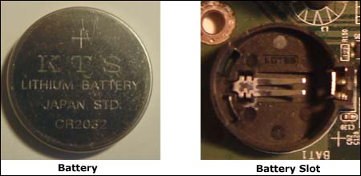

**Form Factor:**  
The form factor refers to a motherboard's dimensions and layout of its components. The primary standard today is some type of ATX form factor, developed from the obsolete AT. ATX and micro ATX (mATX) are still the most popular, but there are others such as Extended ATX(EATX, which is slightly bigger than the standard ATX) and mini ATX (smaller than ATX but bigger than mATX). VIA developed the mini ITX factor, which is smaller than any of the aforementioned.   
  
Small motherboards were basically designed for low cost PCs but still implement the latest technology. A main disadvantage, though, is they have fewer expansion slots than their larger counterparts.

|  |  |
| --- | --- |
| **Form Factor** | **Size** |
| ATX (Standard) | 9.6" x 12" |
| microATX | 9.6" x 9.6" |
| Extended ATX | 13" x 12" |
| Mini ATX | 8.2" x 11.2" |
| Mini ITX | 6.7" x 6.7" |

**Type Of Processor Support:**  
Every motherboard supports either an AMD or an Intel processor (called the central processing unit or CPU). They are not interchangeable. If a motherboard requires an AMD processor, it cannot use an Intel, and vice-versa. You don't have to figure out which CPU matches a particular board. You're always told the type of CPU that a motherboard uses.   
  
**Chipset:**  
The chipset is either one chip or a pair of chips that allows communication between the CPU and other components. If there are two chips one is called the northbridge and the other southbridge.   
  
The northbridge connects directly to the processor through the front side bus and lets it talk to the memory, AGP, and PCI Express controllers. The southbridge connects to the processor indirectly via the northbridge and controls slower devices such as the hard drive, USB, audio, video, LAN, and PCI. If there is one chip, then everything is controlled by that chip.

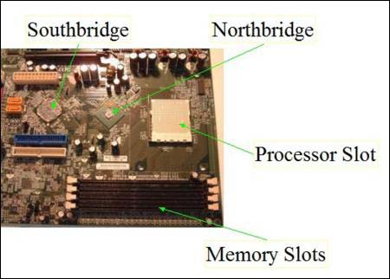

The motherboard is useless without a chipset. Unlike the CPU, it is integrated into the motherboard, so it can't be removed. When a new processor is developed, a new chipset has to also be developed to accommodate its technology. The two main manufacturers are nVIDIA and Intel.   
  
**Bus & Bus Speed:**  
In electronics, you can think of a bus as an electronic highway on which data travels. With computers there has to be a communication highway between the CPU and other parts. AMD motherboards use HyperTransport technology for data transport and Intel's Core i7 processor-based systems use QuickPath Interconnect. But before these there was/is the front side bus.   
  
On current Intel computers not using the Core i7 processor, the front-side bus is still used as the data path that connects the processor to the northbridge and other components. When shopping for a computer or a motherboard you're almost certain to see the speed listed as something like "1333 MHz". This is the front side bus speed, also known as the motherboard speed. It is how fast data travels between the CPU and memory and is measured in megahertz (MHz). This speed is obtained by using a quartz crystal on the motherboard. When an electrical current passes through it, it vibrates. These vibrations, or pulses, occur millions of times per second. This is what's known as the clock speed.   
  
HyperTransport and QuickPath Interconnect measure speed in GT/s (Giga transfers/sec) and sometimes MT/s (Mega transfers/sec). This is not the actual bus speed but how many 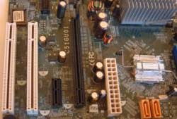transfers, or operations per second. Data is sent on the rising and falling edges of a clock cycle, resulting in two transfers per cycle. So if the bus speed is 1500 MHz (1.5 GHz) that means there are 1500 million rising and falling edges every second. Multiply that by 2, and you get 3000MT/s (3.2 GT/s). HyperTransport and QuickPath are explained in a little more detail on the CPU page. Bus speed is one of the primary factors that has an impact on a computer's performance.   
  
Although front side bus technology no longer exists on any current AMD motherboards, some retailers still use the term to describe HyperTransport.   
  
**Expansion Slots:**  
All computers now-a-days come with audio, video, and other features built right into the motherboard. If you don't want to use these, expansion slots give you the flexibility to choose and have your own audio, video, or other card installed. The number of slots varies according to the manufacturer and model. The board on the left has 2 PCI slots (white) and 2 PCI Express Slots (Black).   
  
Understanding PC motherboard components can greatly help you, but choosing one is still sometimes a confusing ordeal. After all, there are so many manufacturers. But one main thing to remember is that since motherboards support either an Intel or AMD CPU, picking a motherboard and processor go hand in hand, so think about which processor you want first. However, this in itself opens another can of worms because there's an on-going debate about which CPU is better. It seems to never end. And each CPU manufacturer produces various models to add to the confusion. The best thing to do is read reviews of different motherboards and the latest processors. Some main motherboard manufacturers are:

* [**ASUS**](http://www.asus.com/#_blank)
* [**Biostar**](http://www.biostar-usa.com/#_blank)
* [**EVGA**](http://www.evga.com/#_blank)
* [**Gigabyte**](http://www.gigabyte.com.tw/#_blank)
* [**MSI (Micro-Star International)**](http://us.msi.com/#_blank)

|  |
| --- |
| Computer Power Supply |

The power supply (power supply unit or PSU) is a rectangular box with several cables that fits in the top back of the case. Its primary purpose is converting AC power from an outlet to DC power the computer can use. The cables have connectors on the ends which supply different voltages to various internal components with the main connector plugging into the motherboard. However some, called modular power supplies, contain built-in connectors so you can use only the cables that are necessary.

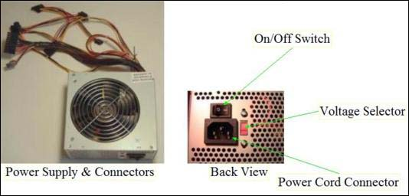

Power supplies conform to the ATX factor and come in a range of different wattages - from less than 300W to more than a 1000W. Which should you buy? Depends on what type of system you have. For the average system with one or two hard drives, a DVD drive, dual core CPU, and a low-end graphics card, I would suggest at least a 500W PSU. If you plan on adding more drives, get a unit that can handle the job. Better yet, go ahead and buy a 600 or 700 watt just in case upgrading is in your future. Very powerful machines such as gaming systems can use power supplies that are 1000W or more. Motherboards designed for SLI or Crossfire have PSUs specifically made for them. After purchasing, make sure the voltage is set to the correct number by using the voltage selector (100-120V for N. America. & 220-240V for Europe). Thermal Take, Cool Max, and Cooler Master are just some of the major manufacturers of PSUs.

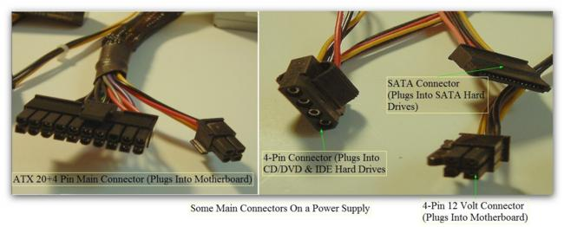

|  |
| --- |
| **Central Processing Unit (CPU)** |

This tutorial discusses the types and speeds of various processors. For information on installing a processor, read [**How To Install a CPU**](http://www.learning-about-computers.com/tutorials/install_a_cpu.shtml).   
  
The Central Processing Unit (Normally called a processor or CPU) is the brain of the PC. It executes instructions, allowing a computer to perform all kinds of tasks. From burning CDs or DVDs to something as simple as a mouse click, the CPU is always at work. Processors consist of two parts: The Arithmetic Unit, which performs math and logical operations, & the Control Unit, which decodes instructions. Over the years, processors have become extremely fast. AMD and Intel are the two primary manufacturers.   
  
CPU technology constantly changes, probably faster than any other type of hardware. On this page I highlight what I consider are the main specifications.   
  
When looking at a CPU, you don't really see the processor itself. The little piece of silicon that contains the circuitry is very small. What you actually see is the package that it's in. Both AMD and Intel have had many types over the years. Packages are usually square with pins underneath that fit into holes on the CPU's slot. This arrangement is known as Pin Grid Array (PGA) and is now only used by AMD.

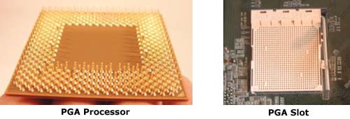

Intel abandoned PGA years ago and now have the pins located on the slots themselves, called Land Grid Array (LGA).

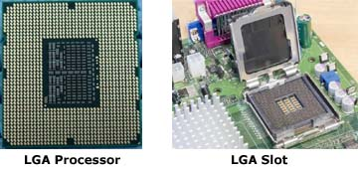

**Types**  
Processors are designed to fit into a certain type of socket on the motherboard. Every socket has a name, indicating whether it's for an AMD or Intel CPU. Keep in mind that AMD and Intel have different socket designs, so their processors are not interchangeable. But regardless of manufacturer, CPUs usually differ in the number of pins used and are often named accordingly.

|  |  |
| --- | --- |
| **Socket Type** | **Manufacturer** |
| LGA 771 (Socket J) | Intel (Xeon Server) |
| LGA 775 (Socket T) | Intel |
| LGA 1156 (Socket H) | Intel |
| LGA 1166 (Socket B) | Intel |
| AM2 | AMD |
| AM2+ | AMD |
| AM3 | AMD |

AM2+ and AM3 mainly differ in terms of the memory each supports. AM2+ supports DDR2 while AM3 supports DDR2 and DDR3, making it backward-compatible with the AM2+ motherboard.   
  
**Rates & Data Transfer:**  
What characterizes a computer processor is its speed or rate - how fast it can execute instructions. As of now, speed is measured in gigahertz (GHz), or billions of cycles a second. Some CPU rates are 2.0 GHz, 2.40 GHz, and 3.20 GHz. These rates and others are obtained by using the motherboard's bus speed.   
  
CPUs contain a multiplier that when multiplied by the bus speed, yields the appropriate CPU speed for a given motherboard. For example, if the speed of a motherboard is 800 MHz, and the CPU multiplier is 4, then the processor's speed is 800 x 4 = 3200 MHz or 3.2 GHz.   
  
Because the CPU greatly determines the overall performance of a PC, the type of processor and its speed are two of the main factors to look for when deciding to buy a computer. But keep in mind there are other important things, such as the amount of memory.   
  
CPUs are either 32-bit or 64-bit. This means how much data that can be processed in terms of bits. In computers data is composed of 1's and 0's (e.g. 01110010). Each individual 1 or 0 is called a bit. A 32-bit CPU can process a max of 2^32 (2 raised to 32nd power) or about 4.3 billion bits per cycle. A 64-bit processor 2^64 or about 18,400,000,000,000,000,000 of data per cycle. The more data a computer can handle means improved performance.   
  
The amount of memory supported by a processor is also determined by the number of bits. Using the same math above, a 32-bit processor supports 2^32 or approximataely 4 GB of memory.   
  
**Cache:**  
In addition to CPU speed, another important processor feature that influences performance is the amount of cache (pronounced cash) it has. CPU cache is memory set aside for the most frequently used data. There's Level 1, Level 2, and Level 3 (commonly just called L1, L2, and L3). L1 uses extremely fast and expensive SRAM (Static RAM) and is the smallest in size. L2 is slightly larger in size. Both L1 and L2 are located on the processor. L3 is the largest and is usually located outside the CPU and shared by all the cores. When data is requested, the CPU first checks the L1 to see if it's there. If not it checks L2 and so on. Accessing data in the cache is far more faster and efficient than fetching it from RAM.   
  
**Dual Core & Multicore Processors:**  
Most computer processors today are dual core or multicore. Both terms are generic for any processor that literally contains two or more CPUs in one package. Both Intel and AMD produce versions of these processors. AMD's Athlon x2, Turion x2, and Intel's Core 2 Duo and Core 2 Extreme are examples of dual core CPUs. Multicore examples are the AMD Phenom x3 and x4 and Intel's Core 2 Quad and the Core i7. These powerful CPUs allow users to run several applications simultaneously as well as play the latest games.   
  
**HyperTransport:**  
AMD's HyperTransport Technology has been around since 2003. All of their processors based on AMD64 architecture use HypertTransport. It eliminated the front side bus (FSB) and took the memory controller, which was previously on the chipset, and placed it on the processor. The old front side bus used one data path from the CPU for memory and I/O (Input/Output). HTT implements two separate data paths for memory and I/O. Also, unlike the FSB, data flow between the CPU and the chipset can be sent and received at the same time.   
  
In late 2008, Intel released the quad-core Core i7 CPU with its own version of HyperTransport called QuickPath Interconnect (QPI). It basically does the same thing as HTT but only uses DDR3 memory, and depending on which model some support three memory channels. They also had to develop a new chipset which includes PCI Express enhancements.   
  
In addition supporting QPI, the Core i7 includes 64K L1 and 256K L2 cache for each core, 8MB L3 shared cache, turbo boost, and HD boost for improved high definition. It brings back the old hyper-threading. Before dual cores came on the scene, hype-rthreading was used to make the operating system think there were two processors. Since the i7 is quad-core hyper-threading makes it seem as if there are eight cores.   
  
All these combined make for an extremely fast system for multitasking, gaming and multimedia needs.   
  
The Core i7 computer processor comes in several variations, and it can get confusing. There is also the Core i5 and Core i3. Below are tables showing the Intel processors recently released in each class.

|  |  |  |  |  |  |  |
| --- | --- | --- | --- | --- | --- | --- |
| **i7 Series Processor (All Quad Core & Use Hyperthreading)** | **Released** | **Speed** | **Transfers/Sec** | **Maximum Amount of  Memory & Number of Channels Supported** | **Integrated HD Graphics** | **Cache Size** |
| **i7-930** | Q1 2010 | 2.8 GHZ; 3.46 GHz w/Turbo Boost | 4.8 GT/s | 24 GB, 3 Channels | N | 8 MB |
| **i7-960** | Q4 2009 | 3.2 GHz; 3.46 GHz w/Turbo Boost | 4.8 GT/s | 24 GB, 3 Channels | N | 8 MB |
| **i7-860** | Q3 2009 | 2.8 GHz; 3.46 GHz w/Turbo Boost | 2.5 GT/s | 16 GB, 2 Channels | N | 8 MB |
| **i7-870** | Q3 2009 | 2.93GHz; 3.6 GHz w/Turbo Boost | 2.5 GT/s | 16 GB, 2 Channels | N | 8 MB |
| **i7-950** | Q2 2009 | 3.06 GHz; 3.33 GHz w/ Turbo Boost | 4.8 GT/s | 24 GB, 3 Channels | N | 8 MB |
| **i7-920** | Q4 2008 | 2.66 GHz; 2.93 GHz w/Turbo Boost | 4.8 GT/s | 24 GB, 3 Channels | N | 8 MB |
| **i7-940** | Q4 2008 | 2.93 GHz; 3.2 GHz w/Turbo Boost | 4.8 GT/s | 24 GB, 3 Channels | N | 8 MB |

|  |  |  |  |  |  |  |
| --- | --- | --- | --- | --- | --- | --- |
| **i7 Extreme Editions** | **Released** | **Speed** | **Transfers/Sec** | **Maximum Amount of  Memory & Number of Channels Supported** | **Integrated HD Graphics** | **Cache Size** |
| **i7-980X ( 6 Cores)** | Q1 2010 | 3.33 GHz; 3.6 GHz w/Turbo Boost | 6.4 GT/s | 24 GB, 3 Channels | N | 12 MB |
| **i7-975 (4 Cores)** | Q2 2009 | 3.33 GHz; 3.6 GHz w/Turbo Boost | 6.4 GT/s | 24 GB, 3 channels | N | 8 MB |
| **i7-965 (4 Cores)** | Q4 2008 | 3.2 GHz; 3.46 GHz w/ Turbo Boost | 6.4 GT/s | 24 GB, 3 channels | N | 8 MB |

|  |  |  |  |  |  |  |
| --- | --- | --- | --- | --- | --- | --- |
| **Processor** | **Released** | **Speed** | **Transfers/Sec** | **Maximum Amount of Memory & Number of Channels Supported** | **Integrated HD Graphics** | **Cache Size** |
| **i3-530** (Dual Core) | Q1 2010 | 2.93 GHz | 2.5 GT/s | 16 GB, 2 Channels | Y | 4 MB |
| **i3-540** (Dual Core) | Q1 2010 | 3.06 GHz | 2.5 GT/s | 16 GB, 2 Channels | Y | 4 MB |
| **i5-670** (Dual Core) | Q1 2010 | 3.46 GHz; 3.73 GHz w/Turbo Boost | 2.5 GT/s | 16 GB, 2 Channels | Y | 4 MB |

|  |  |  |  |  |  |  |
| --- | --- | --- | --- | --- | --- | --- |
| **Mobile Processors** | **Released** | **Speed** | **Transfers/Sec** | **Maximum Amount of Memory & Number of Channels Supported** | **Integrated HD Graphics** | **Cache Size** |
| **i3-350M** (Dual Core) | Q1 2010 | 2.26 GHz (No Turbo Boost) | 2.5 GT/s | 8 GB, 2 Channels | Y | 3 MB |
| **i5-540M** (Dual Core) | Q1 2010 | 2.53 GHZ; 3.066 GHz w/ Turbo Boost | 2.5 GT/s | 8 GB, 2 Channels | Y | 3 MB |
| **i7-640UM** (Dual Core) | Q1 2010 | 1.2 GHz; 2.266GHz w/Turbo Boost | 2.5 GT/s | 8 GB, 2 Channels | Y | 4 MB |
| **i7-920XM Extreme** (Quad Core) | Q3 2009 | 2 GHz; 3.2 GHz w/Turbo Boost | 2.5 GT/s | 8GB, 2 Channels | N | 8 MB |

Believe or not, this is not the full list. To see others you can go to [**Intel's CPU page**](http://www.intel.com/products/processor/index.htm?iid=subhdr+prod_proc#_blank). Below are tables showing AMD CPUs specs.

|  |  |  |  |  |  |
| --- | --- | --- | --- | --- | --- |
| **CPU** | **Speed** | **Transfers/Sec** | **L1 Cache** | **L2 Cache** | **Type of Memory Supported** |
| **Athlon II x3** (Three Core) | 3 GHz | 4.4GT/s | 128 KB | 512 KB | DDR2 & DDR3 |
| **Athlon II x4** (Quad Core) | 2.9 GHz | 4.4 GT/s | 128 KB | 512 KB | DDR2 & DDR3 |
| **Phenom II x2** (Dual Core) | 3.2 Ghz | 4.0 GT/s | 128 KB | 512 KB | DDR 2 & DDR3 |
| **Phenom II x3** (Three Core) | 2.8 GHz | 4.0 GT/s | 128 KB | 512 KB | DDR2 & DDR3 |
| **Phenom II x4** (Quad Core) | 3.4 GHz | 4.0 GT/s | 128 KB | 512 KB | DDR2 **or** DDR3 (Depends on the type of socket) |

|  |  |  |  |  |
| --- | --- | --- | --- | --- |
| **Mobile CPUs** | **Speed** | **L1 Cache** | **L2 Cache** | **Type of Memory Supported** |
| **Turion x2 Ultra** | Max 2.4 GHz |  | 2 MB | DDR2 |
| **Turion Neo x2** | 1.6 GHz | 128 KB | 1 MB | DDR 2 |

Processor Specifications

Many confusing specifications often are quoted in discussions of processors. The following sections discuss some of these specifications, including the data bus, address bus, and speed. The next section includes a table that lists the specifications of virtually all PC processors.

Processors can be identified by two main parameters: how wide they are and how fast they are. The speed of a processor is a fairly simple concept. Speed is counted in megahertz (MHz), which means millions of cycles per second—and faster is better! The width of a processor is a little more complicated to discuss because there are three main specifications in a processor that are expressed in width. They are

Internal registers

Data input and output bus

Memory address bus

Systems below 16MHz usually had no cache memory at all. Starting with 16MHz systems, high-speed cache memory appeared on the motherboard because the main memory at the time could not run at 16MHz. Prior to the 486 processor, the cache on the motherboard was the only cache used in the system.

Starting with the 486 series, processors began including what was called L1 (Level 1) cache directly on the processor die. This meant that the L1 cache always ran at the full speed of the chip, especially important when the later 486 chips began to run at speeds higher than the motherboards they were plugged into. During this time the cache on the motherboard was called the second level or L2 cache, which ran at the slower motherboard speed.

Starting with the Pentium Pro and Pentium II, Intel began including L2 cache memory chips directly within the same package as the main processor. Originally this built-in L2 cache was implemented as physically separate chips contained within the processor package but not a part of the processor die. Since the speed of commercially available cache memory chips could not keep pace with the main processor, most of the L2 cache in these processors ran at one-half speed (Pentium II/III and AMD Athlon), while some ran the cache even slower, at two-fifths or even one-third the processor speed (AMD Athlon).

The original Pentium II, III, Celeron, and Athlon (Model 1 and 2) processors use 512KB of either one-half, two-fifths, or one-third speed L2 cache as Table 3.1 shows:

Table 3.1 L2 Cache Speeds

| Processor | Speed | L2 Size | L2 Type | L2 Speed |
| --- | --- | --- | --- | --- |
| Pentium III | 450–600MHz | 512KB | External | 1/2 core (225–300MHz) |
| Athlon | 550–700MHz | 512KB | External | 1/2 core (275–350MHz) |
| Athlon | 750–850MHz | 512KB | External | 2/5 core (300–340MHz) |
| Athlon | 900–1000MHz | 512KB | External | 1/3 core (300–333MHz) |

The Pentium Pro, Pentium II/III Xeon, newer Pentium III, Celeron, K6-3, Athlon (Model 4), and Duron processors include full-core speed L2 as shown in Table 3.2.

Table 3.2 Full-Core Speed Cache

| Processor | Speed | L2 Size | L2 type | L2 Speed |
| --- | --- | --- | --- | --- |
| Pentium Pro | 150–200MHz | 256KB–1MB | External | Full core |
| K6-3 | 350–450MHz | 256KB | On-die | Full core |
| Duron | 550–700+MHz | 64KB | On-die | Full core |
| Celeron | 300–600+MHz | 128KB | On-die | Full core |
| Pentium II Xeon | 400–450MHz | 512KB–2MB | External | Full core |
| Athlon | 650–1000+MHz | 256KB | On-die | Full core |
| Pentium III | 500–1000+MHz | 256KB | On-die | Full core |
| Pentium III Xeon | 500–1000+MHz | 256KB–2MB | On-die | Full core |

The problem originally forcing the L2 cache to run at less than the processor core speed was simple: The cache chips available on the market simply couldn't keep up. Intel built its own high-speed cache memory chips for the Xeon processors, but it also made them very expensive. A breakthrough occurred in the second-generation Celeron, where Intel built both the L1 and L2 caches directly on the processor die, where they both ran at the full-core speed of the chip. This type of design was then quickly adopted by the second generation Pentium III, as well as the AMD K6-3, Athlon, and Duron processors. In fact virtually all future processors from Intel and AMD have adopted or will adopt on-die L2 cache as it is the only cost-effective way to include the L2 and bring the speed up.

Table 3.3 lists the primary specifications for the Intel family of processors used in IBM and compatible PCs. Table 3.4 lists the Intel-compatible processors from AMD, Cyrix, NexGen, IDT, and Rise.

NOTE

Note in Table 3.3 that the Pentium Pro processor includes 256KB, 512KB, or 1MB of full-core speed L2 cache in a separate die within the chip. The Pentium II/III processors include 512KB of 1/2 core speed L2 cache on the processor card. The Celeron, Pentium II PE, and Pentium IIIE processors include full-core speed L2 cache integrated directly within the processor die. The Celeron III uses the same die as the Pentium IIIE, however half of the on-die cache is disabled, leaving 128KB functional.

The transistor count figures do not include the external (off-die) 256KB, 512KB, 1MB, or 2MB L2 cache built in to the Pentium Pro, Pentium II/III, Xeon, or AMD Athlon CPU packages. The external L2 cache in those processors contains an additional 15.5 (256KB), 31 (512KB), 62 million (1MB), or 124 million (2MB) transistors in separate chips!

Note in Table 3.4 that the Athlon includes either 512KB of L2 cache via separate chips, running at either one-half, two-fifths, or one-third the core speed, or 256KB of on-die L2 running at full-core speed, depending on which version you have.

Processor Speed Ratings

A common misunderstanding about processors is their different speed ratings. This section covers processor speed in general, and then provides more specific information about Intel processors.

A computer system's clock speed is measured as a frequency, usually expressed as a number of cycles per second. A crystal oscillator controls clock speeds using a sliver of quartz sometimes contained in what looks like a small tin container. Newer systems include the oscillator circuitry in the motherboard chipset, so it might not be a visible separate component on newer boards. As voltage is applied to the quartz, it begins to vibrate (oscillate) at a harmonic rate dictated by the shape and size of the crystal (sliver). The oscillations emanate from the crystal in the form of a current that alternates at the harmonic rate of the crystal. This alternating current is the clock signal that forms the time base on which the computer operates. A typical computer system runs millions of these cycles per second, so speed is measured in megahertz. (One hertz is equal to one cycle per second.) An alternating current signal is like a sine wave, with the time between the peaks of each wave defining the frequency (see [Figure 3.1](javascript:popUp('/content/images/0789725363/elementLinks/03fig01.gif'))).

[Figure 3.1](javascript:popUp('/content/images/0789725363/elementLinks/03fig01.gif')) Alternating current signal showing clock cycle timing.

NOTE

The hertz was named for the German physicist Heinrich Rudolf Hertz. In 1885, Hertz confirmed the electromagnetic theory, which states that light is a form of electromagnetic radiation and is propagated as waves.

A single cycle is the smallest element of time for the processor. Every action requires at least one cycle and usually multiple cycles. To transfer data to and from memory, for example, a modern processor such as the Pentium II needs a minimum of three cycles to set up the first memory transfer and then only a single cycle per transfer for the next three to six consecutive transfers. The extra cycles on the first transfer are normally called wait states. A wait state is a clock tick in which nothing happens. This ensures that the processor isn't getting ahead of the rest of the computer.

Table 3.3 Intel Processor Specifications

| Processor | CPU Clock | Voltage | Internal Register Size | Data Bus Width | Max. Memory | Level 1 Cache | L1 Cache Type | Level 2 Cache | L2 Cache Speed | Integral FPU | Multimedia Instructions | No. of Transistors | Date Introduced |
| --- | --- | --- | --- | --- | --- | --- | --- | --- | --- | --- | --- | --- | --- |
| 8088 | 1x | 5v | 16-bit | 8-bit | 1MB | — | — | — | — | — | — | 29,000 | June 1979 |
| 8086 | 1x | 5v | 16-bit | 16-bit | 1MB | — | — | — | — | — | — | 29,000 | June 1978 |
| 286 | 1x | 5v | 16-bit | 16-bit | 16MB | — | — | — | — | — | — | 134,000 | Feb. 1982 |
| 386SX | 1x | 5v | 32-bit | 16-bit | 16MB | — | — | — | Bus | — | — | 275,000 | June 1988 |
| 386SL | 1x | 3.3v | 32-bit | 16-bit | 16MB | 0KB[1](javascript:popUp('/content/images/0789725363/elementLinks/ch03fn01.html')) | WT | — | Bus | — | — | 855,000 | Oct. 1990 |
| 386DX | 1x | 5v | 32-bit | 32-bit | 4GB | — | — | — | Bus | — | — | 275,000 | Oct. 1985 |
| 486SX | 1x | 5v | 32-bit | 32-bit | 4GB | 8KB | WT | — | Bus | — | — | 1.185M | April 1991 |
| 486SX[2](javascript:popUp('/content/images/0789725363/elementLinks/ch03fn02.html')) | 2x | 5v | 32-bit | 32-bit | 4GB | 8KB | WT | — | Bus | — | — | 1.185M | April 1994 |
| 487SX | 1x | 5v | 32-bit | 32-bit | 4GB | 8KB | WT | — | Bus | Yes | — | 1.2M | April 1991 |
| 486DX | 1x | 5v | 32-bit | 32-bit | 4GB | 8KB | WT | — | Bus | Yes | — | 1.2M | April 1989 |
| 486SL[2](javascript:popUp('/content/images/0789725363/elementLinks/ch03fn02.html')) | 1x | 3.3v | 32-bit | 32-bit | 4GB | 8KB | WT | — | Bus | Opt. | — | 1.4M | Nov. 1992 |
| 486DX2 | 2x | 5v | 32-bit | 32-bit | 4GB | 8KB | WT | — | Bus | Yes | — | 1.2M | March 1992 |
| 486DX4 | 2–3x | 3.3v | 32-bit | 32-bit | 4GB | 16KB | WT | — | Bus | Yes | — | 1.6M | Feb. 1994 |
| 486Pentium OD | 2.5x | 5v | 32-bit | 32-bit | 4GB | 2x16KB | WB | — | Bus | Yes | — | 3.1M | Jan. 1995 |
| Pentium 60/66 | 1x | 5v | 32-bit | 64-bit | 4GB | 2x8KB | WB | — | Bus | Yes | — | 3.1M | March 1993 |
| Pentium 75–200 | 1.5–3x | 3.3–3.5v | 32-bit | 64-bit | 4GB | 2x8KB | WB | — | Bus | Yes | — | 3.3M | Oct. 1994 |
| Pentium MMX | 1.5–4.5x | 1.8–2.8v | 32-bit | 64-bit | 4GB | 2x16KB | WB | — | Bus | Yes | MMX | 4.5M | Jan. 1997 |
| Pentium Pro | 2–3x | 3.3v | 32-bit | 64-bit | 64GB | 2x8KB | WB | 256KB 512KB 1MB | Core | Yes | — | 5.5M | Nov. 1995 |
| Pentium II | 3.5–4.5x | 1.8–2.8v | 32-bit | 64-bit | 64GB | 2x16KB | WB | 512KB | ? Core | Yes | MMX | 7.5M | May 1997 |
| Pentium II PE | 3.5–6x | 1.6v | 32-bit | 64-bit | 64GB | 2x16KB | WB | 256KB | Core[3](javascript:popUp('/content/images/0789725363/elementLinks/ch03fn03.html')) | Yes | MMX | 27.4M | Jan. 1999 |
| Celeron | 3.5–4.5x | 1.8–2.8v | 32-bit | 64-bit | 64GB | 2x16KB | WB | 0KB | — | Yes | MMX | 7.5M | April 1998 |
| Celeron A | 3.5–8x | 1.5–2v | 32-bit | 64-bit | 64GB | 2x16KB | WB | 128KB | Core[3](javascript:popUp('/content/images/0789725363/elementLinks/ch03fn03.html')) | Yes | MMX | 19M | Aug. 1998 |
| Celeron III | 4.5–9x | 1.3–1.6v | 32-bit | 64-bit | 64GB | 2x16KB | WB | 128KB | Core[3](javascript:popUp('/content/images/0789725363/elementLinks/ch03fn03.html')) | Yes | SSE | 28.1M[4](javascript:popUp('/content/images/0789725363/elementLinks/ch03fn04.html')) | Feb. 2000 |
| Pentium III | 4–6x | 1.8–2v | 32-bit | 64-bit | 64GB | 2x16KB | WB | 512KB | ? Core | Yes | SSE | 9.5M | Feb. 1999 |
| Pentium IIIE | 4–9x | 1.3–1.7v | 32-bit | 64-bit | 64GB | 2x16KB | WB | 256KB | Core[3](javascript:popUp('/content/images/0789725363/elementLinks/ch03fn03.html')) | Yes | SSE | 28.1M | Oct. 1999 |
| Pentium II Xeon | 4–4.5x | 1.8–2.8v | 32-bit | 64-bit | 64GB | 2x16KB | WB | 512KB 1MB 2MB | Core | Yes | MMX | 7.5M | April 1998 |
| Pentium III Xeon | 5–6x | 1.8–2.8v | 32-bit | 64-bit | 64GB | 2x16KB | WB | 512KB 1MB 2MB | Core | Yes | SSE | 9.5M | March 1999 |
| Pentium IIIE Xeon | 4.5—6.5x | 1.65v | 32-bit | 64-bit | 64GB | 2x16KB | WB | 256KB 1MB 2MB | Core[3](javascript:popUp('/content/images/0789725363/elementLinks/ch03fn03.html')) | Yes | SSE | 28.1M 84M 140M | Oct. 1999 May 2000 |

Table 3.4 AMD, Cyrix, NexGen, IDT, and Rise Processors

| Processor | CPU Clock | Voltage | Internal Register Size | Data Bus Width | Max. Memory | Level 1 Cache | L1 Cache Type | Level 2 Cache | L2 Cache Speed | Integral FPU | Multimedia Instructions | No. of Transistors | Date Introduced |
| --- | --- | --- | --- | --- | --- | --- | --- | --- | --- | --- | --- | --- | --- |
| AMD K5 | 1.5–1.75x | 3.5v | 32-bit | 64-bit | 4GB | 16+8KB | WB | — | Bus | Yes | — | 4.3M | Mar 1996 |
| AMD K6 | 2.5–4.5x | 2.2–3.2v | 32-bit | 64-bit | 4GB | 2x32KB | WB | — | Bus | Yes | MMX | 8.8M | April 1997 |
| AMD K6-2 | 2.5–6x | 1.9–2.4v | 32-bit | 64-bit | 4GB | 2x32KB | WB | — | Bus | Yes | 3DNow | 9.3M | May 1998 |
| AMD K6-3 | 3.5–4.5x | 1.8–2.4v | 32-bit | 64-bit | 4GB | 2x32KB | WB | 256KB | Core[3](javascript:popUp('/content/images/0789725363/elementLinks/ch03fn03.html')) | Yes | 3DNow | 21.3M | Feb. 1999 |
| AMD Athlon | 5–10x | 1.6–1.8v | 32-bit | 64-bit | 8TB | 2x64KB | WB | 512KB | 1/2–1/3 Core | Yes | Enh. 3DNow | 22M | Jun. 1999 |
| AMD Duron | 5–10x | 1.5–1.8v | 32-bit | 64-bit | 8TB | 2x64KB | WB | 64KB | Core[3](javascript:popUp('/content/images/0789725363/elementLinks/ch03fn03.html')) | Yes | Enh. 3DNow | 25M | Jun. 2000 |
| AMD Athlon 4 (Thunderbird) | 5–10x | 1.5–1.8v | 32-bit | 64-bit | 8TB | 2x64KB | WB | 256KB | Core[3](javascript:popUp('/content/images/0789725363/elementLinks/ch03fn03.html')) | Yes | Enh. 3DNow | 37M | Jun. 2000 |
| Cyrix 6x86 | 2x | 2.5–3.5v | 32-bit | 64-bit | 4GB | 16KB | WB | — | Bus | Yes | — | 3M | Feb. 1996 |
| Cyrix 6x86MX/MII | 2–3.5x | 2.2–2.9v | 32-bit | 64-bit | 4GB | 64KB | WB | — | Bus | Yes | MMX | 6.5M | May 1997 |
| Cyrix III | 2.5–7x | 2.2v | 32-bit | 64-bit | 4GB | 64KB | WB | 256KB | Core[3](javascript:popUp('/content/images/0789725363/elementLinks/ch03fn03.html')) | Yes | 3DNow | 22M | Feb 2000 |
| NexGen Nx586 | 2x | 4v | 32-bit | 64-bit | 4GB | 2x16KB | WB | — | Bus | Yes | — | 3.5M | Mar 1994 |
| IDT Winchip | 3–4x | 3.3–3.5v | 32-bit | 64-bit | 4GB | 2x32KB | WB | — | Bus | Yes | MMX | 5.4M | Oct. 1997 |
| IDT Winchip2/2A | 2.33–4x | 3.3–3.5v | 32-bit | 64-bit | 4GB | 2x32KB | WB | — | Bus | Yes | 3DNow | 5.9M | Sept. 1998 |
| Rise mP6 | 2–3.5x | 2.8v | 32-bit | 64-bit | 4GB | 2x8KB | WB | — | Bus | Yes | MMX | 3.6M | Oct. 1998 |

FPU = Floating-Point Unit (internal math coprocessor)

WT = Write-Through cache (caches reads only)

WB = Write-Back cache (caches both reads and writes)

Bus = Processor external bus speed (motherboard speed)

Core = Processor internal core speed (CPU speed)

MMX = Multimedia extensions, 57 additional instructions for graphics and sound processing

3DNow = MMX plus 21 additional instructions for graphics and sound processing

Enh. 3DNow = 3DNow plus 24 additional instructions for graphics and sound processing

SSE = Streaming SIMD (Single Instruction Multiple Data) Extensions, MMX plus 70 additional instructions for graphics and sound processing

The time required to execute instructions also varies:

8086 and 8088. The original 8086 and 8088 processors take an average of 12 cycles to execute a single instruction.

286 and 386. The 286 and 386 processors improve this rate to about 4.5 cycles per instruction.

486. The 486 and most other fourth-generation Intel compatible processors such as the AMD 5x86 drop the rate further, to about two cycles per instruction.

Pentium, K6 series. The Pentium architecture and other fifth-generation Intel compatible processors such as those from AMD and Cyrix include twin instruction pipelines and other improvements that provide for operation at one or two instructions per cycle.

Pentium Pro, Pentium II/III/Celeron and Athlon/Duron. These P6 class processors, as well as other sixth-generation processors such as those from AMD and Cyrix, can execute as many as three or more instructions per cycle.

Different instruction execution times (in cycles) make it difficult to compare systems based purely on clock speed or number of cycles per second. How can two processors that run at the same clock rate perform differently with one running "faster" than the other? The answer is simple: efficiency.

The main reason why the 486 was considered fast relative to a 386 is that it executes twice as many instructions in the same number of cycles. The same thing is true for a Pentium; it executes about twice as many instructions in a given number of cycles as a 486. This means that given the same clock speed, a Pentium will be twice as fast as a 486, and consequently a 133MHz 486 class processor (such as the AMD 5x86-133) is not even as fast as a 75MHz Pentium! That is because Pentium megahertz are "worth" about double what 486 megahertz are worth in terms of instructions completed per cycle. The Pentium II and III are about 50 percent faster than an equivalent Pentium at a given clock speed because they can execute about that many more instructions in the same number of cycles.

Comparing relative processor performance, you can see that a 1000MHz Pentium III is about equal to a (theoretical) 1,500MHz Pentium, which is about equal to an 3,000MHz 486, which is about equal to a 6,000MHz 386 or 286, which is about equal to a 12,000MHz 8088. The original PC's 8088 ran at only 4.77MHz; today, we have systems that are comparatively about 2,500 times faster! As you can see, you have to be careful in comparing systems based on pure MHz alone, because many other factors affect system performance.

Evaluating CPU performance can be tricky. CPUs with different internal architectures do things differently and may be relatively faster at certain things and slower at others. To fairly compare different CPUs at different clock speeds, Intel has devised a specific series of benchmarks called the iCOMP (Intel Comparative Microprocessor Performance) index that can be run against processors to produce a relative gauge of performance. The iCOMP index benchmark has been updated twice and released in original iCOMP, iCOMP 2.0, and now iCOMP 3.0 versions.

Table 3.5 shows the relative power, or iCOMP 2.0 index, for several processors.

Table 3.5 Intel iCOMP 2.0 Index Ratings

| Processor | iCOMP 2.0 Index | Processor | iCOMP 2.0 Index |
| --- | --- | --- | --- |
| Pentium 75 | 67 | Pentium Pro 200 | 220 |
| Pentium 100 | 90 | Celeron 300 | 226 |
| Pentium 120 | 100 | Pentium II 233 | 267 |
| Pentium 133 | 111 | Celeron 300A | 296 |
| Pentium 150 | 114 | Pentium II 266 | 303 |
| Pentium 166 | 127 | Celeron 333 | 318 |
| Pentium 200 | 142 | Pentium II 300 | 332 |
| Pentium-MMX 166 | 160 | Pentium II Overdrive 300 | 351 |
| Pentium Pro 150 | 168 | Pentium II 333 | 366 |
| Pentium-MMX 200 | 182 | Pentium II 350 | 386 |
| Pentium Pro 180 | 197 | Pentium II Overdrive 333 | 387 |
| Pentium-MMX 233 | 203 | Pentium II 400 | 440 |
| Celeron 266 | 213 | Pentium II 450 | 483 |

The iCOMP 2.0 index is derived from several independent benchmarks and is a stable indication of relative processor performance. The benchmarks balance integer with floating point and multimedia performance.

Recently Intel discontinued the iCOMP 2.0 index and released the iCOMP 3.0 index. iCOMP 3.0 is an updated benchmark that incorporates an increasing use of 3D, multimedia, and Internet technology and software, as well as the increasing use of rich data streams and compute-intensive applications, including 3D, multimedia, and Internet technology. iCOMP 3.0 combines six benchmarks: WinTune 98 Advanced CPU Integer test, CPUmark 99, 3D WinBench 99-3D Lighting and Transformation Test, MultimediaMark 99, Jmark 2.0 Processor Test, and WinBench 99-FPU WinMark. These newer benchmarks take advantage of the SSE (Streaming SIMD Extensions), additional graphics and sound instructions built in to the PIII. Without taking advantage of these new instructions, the PIII would benchmark at about the same speed as a PII at the same clock rate.

Table 3.6 shows the iCOMP Index 3.0 ratings for newer Intel processors.

Table 3.6 Intel iComp 3.0 Ratings

| Processor | iCOMP3.0 Index | Processor | iCOMP 3.0 Index |
| --- | --- | --- | --- |
| Pentium II 350 | 1000 | Pentium III 650 | 2270 |
| Pentium II 450 | 1240 | Pentium III 700 | 2420 |
| Pentium III 450 | 1500 | Pentium III 750 | 2540 |
| Pentium III 500 | 1650 | Pentium III 800 | 2690 |
| Pentium III 550 | 1780 | Pentium III 866 | 2890 |
| Pentium III 600 | 1930 | Pentium III 1000 | 3280 |
| Pentium III 600E | 2110 |  |  |

**Considerations When Interpreting iCOMP Scores**

Each processor's rating is calculated at the time the processor is introduced, using a particular, well-configured, commercially available system. Relative iCOMP Index 3.0 scores and actual system performance might be affected by future changes in software design and configuration. Relative scores and actual system performance also may be affected by differences in components or characteristics of microprocessors such as L2 cache, bus speed, extended multimedia or graphics instructions, or improvements in the microprocessor manufacturing process.

Differences in hardware components other than microprocessors used in the test systems also can affect how iCOMP scores relate to actual system performance. iCOMP 3.0 ratings cannot be compared with earlier versions of the iCOMP index because different benchmarks and weightings are used in calculating the result.

Processor Speeds and Markings Versus Motherboard Speed

Another confusing factor when comparing processor performance is that virtually all modern processors since the 486DX2 run at some multiple of the motherboard speed. For example, a Celeron 600 runs at a multiple of nine times the motherboard speed of 66MHz, while a Pentium III 1GHz runs at 7 1/2 times the motherboard speed of 133MHz. Up until early 1998, most motherboards ran at 66MHz or less because that is all Intel supported with its processors until then. Starting in April 1998, Intel released both processors and motherboard chipsets designed to run at 100MHz. Cyrix has a few processors designed to run on 75MHz motherboards, and many Pentium motherboards are capable of running that speed as well, although technically Intel never supported it. AMD also has versions of the K6-2 designed to run at motherboard speeds of 100MHz.

Starting in late 1999, chipsets and motherboards running at 133MHz became available to support the newer Pentium III processors. At that time AMD Athlon motherboards and chipsets were introduced running at 100MHz but using a double transfer technique for an effective 200MHz data rate between the Athlon processor and the main chipset North Bridge chip.

NOTE

See Chapter 4, "Motherboards and Buses," for more information on chipsets and bus speeds.

Normally, you can set the motherboard speed and multiplier setting via jumpers or other configuration mechanism (such as BIOS setup) on the motherboard. Modern systems use a variable- frequency synthesizer circuit usually found in the main motherboard chipset to control the motherboard and CPU speed. Most Pentium motherboards will have three or four speed settings. The processors used today are available in a variety of versions that run at different frequencies based on a given motherboard speed. For example, most of the Pentium chips run at a speed that is some multiple of the true motherboard speed. For example, Pentium processors and motherboards run at the speeds shown in Table 3.7.

NOTE

For information on specific AMD or Cyrix processors, see their respective sections later in this chapter.

Table 3.7 Intel Processor and Motherboard Speeds

| CPU Type | | CPU Speed (MHz) | CPU Clock Multiplier | Motherboard Speed (MHz) |
| --- | --- | --- | --- | --- |
| Pentium | | 60 | 1x | 60 |
| Pentium | | 66 | 1x | 66 |
| Pentium | |  |  |  |
| **Computer Memory** | | | | |

This tutorial discusses the various types and features of computer memory. For information on installing memory, read [**How to Install Desktop Memory**](http://www.learning-about-computers.com/tutorials/installing_memory.shtml).   
  
Every PC or laptop must have RAM (Random Access Memory). RAM is temporary storage, meaning that once a computer is turned off, everything stored in it is lost. When an application is opened, it is copied into RAM. Having adequate computer memory is important. Even with a fast processor, not having enough memory can result in a slower running computer. RAM is sold in modules (more commonly called sticks). Just as motherboards are designed for certain CPUs, they are also designed to use certain types of RAM. There have been several types of computer memory over the years, but as of this writing, the prevailing standard is some form of DDR SDRAM.   
  
Before explaining DDR, let's take a quick look at what SDRAM is.   
  
SDRAM was developed many, many years ago and stands for Synchronous Dynamic Random Access Memory. It means that RAM was synchronized with the motherboard's speed. In other words, the speed of the RAM matched the speed of the motherboard (The front side bus speed is discussed in the motherboard section). Therefore, if a motherboard's FSB speed was 66 MHz, the memory ran at 66 MHz (called PC66 memory). If the FSB speed was 100 MHz, the memory ran at 100 MHz (called PC100 memory), and so on. This type was called Single Data Rate and is basically found on old motherboards.

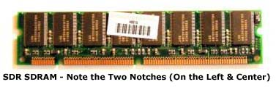

To speed things up, Double Data Rate SDRAM (DDR SDRAM) was developed. As mentioned above, practically every motherboard today supports some type of DDR RAM. As the name implies, it was designed to run at twice the speed of the front-side bus. On a motherboard having a speed of 133 MHz, DDR memory would run at 266MHz (called DDR266 or PC 2100 memory). Eventually came DDR2 and DDR3, each running at twice the clock speed of its predecessor. DDR2 running at speeds from 400 to 1066 MHz and DDR3 from 800-2000MHz.   
  
In addition to speed, DDR2 and DDR3 were developed to run at lower voltages than regular DDR RAM, resulting in less power consumption. DDR used 2.5v. DDR2 runs off 1.8v and DDR3 1.5v.

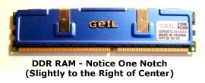

**Physical Characteristics:**  
SDR RAM has 168 pins and two notches (holes). Regular DDR memory has 184 pins and DDR2 and DDR3 have 240 pins. Each type of DDR has one notch that is in a different location to prevent installing the wrong type.   
  
Just like processors fit into certain sockets, different types of computer memory fit into certain slots called banks. Banks are designed to match the number of pins on a stick of RAM, much like cpu sockets are designed to match the number of pins on different processors. All types of SDRAM are DIMM modules and fit into DIMM slots. DIMM stands for Dual Inline Memory Module. DIMMs have a 64-bit bus width which means data can be accessed 64 bits at a time.

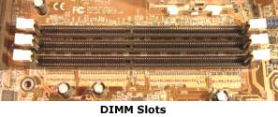

Laptops use a smaller version of DIMMS called SODIMM (Small Outline DIMM).

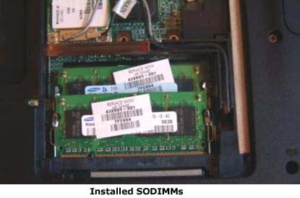

**Dual Channel & Three Channel (tri-channel):**  
Dual channel is a process that allows twice as much information to be sent to and from memory at the same time. As the name implies, two memory controllers are used for data transfer instead of one. Three channel moves data much faster with three memory controllers.   
  
To take advantage of this technology, a motherboard's chipset must support it, and the memory has to be installed in pairs (dual Channel) or in threes (tri channel) in the proper banks, which are usually colored coded. To avoid possible compatibility problems with motherboards, it's best to use identical memory sticks.   
  
There is no such thing as dual channel or three channel memory. You may see matched sticks of RAM advertised as such, sometimes called memory "kits", but this is simply memory that has been tested to work on a dual or three channel board. Remember, the technology is on the motherboard, not on the memory itself.   
  
Dual channel uses DDR, DDR2, or DDR3 RAM and is supported by most motherboards. Tri-channel only uses DDR3.

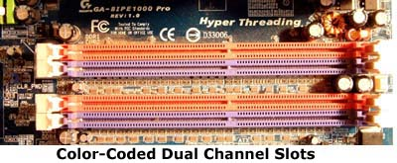

**Capacity:**  
Memory capacity is the total amount of RAM that can be used in a PC. It also refers to the amount of data an individual memory module can store (also called density memory size). Some RAM module capacities are 1GB and 4GB.   
  
All the slots on a particular board have the same maximum capacity. The sum of these capacities determines the total amount of memory a system can support. For example, a motherboard may have four banks, each with a capacity of 1GB (gigabyte). If you add these then the total amount of memory that can be used for that PC is 4GB of memory.   
  
Bank capacities vary from board to board. You do not have to use the maximum amount supported, but generally the more RAM the better.   
  
**CAS Latency:**  
CAS (Column Address Strobe) latency is the time between when the processor asks for data and when that data is sent.The smaller the CAS latency, the quicker data is retrieved.   
  
**SRAM:**  
Among other types of RAM is SRAM (Static RAM). SRAM is a lot faster because it doesn't have to constantly be refreshed like DRAM. But since it is expensive, SRAM is limited to being used in small amounts as CPU cache.   
  
**What is Flash Memory?**  
Flash memory is another type of computer memory and a popular method of storage. Unlike DRAM, flash memory is non-volatile, meaning it doesn't require electricity to retain its contents. It is a type of EEPROM (Electrically Erasable Programmable Read Only Memory) that is erased and rewritten in chunks called blocks. Regular EEPROM is erased and reprogrammed a byte at a time. Using chunks makes erasing and rewriting much faster. This is why flash memory is the primary choice for so many devices: USB flash drives, memory cards for digital cameras, notebook cards, and more. The BIOS program that allows your computer to boot, resides on a flash memory chip on the motherboard-making updating very simple.

|  |
| --- |
| **Computer Hard Drive** |

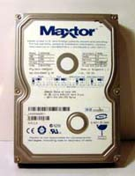This tutorial discusses the various types of hard drives and their features. Separate tutorials discuss [**installing hard drives**](http://www.learning-about-computers.com/tutorials/installing_hard_drives.shtml) and [**partitioning hard drives**](http://www.learning-about-computers.com/tutorials/partitioning_hard_drives.shtml).   
  
Every computer must have a hard disk drive (commonly called a hard drive, hard disk, or abbreviated HDD). Your operating system is stored on the hard drive. Of course any other file can be saved there too. It is the main location where people save data. Having adequate hard disk storage for your needs is important. The main purpose of this page explains the difference between a IDE and SATA hard drive, although a brief description of SCSI, solid state, and flash drives are discussed as well. But first I explain some common terminology.   
  
**Capacity:**  
Capacity is the maximum amount of data a drive or disk (for example, a DVD disk) can store. Typical hard disk storage capacities today are either in gigabytes or terabytes. These sizes store enormous amounts of data. This is very useful when saving music and video, especially video files, which can get very large.   
  
**RPM:**  
RPM (Revolutions Per Minute) - Within a hard disk case are round platters (the actual disks) that are attached to a spindle that spins. The disks are written to or read from while spinning. One revolution is how many times the platters make a complete rotation. Disks in a HDD literally rotate thousands of times per minute. The greater the RPM, the faster data is read or written. 7200 RPM is typically what you will see in home computer hard drives.   
  
**Form Factor:**  
The form factor of a hard drive is the actual physical size of the case the platters are in. The main sizes are 3.5in and 2.5in.   
  
**Cache Memory:**  
A small amount of memory, usually 8, 16, or 32MB, is set aside for the most frequently accessed files. When one of these files is selected, it is retrieved from the cache. This reduces access time since the system does not have to search the drive for the data.   
  
**Types of Drives:**  
Now that the basics have been covered, let's look at some different kinds of drives. There are two main types used by home PCs and laptops: IDE/EIDE and Serial ATA (SATA).   
  
**IDE (Integrated Drive Electronics):**  
The IDE interface standard has been around for a very long time. The term interface in this sense means how the drive connects to the motherboard. As improvements were developed it later was called EIDE for Enhanced IDE. And after even further developments it has also come to be known as ATA (Advanced Technology Attachment). These drives connect to the motherboard via a flat, 80-wire cable to an IDE connector. Two drives can be attached on one cable.

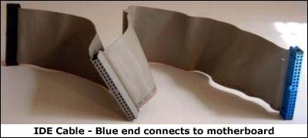

The speed of a hard drive is determined by how fast the connector can send data. Currently the primary drive rates are 100 MB/s and 133 MB/s - 133 MB/s being the maximum. These hard disks are commonly described by the abbreviation "ATA" followed by the speed of its connector (ATA 100, ATA 133).   
  
IDE drive connectors use a parallel bus, meaning multiple bits are transmitted simultaneously. To distinguish between Serial ATA drives, IDE disks are also referred to as PATA (the "P" stands for parallel).

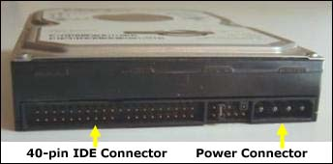

To make it a little less confusing, here are some different names for IDE:

* EIDE (Enhanced IDE)
* ATA (Advanced Technology Attachment)
* PATA (Parallel ATA)

Although there are still IDE drives around, Serial ATA is now the standard and is discussed next.   
  
**Serial ATA (SATA):**  
Today, SATA disk drives are the current standard and use a serial interface to transfer data, i.e. data is transmitted one bit at a time. Using a faster clock rate, sending one bit is faster than sending several with a slower clock, as with IDE. Data also travels along a single wire, reducing inteference. With SATA, one path is used for sending and another for receiving. With PATA, data is sent and received on one path.   
  
The original SATA standard has a transfer rate of 150 MB/s (SATA-150). Now SATA can transmit up to 300 MB/s (SATA II or SATA-300), and 6 Gb/s (SATA 3), far surpassing PATA's 133 MB/s. SATA uses a 7-wire cable for connecting to the motherboard.

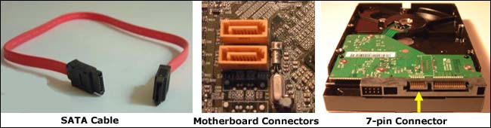

**SCSI Drives:**  
SCSI (Pronounced "scuzzy") stands for Small Computer Systems Interface, and was originally developed to replace IDE before SATA came about. In addition to hard drives, other devices can use SCSI. Because PCs use either IDE or Serial ATA drives, I am not going to go into a lot of detail about SCSI, but I do want you to know that it exists and a PC is capable of using a SCSI drive if it has a SCSI controller.   
  
SCSI is much faster than IDE. Several types developed over time: Narrow, Wide, Fast, Fast Wide, and Ultra. These refer to how much and how fast data is sent for each standard. The only one in use today is Ultra, itself consisting of various types. 8 or 16 devices are supported on one cable, depending on which kind is implemented. SCSI devices are a little more troublesome to configure than IDE and SATA and generally tend to be more expensive.   
  
**External Drives:**  
Hard disk drives can connect externally to a computer. The drive is placed in a case called an enclosure that contains a port(s) on the back for connecting to the computer via a cable. For quite some time enclosures used USB or Firewire. Now, many support any combination of USB, Firewire, and External SATA (eSATA) ports on the same encasement. External SATA is far faster than USB and Firewire. To use it, a computer must also have an eSATA connector. If it doesn't, a card can be purchased with the interface on it. Enclosures are manufactured to match the form factor of particular drive.

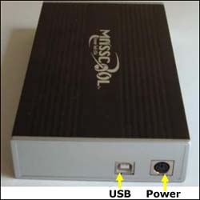

**Solid State Drives:**  
Solid State Drives, or SSDs, differ from traditional hard drives in that they contain flash memory rather than a motor, spinning platters, and a read/write head. A big advantage is that you do not have to concern yourself with drive failure due to some mechanical failure, and they require much less power to run.   
  
Like standard drives they come as internal or external, IDE or SATA. Most are 2.5 inches.   
  
A big disadvantage with solid state hard drives, however, is capacity and cost. Presently, most come in much smaller capacities than regular drives and are quite expensive. So you will have to decide if the cost is worth it.   
  
**Flash Drives:**  
Flash Drives are portable drives about the size of your thumb that use flash memory to store data. They replaced floppy disks years ago as the primary method of transporting data from place to place. The early ones only had a capacity of 8 or 16 MB megabytes. Now, storage is in the gigabytes which allows you to store large files such as music and pictures. They connect using a USB interface.

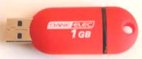

|  |
| --- |
| **Computer Video** |

On the "Sound" page I talked about how advancements in audio technology make our PC experience enjoyable. Well, the same can be said about good video. People love a good, clear picture, whether it's on a television or a monitor. When it comes to computers, graphics card technology has come a long way and is the main factor that determines the type of image quality and performance you will see.   
  
Like the sound card, all PCs today come with built-in video on the motherboard, or you can install your own or have one installed if you don't want to use the on-board graphics. Most of them contain more advanced features than what's on a motherboard.

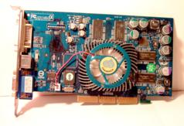

Current video cards are designed for PCI Express slots because they provide excellent speed that is needed for today's video games and other applications that require superior video quality. Before PCI Express, AGP (Accelerated Graphics Port) was the main slot used for video cards, but is now too slow for today's standards. AGP slots can still be found on some motherboards, but they are practically obsolete.   
  
Video cards contain their own processor (called a GPU for Graphics Processing Unit), memory, and BIOS. The GPU carries out all the difficult math calculations to produce images, especially real life-like 3D images like those in video games. They generate lots of heat like a computer CPU and also require a heat sink or fan on them. When it comes to memory, adapters use a type of DDR called GDDR (the "G" is for graphical) to distinguish it from regular DDR memory used by the PC. Most today support GDDR3, GDDR4, or GDDR5. These differ in terms of bandwidth (the amount of data transmitted) and power usage.   
  
The type of processor technology and amount of memory are two key factors determining performance. However, the kind of port a card has also plays a role in the clarity of the image.   
  
Nvidia, ATI (ATI was bought out by AMD) and Intel are the main competing graphics processor producing companies. Right now Intel only produces onboard graphics. Nvidia and ATI have developed graphics card technology primarily for games - SLI and Crossfire.   
  
For those who are serious about games, SLI technology and Crossfire give you the ability to use multiple video cards in one system for ultimate performance. Let's take a look at a few features from both.   
  
**SLI:**

* SLI technology was developed by Nvidia
* You must have a motherboard with at least two PCI Express x 16 slots and an SLI MCP (media and communications processor). Boards with these on them are termed SLI-Ready.
* You need an SLI connector for joining the two cards (although not necessary with some mainstream cards)
* It can output in analog or digital
* You must have an SLI-Ready power supply
* You must use Nvidia video cards with the same GPU model
* Supports Intel and AMD CPUs
* Supports 32 & 64 bit versions of Windows XP, Vista, 7, & Linux
* Designed to support two monitors but can run multiple monitors (up to 6) using GeForce 8 series cards & later with Win Vista or Win 7 OS only
* 3-way SLI is also available allowing you to utilize three GPUs with even better image quality and a resolution up to 2560 x 1600. A 3-way connector is required and a motherboard with at least three PCIe slots.
* Quad SLI has come on the scene too, meaning four graphics processors are supported, in other words, two cards with two GPUs on each. A Quad SLI motherboard has to have extra spacing between the PCIe slots.

**Crossfire**

* Developed by ATI
* Uses ATI Radeon cards
* Must have a Crossfire-Ready motherboard with PCIe slots
* Supports up to five monitors when not in Crossfire mode
* Uses a DVI cable to join cards
* Supports a mode called Super AA for high-quality images

Since both are similar and offer excellent quality, when choosing a video card, you may want to consider other factors such as price.   
  
**DirectX Drivers & Other APIs:**  
For multimedia in general and especially games, Microsoft uses DirectX drivers. DirectX is an application programming interface (API) that lets programmers write software to control multimedia hardware. The part that deals with graphics is called DirectX 3D. It has been around for a long time with version 11 being the latest release and is supported by Windows 7 and also Vista.   
  
OpenGL is an API for non-Windows and Windows systems alike. OpenCL is the latest standard but is used for non-graphics intense jobs like performing video conversions. Nvidia released this driver for the public in late Sept. 2009 and it supports Win XP, Vista, 7 and Mac's Snow Leopard.   
  
**Connectors:**  
Below are the main monitor connectors you'll see when looking for a video card:   
  
VGA - VGA monitor connectors have been around for a long, long time. They are usually blue and use a 15-pin cable for connecting CRT monitors(although some flat panel monitors have a VGA connector). VGA is analog and provides a maximum display resolution of 800 x 600 pixels. Although digital video technology has replaced analog, a number of graphics cards still come with a VGA port.   
  
S-Video (Separate Video) - An S-Video port is a small, round, black connector that lets you attach a monitor or TV. It is sometimes labeled TV Out. With S-video, brightness and color are transmitted along separate wires (hence the term Separate Video), reducing interference with each other and thus providing a better image. S-Video is analog.   
  
DVI (Digital Visual Interface) - The DVI monitor connector provides an all-digital signal from the PC to the display and is on flat-panel monitors. Since there is no digital to analog conversion process as with CRT displays, there is no loss of image quality. DVI uses either a single link or double link cable. A single link cable can support a max 1920 x 1080 pixel image and a dual link 2048 x 1536 image. DVI carries no audio.   
  
HDMI (High Definition Multimedia Interface) - HDMI is the latest digital technology and is replacing DVI. Unlike DVI, HDMI delivers audio as well as video on one cable. In addition, video data is transmitted uncompressed, meaning it is not "shrunk" into a smaller file before being sent over the internet, resulting in even better quality images. The connector kind of resembles a USB port, but is more trapezoidal in shape.

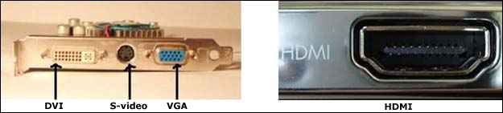

**LCD Monitors**  
A good monitor is an important part to any system. We all love those clear, sharp images. LCD computer monitors are what's sold today. They are lightweight and easy to carry - a far cry from the old heavy and bulky CRTs. But when it comes time to buy one, how do you select? As with just about any product, there are so many choices. The main two considerations that first come to mind are screen size and resolution. Most screens now range from 17 inches to over 25 inches, and screen size is always measured diagonally across the viewing area only. With resolution, the higher the better. Resolution is how many pixels that are on the screen. The more pixels, the sharper the image. It is listed by the number of pixels across the screen followed by the number of rows. For example, the minimum resolution for a widescreen HD monitor (or TV) is 1280 x 720. 1280 is the number of pixels in each row and 720 is the number of rows. Multiplying these numbers gives the total number of pixels.   
  
Another feature that affects clarity is contrast ratio. It is the ratio of the brightest white to the darkest black. The greater the contrast, the clearer the image. Popular ratios are 500:1 and 800:1, although you sometimes see 1000:1. A monitor with a contrast ratio of 800:1 means that the brightest point is 800 times as bright as the darkest point.   
  
**Additional Features:**  
Viewing Angle: If you move to the left or right of the screen (or top or bottom), you'll notice that at some point the picture begins to fade out. The horizontal and vertical viewing angle is the degree you can move from the center of the screen before the image fades. The minimum is usually about 120 degrees.   
  
Brightness (Luminance): Amount of light produced, measured in nits or candelas per square meter (cd/m2). 1 nit is 1 candela per square meter.   
  
Response Time: How fast pixels change colors, measured in milliseconds (ms). It has a direct impact on the ghosting effect. Ghosting is when a moving object leaves a trail. If playing games or viewing anything with fast motion, try to get a monitor with 16ms or faster response time.   
  
Tilt/Swivel: In addition to tilting, many LCD monitors can now swivel, and some even come with height adjustment.   
  
**Cleaning Your Monitor:**  
When cleaning a LCD monitor use a lint-free cloth. There are cleaners and cloths you can buy that are specially made for LCDs. Do not apply the cleaner directly to the screen. Always spray it on the cloth. Wait until the screen is completely dry before turning it back on.   
  
When buying a monitor at a local store, it's a little easier to choose because you can view the products and performance with your own eyes. But if purchasing online, read product reviews on retail sites or visit sites that compare the prices and performance of various products.

|  |
| --- |
| **Computer Ports** |

Just having a computer itself is not enough. You must have some way to attach external devices. Let's face it, without a monitor, printer, mouse, and keyboard, a computer would be completely worthless. All of the aforementioned devices and a host of others have to connect to a PC or a laptop somehow. Computer ports, normally just called ports, are the physical interfaces that connect these external components. Do not confuse these with network ports, which are virtual ports represented by numbers used for communication among networks. Remember, I am referring to actual physical connections on a computer. There are several different types of computer ports, the majority located on the back of a motherboard, while there are some on the front of most computer cases.   
  
There are two types of ports: serial and parallel. Both are bi-directional, meaning data can be sent and received. Serial ports send information one bit at a time down a single wire. You can look at it like a two-way street. Every car in a lane travels in a single line. A parallel port carries data several bits at once on multiple wires much like vehicles on a multi-lane highway.   
  
Serial ports were basically developed for devices that didn't require speed such as mice and keyboards, while parallel ports were used for devices that needed data to be processed much faster, like printers. The ancient DB 9 serial port has long been obsolete, but many motherboards still have PS 2 ports for a mouse and keyboard. These are round and color coded. The green one is the mouse connector and the purple for the keyboard. However, many people nowadays use a USB or wireless keyboard and mouse instead.   
  
The parallel printer port (a.k.a IEEE 1284 or DB 25 because it has 25 pin holes) has practically been replaced by USB and are rarely seen on newer motherboards.

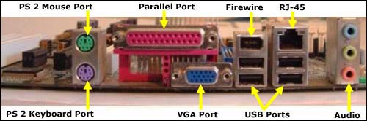

Most motherboards have mouse, keyboard, audio, video, USB, Firewire, and LAN ports. How many and what type varies from board to board. Common video ports are HDMI, S-Video, and DVI, listed on the monitor connector page. Audio ports are on the sound page. Here we'll take a look at LAN, USB, and Firewire.   
  
**LAN (Local Area Network) Port:**  
The LAN port is used to connect computers to each other in a network or to high-speed internet such as DSL or cable. It looks exactly like a regular telephone jack (RJ-11) except it's a little larger. It also goes by the name RJ-45 and uses an Ethernet cable for connecting.

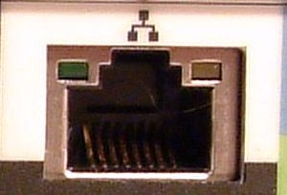

The speed of a LAN port can be 10, 100, or 1000 megabits per second (Mbps). Most today support all three speeds. These rates are based on the type of Ethernet cabling that's used. Ethernet cables are divided into categories. Category 5, or CAT5, supports traditional 10 Mbps Ethernet and 100 Mbps (the 100 Mbps standard is called Fast Ethernet). Category 5e (CAT5e) and CAT 6 support 1000 Mbps. Since 1000 megabits equals 1 billion bits, this standard is often termed Gigabit Ethernet (the prefix giga means billion).   
  
You may see some motherboards with dual gigabit LAN. This is just a board with two LAN ports, each supporting Gigabit Ethernet.   
  
As with sound and video, you're not limited to using built-in LAN. You can by a PCI network card.   
  
**USB:**  
The Universal Serial Bus port is a small rectangular port and is the primary way used today to attach all kinds of devices via a USB cable. Devices must have a USB connector in order to connect to a USB port. Mice, keyboards, printers, and digital cameras are only a few of the many devices that can be USB. Below are four USB ports on the back of a computer.

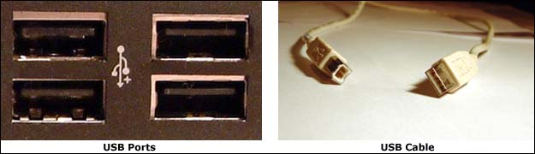

The USB standards are USB 1.1 (obsolete), 2.0, and 3.0. The major difference is speed. USB 1.1 could transfer data up to 12 Mbps (megabits per second - the prefix mega means million). USB 2.0, also called High-Speed USB, can transmit a max of 480 Mbps. The USB 3.0 standard (a.k.a USB Superspeed), completed in late 2008, is 10x faster than USB 2.0, with a maximum rate of 4.8 Gbps (gigabits/sec, or billions of bits) and is backward compatible. In addition to superior speed, 3.0 is bidirectional and adds five additional wires - two for sending & two for receiving. The extra wires make the cable a lot thicker. It increases power output for charging USB devices, allowing you to use more than four devices per hub, and there's no power drain on non-active devices.   
  
Although USB 3.0 exists, it has not made it to consumer products yet. This is expected to occur sometime in 2010. It's main advantage will be transferring digital content, more than likely replacing Firewire. But don't expect USB 2.0 to die anytime soon. There are still plenty of uses for it on slower devices such as printers, keyboards, mice, flash drives, etc.   
  
USB devices are hot-swappable, meaning they can be plugged or unplugged without turning off the computer. Another nice feature is that you can attach numerous devices to a computer indirectly. Called daisy chaining, 127 devices can be connected via USB hubs. A USB hub is a small component that contains additional USB ports. You plug it into your computer, and immediately you can connect more devices. There are also PCI expansion cards with USB ports.   
  
**Firewire:**  
Firewire is similar to USB. Also known as IEEE 1394, 1394, or i.LINK, it was mainly developed to transmit data between digital devices. IEEE stands for Institute of Electrical and Electronics Engineers, the group that made the standard. Firewire is also a competitor with USB. Its speeds far surpass those of USB, making it ideal for transferring large files like audio and video. The first standard, called 1394a, has a data speed up to 400 Mbps. For this reason, 1394a is also known as Firewire 400. The second, 1394b, transfers data at a max of 800 Mbps. And as you might guess, it's called Firewire 800.   
  
The typical port on a PC or laptop is Firewire 400. It looks a lot like USB except it's triangular at one end. To use a 1394, 400 connector in a 1394, 800 port requires a special cable. Devices must have a firewire connector in order to attach to a 1394 port. Like USB, they are hot-swappable, but unlike USB, devices can connect to each other without a computer (called peer to peer). You can also purchase a Firewire hub to attach several devices. A max of 63 devices can connect to each other.

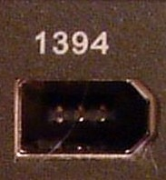

**Multimedia:**  
No computer is complete without sound and video. The type of sound and video is a main consideration for many who are looking for a computer. These topics are covered separately in the [**sound card**](http://www.learning-about-computers.com/tutorials/sound.shtml) and [**video card**](http://www.learning-about-computers.com/tutorials/video.shtml) tutorials.

|  |
| --- |
| **PCI and PCIe** |

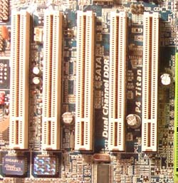PCI (Peripheral Component Interconnect) expansion slots came on the scene in 1993. As I stated on another page, expansion slots are a means by which you can add different types of expansion cards, such as a sound or video card, to enhance a PCs functionality. Before PCI, there were the now obsolete ISA slots. PCI is still in use today but has basically been replaced by PCI Express. This describes a brief overview of PCI vs PCIe. Most PCI slots are white but can be other colors.   
  
PCI utilizes a 32-bit bus, meaning data is transmitted 32 bits at a time, that is shared among all the PCI devices attached to it. Because of this, the bus has to have some way of deciding which component gains access to it. Also, more cards connected results in more interference from each device, which makes it more difficult for a signal to be detected. That's why PCI allows no more than five devices. Below is a simple diagram of PCI design.

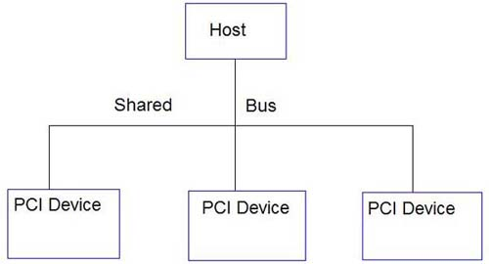

**PCI Express:**  
In 2004 another standard was introduced called PCI Express, also written as PCIe or PCIe. PCIe is extremely high-speed. The reason is that unlike traditional PCI, PCI Express does not use a shared bus. Each device has a dedicated path to a single chip called a switch, therefore resulting in faster data transmission.

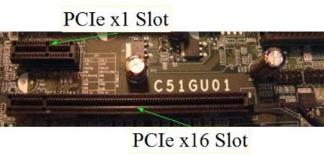

The individual paths are termed lanes. The number of lanes in a slot determines the type of PCI-E, and there are several: x1, x2, x4, x8, x16, and x32 (powers of 2). If there's a single lane, then it's x1. If there are two lanes, it's x2, and so forth. x1 and x16 are the most popular. The more lanes, the faster the data transfer, just like a highway. With these incredible speeds, PCIe is an excellent fit for today's video and audio technology. The connectors come in different lengths and unlike PCI, PCI Expess supports hot swapping, meaning expansion cards can be added or removed without turning off the machine. PCI and PCIe are not compatible. You cannot use a regular PCI card in a PCIe slot and vice versa. The architecture is different. A PCIe diagram is shown below.

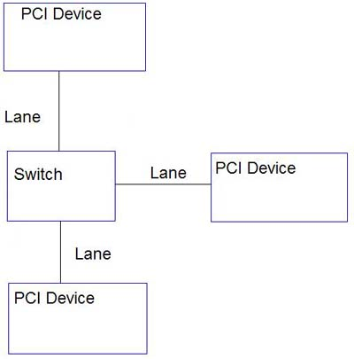

**Types & Compatibility:**  
Presently we have PCIe 1.x and 2.0. The first version carries data at 250 MB/s (2.5GB/s) per lane. Version2.0, which arrived in 2007, doubles the rate of the previous bus at 500MB/s (5GB/s) and is backward compatible, so plugging a version 1.0 card into a 2.0 slot works, but will still run at 1.0 speed. It was also designed for forward compatibility - sticking a 2.0 card in a 1.0 slot. But this defeats the purpose of using PCIe2, since it will run at the slower speed.

|  |
| --- |
| **Uninterruptible Power Supplies (UPS)** |

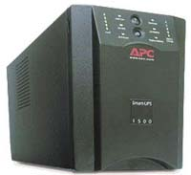If you're using a computer and there is a power outage, physical damage can occur as well as losing your data. Many users have surge protectors that guard against a sudden increase of electricity (above the standard 120 volts) that could possibly harm components, but they do not prevent data loss. Moreover, depending on how strong the surge, even a regular surge protector may not protect from extensive physical damage.   
  
An uninterruptible power supply (UPS) is an external box containing a battery that provides power to a computer and other electronics in case there is a loss of power. There are two types: standby (offline) and online.   
  
A standby UPS uses regular AC power from a wall outlet for a computer. When a problem arises, it immediately switches (usually under 5 milliseconds) to the battery using an inverter so the PC will not lose power and can be shut down properly. The battery charges as long as the unit connects to AC power. With an online UPS, the computer is constantly using the battery, which is continuously recharged. As a result, there is no switch over time as with a standby. The DC power produced by the charger is converted to AC by the inverter. This is an on-going cycle. During a power failure, the battery sends power to the inverter. These types are also called a true UPS.   
  
A standby UPS is much cheaper than an online and is mostly used for homes and small offices.

**CHAPTER III Identifying parts and function of the computer system**

**Identifying Motherboard Hardware Parts and its Function**

The motherboard is considered as the main circuit of the computer, it contains the connectors for attaching additional boards. Typically, the motherboard contains the CPU, BIOS, memory, mass storage interfaces, serial and parallel ports, expansion slots, and all the controllers required to control standard peripheral devices, such as the display screen, keyboard, and disk drive. Collectively, all these chips that reside on the motherboard are known as the motherboard's chipset. You must familiarize the motherboard parts and its function since this is needed to pass the TESDA NC II Computer Servicing Exam.

**Parts of the Mother Board**

[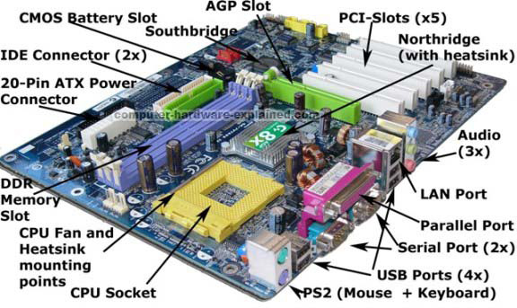](http://4.bp.blogspot.com/-kHCk15xhQIA/UBzG7HoMvHI/AAAAAAAAAFc/eUUIeOfEdMk/s1600/motherboard-labelled5.jpg)

**BIOS or Basic Input Output System**

[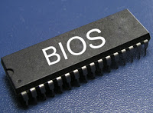](http://4.bp.blogspot.com/-mrr4uNtkIT8/UBzJdnxYT2I/AAAAAAAAAFk/JmtkDurOfUg/s1600/laptop+bios.jpg)

A main function of the BIOS is to give instructions for the power-on self test (POST).This self test ensures that the computer has all of the necessary parts and functionality needed to successfully start itself, such as use of memory, a keyboard and other parts. If errors are detected during the test, the BIOS instruct the computer to give a code that reveals the problem. Computer Error codes are typically a series of beeps heard shortly after startup.

***Carbon Metal–Oxide–Semiconductor (CMOS)*** - is a technology for making integrated circuits. CMOS technology is used in microprocessors, microcontrollers, static RAM, and other digital logic circuits. CMOS technology is also used for a wide variety of analog circuits such as image sensors, data converters, and highly integrated transceivers for many types of communication. Frank Wanlass successfully patented CMOS in 1967 (US Patent 3,356,858).

[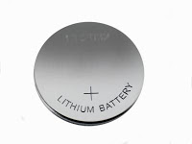](http://2.bp.blogspot.com/-A76LzXrYxMQ/UBzJ-DBasOI/AAAAAAAAAFs/ndt4mEGI3no/s1600/cmos-battery.jpg)

***CMOS Battery*** - Is a button cell battery that gives power to CMOS so that the Bios setting is retain when the PC is turn off.

[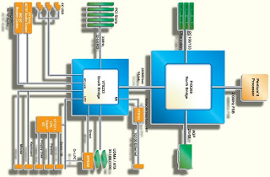](http://4.bp.blogspot.com/-T2vlI65ym6c/UCHxanvh2hI/AAAAAAAAAGc/XnQxse-92YE/s1600/chipset.jpg)

***Chipset*** - Refers to a specific pair of chips on the motherboard: the NORTHBRIDGE and the SOUTHBRIDGE.The northbridge links the CPU to very high-speed devices, especially main memory and graphics controllers.

The southbridge connects to lower-speed peripheral buses (such as PCI or ISA). In many modern chipsets, the southbridge actually contains some on-chip integrated peripherals, such as Ethernet, USB, and audio devices. A chipset is usually designed to work with a specific family of microprocessors. Because it controls communications between the processor and external devices, the chipset plays a crucial role in determining system performance.

**Types of Processor Sockets or Slots**

|  |
| --- |
| [http://1.bp.blogspot.com/-UorbjwrGu-4/UCHj9xr7YhI/AAAAAAAAAF8/7r86O3WE6Tg/s200/pga.jpg](http://1.bp.blogspot.com/-UorbjwrGu-4/UCHj9xr7YhI/AAAAAAAAAF8/7r86O3WE6Tg/s1600/pga.jpg) |
| PGA Processor Slot |

A CPU socket or CPU slot is an electrical component that attaches to a printed circuit board (PCB) and is designed to house a CPU (also called a microprocessor). CPU socket structure is largely dependent on the packaging of the CPU it is designed to house. Most CPUs are based on the pin grid array (PGA) architecture in which short, stiff pins are arranged in a grid on the underside of the processor are mated with holes in the socket. To minimize the risk of bent pins, zero insertion force (ZIF) sockets allow the processor to be inserted without any resistance and then lock in place with a lever or latch mechanism.

[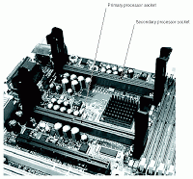](http://3.bp.blogspot.com/-H0PrgZmy3lQ/UCHku8Bt3PI/AAAAAAAAAGE/ehYJCxBt6pA/s1600/slot.gif)

***SLOT TYPE CPU slot*** - are single-edged connectors similar to expansion slots, into which a PCB holding a processor is inserted. Slotted CPU packages offered two advantages: L2 cache memory size could be packaged with the CPU rather than the motherboard and processor insertion and removal was often easier. However, they proved to have performance limitations and once it was possible to place larger cache memory directly on the CPU die the industry reverted back to sockets.

[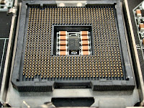](http://2.bp.blogspot.com/-OevNs4MJpWA/UCHl8g2PhXI/AAAAAAAAAGM/3jqJttB0nIQ/s1600/lga.jpg)

***Land grid array (LGA)*** - packages have started to supplant PGA with most modern CPU designs using this scheme. The term LGA "socket" is actually a bit of a misnomer. With LGA sockets, the socket contains pins that make contact with pads or lands on the bottom of the processor package.

**Types of Memory Socket or Slot**

***Memory Socket or Slot*** - is commonly refers to the slot in a motherboard were the extended memory modules are installed.

|  |
| --- |
| [http://4.bp.blogspot.com/-jHaoEFDtJ0M/UCHycdWEDsI/AAAAAAAAAGk/AI4h1mK_XoY/s400/simm.png](http://4.bp.blogspot.com/-jHaoEFDtJ0M/UCHycdWEDsI/AAAAAAAAAGk/AI4h1mK_XoY/s1600/simm.png) |
| SIMM (Single-inline-memory module) slot, 72 pins |

|  |
| --- |
| [http://2.bp.blogspot.com/-cswSlWSo5po/UCHzRR9gF-I/AAAAAAAAAGs/5WsDRE_1r9w/s400/dimm.jpg](http://2.bp.blogspot.com/-cswSlWSo5po/UCHzRR9gF-I/AAAAAAAAAGs/5WsDRE_1r9w/s1600/dimm.jpg) |
| DIMM (Dual-inline-memory modules) slot. SDR (Single Data Rate) DIMM slot. 168 edge contacts. |

|  |
| --- |
| [http://2.bp.blogspot.com/-jmcJ5QOiFSQ/UCH08XZPMPI/AAAAAAAAAG0/_bNy7krupUU/s400/ddr1.jpg](http://2.bp.blogspot.com/-jmcJ5QOiFSQ/UCH08XZPMPI/AAAAAAAAAG0/_bNy7krupUU/s1600/ddr1.jpg) |
| DDR (Dual/Double Data Rate) DIMM slot. 184 edge contacts (DDR 1) |
|  |

|  |
| --- |
| [http://4.bp.blogspot.com/-miMygC8Gi2Y/UCH5bL8es9I/AAAAAAAAAHM/1WPKknwLbmc/s400/ddr2-vs-ddr3_thumb.jpg](http://4.bp.blogspot.com/-miMygC8Gi2Y/UCH5bL8es9I/AAAAAAAAAHM/1WPKknwLbmc/s1600/ddr2-vs-ddr3_thumb.jpg) |
| DDR (Dual/Double Data Rate) DIMM slot. 240 edge contacts (DDR 2 / 3) |
|  |
|  |
|  |

[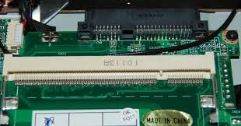](http://1.bp.blogspot.com/-Akl7zBgTIBk/UCH6hPcir4I/AAAAAAAAAHU/ltDYQBEvcrc/s1600/sodimm.jpg)

SODIMM (SO-DIMM is short for Small Outline DIMM ) Slot A 72-pin and 144-pin configuration. SO-DIMMs are commonly utilized in laptop computers.

**Computer System Expansion Slots**

The Expansion slot is a type of slot that connects an expansion bus (Adapter card), which allows the processor to communicate with peripheral attached to the adapter card. Data is transmitted to the memory or the processor travels from the expansion slot via the expansion bus and the system bus.

|  |
| --- |
| [http://2.bp.blogspot.com/-1jOXdOzdaXA/UCH-d5jux7I/AAAAAAAAAHk/P87GgRWw74E/s400/isaslots.jpg](http://2.bp.blogspot.com/-1jOXdOzdaXA/UCH-d5jux7I/AAAAAAAAAHk/P87GgRWw74E/s1600/isaslots.jpg) |
| ISA Slot |

***ISA SLOT*** - Industry Standard Architecture, is an a 8 bit and 16 bit wide bus, and runs at 4.77 mhz. The ISA bus was developed by a team lead by Mark Dean at IBM as part of the IBM PC project in 1981. It was originated as an 8-bit system and was extended in 1983 for the XT system architecture. The newer 16-bit standard, the IBM AT bus, was introduced in 1984.

|  |
| --- |
| [http://1.bp.blogspot.com/-QE6hQ54rxZE/UCH_nLBahyI/AAAAAAAAAHs/SIutPAq9B6I/s400/pci-slot.JPG](http://1.bp.blogspot.com/-QE6hQ54rxZE/UCH_nLBahyI/AAAAAAAAAHs/SIutPAq9B6I/s1600/pci-slot.JPG) |
| PCI - Slot |

***PCI SLOT*** - Peripheral Component Interconnect is a specification that defines a 32-bit data bus interface. PCI is a standard widely used by expansion card manufacturers.

|  |
| --- |
| [http://2.bp.blogspot.com/-cmg27jRpjqY/UCIAc63Y_VI/AAAAAAAAAH0/gbinnDctMA8/s400/agp-slot.jpg](http://2.bp.blogspot.com/-cmg27jRpjqY/UCIAc63Y_VI/AAAAAAAAAH0/gbinnDctMA8/s1600/agp-slot.jpg) |
| AGP - Slot |

***AGP SLOT*** - Accelerated Graphics Port, also called Advanced Graphics Port, often shortened to AGP it is a high-speed point-to-point channel for attaching a graphics card to a computer's motherboard, primarily to assist in the acceleration of 3D computer graphics. AGP controller is only capable of controlling a single device.

***AMR SLOT*** - Audio Modem Riser,  Is a riser card that supports sound or modem function.

***ACR SLOT*** - Advance Communication Riser, this type of slot is for communication and audio subsystem. The slot supports modem, audio, LAN, and Home Phoneline Networking Alliance (HPNA) or Home Networking cards.

***CNR SLOT*** - Communications network riser, this connector supports specially designed network, audio, or modem riser cards, main processing is done through software and controlled by the [motherboard](http://en.wikipedia.org/wiki/Motherboard)’s system chipset.

|  |
| --- |
| [http://3.bp.blogspot.com/-e-5v2mMssVM/UCIBhkEQ4AI/AAAAAAAAAH8/RSiH0pUYqpk/s400/pci-express.jpg](http://3.bp.blogspot.com/-e-5v2mMssVM/UCIBhkEQ4AI/AAAAAAAAAH8/RSiH0pUYqpk/s1600/pci-express.jpg) |
| PCI - Express |

***PCI –E*** - is a computer expansion card interface format introduced by Intel in 2004. It was designed to replace the general purpose PCI expansion bus.

* PCIe 1.1 (the most common version as of 2007) each lane carries 250 MB/s.
* PCIe 2.0 doubles the bus standard's bandwidth from 2.5 Gbit/s to 5 Gbit/s, meaning a x32 connector can transfer data at up to 16 GB/s in each direction.
* PCI Express 3.0 will carry a bit rate of 8 giga transfers per second.

|  |
| --- |
| [http://4.bp.blogspot.com/-sLYLILGrIqM/UCICFtJFe1I/AAAAAAAAAIE/fc4-_x8-p7M/s400/ide-controller.jpg](http://4.bp.blogspot.com/-sLYLILGrIqM/UCICFtJFe1I/AAAAAAAAAIE/fc4-_x8-p7M/s1600/ide-controller.jpg) |
| IDE - Controller |

***IDE CONTROLLER*** - Integrated Drive Electronics, Parallel ATA (PATA) is an interface standard for the connection of storage devices such as hard disks, solid-state drives, and CD-ROM drives in computers. It uses the underlying AT Attachment and AT Attachment Packet Interface (ATA/ATAPI) standards

|  |
| --- |
| [http://3.bp.blogspot.com/-gVTxi0pDmkw/UCICZtaxRWI/AAAAAAAAAIM/D7Y3NFhSv1o/s400/floppycontroller.jpg](http://3.bp.blogspot.com/-gVTxi0pDmkw/UCICZtaxRWI/AAAAAAAAAIM/D7Y3NFhSv1o/s1600/floppycontroller.jpg) |
| FDD - Controller |

***FDD CONTROLLER*** - Floppy Disk Drive, an onboard floppy drive controller which make your Floppy Disk Drive operational.

|  |
| --- |
| [http://3.bp.blogspot.com/-tKiE02xaxzE/UCICwCk8YGI/AAAAAAAAAIU/yTSvyo6OnLs/s400/sata-controller.jpg](http://3.bp.blogspot.com/-tKiE02xaxzE/UCICwCk8YGI/AAAAAAAAAIU/yTSvyo6OnLs/s1600/sata-controller.jpg) |
| SATA - Controller |

***SATA CONTROLLER*** - Serial Advanced Technology Attachment is a computer bus primarily designed for transfer of data between a computer and storage devices (like hard disk drives or optical drives).

* SATA 1.5 Gbit/s
* SATA 3.0 Gbit/s
* SATA 6.0 Gbit/s

**Types of Power Supply Terminal**

[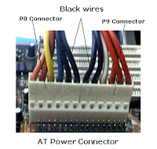](http://2.bp.blogspot.com/-2VQ0p3LS0mo/UCIFlnYzEQI/AAAAAAAAAIs/dXyxkBOfBhY/s1600/at.png)

|  |
| --- |
| [http://1.bp.blogspot.com/-MxCC9W1SjgA/UCIFdWqFtmI/AAAAAAAAAIk/P2XiGMASIEo/s200/atx-power-connector.jpg](http://1.bp.blogspot.com/-MxCC9W1SjgA/UCIFdWqFtmI/AAAAAAAAAIk/P2XiGMASIEo/s1600/atx-power-connector.jpg) |
| ATX - Power Connector |

These connectors are for power supply, the power supply plugs are designed to fit these connectors in only one orientation.

* AT / ATX
* Auxiliary power

FRONT PANEL CONNECTOR / SYSTEM PANEL CONNECTOR - This connector attaches the switches and indicators.

|  |
| --- |
| [http://1.bp.blogspot.com/-jjsRFsiZi9w/UCIfwvRi9BI/AAAAAAAAAI8/9pb3Na5jymI/s400/front+panel.jpg](http://1.bp.blogspot.com/-jjsRFsiZi9w/UCIfwvRi9BI/AAAAAAAAAI8/9pb3Na5jymI/s1600/front+panel.jpg) |
| Front Panel Connectors |

* Power switch (PWRSW) power-on the system unit
* Reset switch (RESET) – Resets the system unit
* Power / System LED – The system power LED lights up when system is powered up / Power indicator
* Hard disk drive LED (HDDLED) –The HDD LED lights up(Blinks) during harddisk activity.

**INPUT/OUTPUT (I/O) PORTS**

I/O Ports are type of interface which a peripheral attaches to or communicates with the system unit so the peripheral can send data to or receive information from the computer.

* Keyboard / mouse
* Monitors, projector
* Printers, flatbed scanner
* External storage devices, external modems
* Headsets, microphones, game pads

|  |
| --- |
| [http://3.bp.blogspot.com/-QJIuNRIXnCQ/UCIjKODsLmI/AAAAAAAAAJM/U6YVl8NlV6A/s400/input-output+ports.jpg](http://3.bp.blogspot.com/-QJIuNRIXnCQ/UCIjKODsLmI/AAAAAAAAAJM/U6YVl8NlV6A/s1600/input-output+ports.jpg) |
| I/O Ports |

***PS2 PORT*** - Personal system 2, are based on IBM Micro Channel Architecture, it is a 6-pin connector.This type of architecture transfers data through a 16-bit or 32-bit bus.

* Keyboard
* Mouse

***LPT PORT or PARALLEL PORT*** - Line Printer Port, This is a 25-pin port that connects a parallel printer, a flatbed scanner and used as a communication link for null modem cables.

***SERIAL PORT or COM PORT*** - is a logical device name used by to designate the computer serial ports. A 9-pin connector used by pointing devices, modems, and infrared modules can be connected to COM ports.

***USB PORT*** - Universal Serial Bus, a 4-pin serial cable bus that allows up to 127 plug-n-play computer peripherals. This allows attaching or detaching of peripherals while the host is in operation. Supports synchronous and asynchronous transfer types over the same set of wires up to 12Mbit/sec. USB 2.0 provides 40 times the transfer rate compared to USB 1.0 and competes with the 1394 standard.As of today we now have USB 3.0.

***GAME/MIDI PORT***  - This connector supports a Joystick or a Game Pad for playing games, and MIDI   Devices for playing or editing audio files.

***LAN PORT*** - Used for Networking

***AUDIO/SOUND port*** - Used for sound output, Line inputs and Microphone inputs

**Identifying Memory Module**

***Memory Module*** - A device that are used to store data or programs (sequences of instructions) on a temporary or permanent basis for use in an electronic digital computer.

* Volatile memory is computer memory that requires power to maintain the stored information.
* Non-volatile memory is computer memory that can retain the stored information even when not powered.

**Types of Memory Module**

|  |
| --- |
| [Single inline memory module](http://2.bp.blogspot.com/-aMNiXX_uhMg/UCSljDeOyfI/AAAAAAAAALo/bCZzoFWJqd4/s1600/SIMMs.jpg) |
| 30 Pin and 72 Pin SIMM Module |

|  |
| --- |
| [Dual inline memory module](http://3.bp.blogspot.com/-3nVOrlNNm_0/UCSmzfmMnJI/AAAAAAAAALw/cbY_0fHpG4g/s1600/SDRAM.jpg) |
| DIMM - SDRAM Single Data Rate |

|  |
| --- |
| [Double data rate](http://4.bp.blogspot.com/-foIaLc3IK1M/UCSsmx2GRiI/AAAAAAAAAMU/E3X2AuCvZGg/s1600/ddr1.jpg) |
| DDR - Double Data Rate |

|  |
| --- |
| [Double data rate](http://2.bp.blogspot.com/-g4tquwJA5xw/UCStFccAp8I/AAAAAAAAAMc/lcQunlmEoeI/s1600/ddr3-vs-ddr2-ram.jpg) |
| DDR2 and DDR3 |

[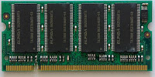](http://1.bp.blogspot.com/-UkdIr4k-23E/UCSuDKwRXNI/AAAAAAAAAMk/40FKescuqZo/s1600/sodimm.jpg)

***SO-DIMM***  (Small outline dual in-line [memory module](http://en.wikipedia.org/wiki/Memory_module))SO-DIMMs are a smaller alternative to a DIMM, being roughly half the size of regular DIMMs. used in systems which have space restrictions such as notebooks.

* 72 Pin SODIMM
* 100 Pin Firmware SODIMM  (32 bit data transfer rate)
* 144 Pin EDO SODIMM (64 bit data transfer rate)
* DDR333 200-Pin SODIMM Memory (64 bit data transfer rate)
* PC3200 DDR400 200-pin SODIMM (64 bit data transfer rate)

**Identifying Expansion Module Cards**

***Expansion Card*** - Is a printed circuit board that can be inserted into an expansion slot of a motherboard to add additional functionality to a computer system. One edge of the [expansion card](http://en.wikipedia.org/wiki/Expansion_card) holds the contacts (the edge connector) that fit exactly into the slot. They establish the electrical contact between the electronics (mostly integrated circuits) on the card and on the motherboard.The primary purpose of an expansion card is to provide or expand on features not offered by the motherboard.

|  |
| --- |
| [http://1.bp.blogspot.com/-qbw1x-l7GvM/UCXvtpmrJVI/AAAAAAAAANw/Ktxh-cjsZXE/s200/ATI-128VR-16M-PCI-VGA-Card.jpg](http://1.bp.blogspot.com/-qbw1x-l7GvM/UCXvtpmrJVI/AAAAAAAAANw/Ktxh-cjsZXE/s1600/ATI-128VR-16M-PCI-VGA-Card.jpg) |
| VGA Card |

***Video cards or VGA Cards*** - The video card is an expansion card that allows the computer to send graphical information to a video display device such as a monitor or projector.

|  |
| --- |
| [http://3.bp.blogspot.com/-quqtQ3cWdSc/UCXwKOEnRlI/AAAAAAAAAN4/XLAsrkimgvI/s200/Sound+Card.jpg](http://3.bp.blogspot.com/-quqtQ3cWdSc/UCXwKOEnRlI/AAAAAAAAAN4/XLAsrkimgvI/s1600/Sound+Card.jpg) |
| Sound Card |

***Sound card*** - Is a computer expansion card that facilitates the input and output of audio signals to and from a computer under control of computer programs. Many computers have sound capabilities built in, while others require additional expansion cards to provide for audio capability.

|  |
| --- |
| [http://1.bp.blogspot.com/-9NgbXbXR_bo/UCXxGhWWhyI/AAAAAAAAAOA/weidB8ooGRI/s200/nic.jpg](http://1.bp.blogspot.com/-9NgbXbXR_bo/UCXxGhWWhyI/AAAAAAAAAOA/weidB8ooGRI/s1600/nic.jpg) |
| NIC Card |

***NIC (Network interface card)*** - A network interface card, more commonly referred to as a NIC, is a device that allows computers to be joined together in a LAN, or local area network. Networked computers communicate with each other using a given protocol or agreed-upon language for transmitting data packets between the different machines, known as nodes.

|  |
| --- |
| [http://2.bp.blogspot.com/-u0J05bgaqgg/UCXxoMQs-NI/AAAAAAAAAOI/Vy_WA8hR4iQ/s200/modem.jpg](http://2.bp.blogspot.com/-u0J05bgaqgg/UCXxoMQs-NI/AAAAAAAAAOI/Vy_WA8hR4iQ/s1600/modem.jpg) |
| Modem Card |

***MODEM*** - Short name for modulator-demodulator. A modem is a device or program that enables a computer to transmit data over, for example, telephone or cable lines. Computer information is stored digitally, whereas information transmitted over telephone lines is transmitted in the form of analog waves. A modem converts between these two forms.

|  |
| --- |
| [http://4.bp.blogspot.com/-UHIbRfoUqA8/UCXyEpYKclI/AAAAAAAAAOQ/lzoV9sJUsF4/s200/scsi.jpg](http://4.bp.blogspot.com/-UHIbRfoUqA8/UCXyEpYKclI/AAAAAAAAAOQ/lzoV9sJUsF4/s1600/scsi.jpg) |
| SCSI Card |

***SCSI Card*** - Short for small computer system interface, a parallel interface standard used by Apple Macintosh computers, PCs, and many UNIX systems for attaching peripheral devices to computers. Nearly all Apple Macintosh computers, excluding only the earliest Macs and the recent iMac, come with a SCSI port for attaching devices such as disk drives and printers. SCSI interfaces provide for faster data transmission rates (up to 80 megabytes per second) than standard serial and parallel ports. In addition, you can attach many devices to a single SCSI port, so that SCSI is really an I/O bus rather than simply an interface.

**Learn About Central Processing Unit**

Learning about central processing unit is also part of the TESDA NC II Computer Servicing exam. So it is advisable to learn about these things.

|  |
| --- |
| [http://4.bp.blogspot.com/-egbLG2pTT5E/UCSJHmv6RgI/AAAAAAAAALE/wNDz2Fpbbuo/s200/processors.jpg](http://4.bp.blogspot.com/-egbLG2pTT5E/UCSJHmv6RgI/AAAAAAAAALE/wNDz2Fpbbuo/s1600/processors.jpg) |
| Processors |

***Central Processing Unit*** - Is a complete computation engine that is fabricated on a single chip. Interprets and carries out the basic instructions that operate a computer. Processors contain a control unit and an arithmetic logic unit (ALU), this two components work together to perform processing operations.

|  |
| --- |
| [http://1.bp.blogspot.com/-NocJSJrksgQ/UCSJuKfbcmI/AAAAAAAAALM/F1u1fQvTABU/s200/dual+core.jpg](http://1.bp.blogspot.com/-NocJSJrksgQ/UCSJuKfbcmI/AAAAAAAAALM/F1u1fQvTABU/s1600/dual+core.jpg) |
| Dual-Processor |

***Dual-processor (DP)*** - systems are those that contain two separate physical [computer processors](http://en.wikipedia.org/wiki/Central_processing_unit) in the same chassis. In dual-processor systems, the two processors can either be located on the same motherboard or on separate boards.

|  |
| --- |
| [http://3.bp.blogspot.com/-IGzFGutvXKI/UCSKvjJAIEI/AAAAAAAAALU/wHXaKFN-P-Q/s200/dual+core+config.gif](http://3.bp.blogspot.com/-IGzFGutvXKI/UCSKvjJAIEI/AAAAAAAAALU/wHXaKFN-P-Q/s1600/dual+core+config.gif) |
| Dual Core Configuration |

***Dual-core configuration*** - an integrated circuit (IC) contains two complete computer processors. Usually, the two identical processors are manufactured so they reside side-by-side on the same die, each with its own path to the system front-side bus.

**Dual core Processor features:**

* Hyper-Threading Technology: Enables you to run multiple demanding applications at the same time.
* Intel Extended Memory 64 Technology: Provides flexibility for future applications that support both 32-bit and 64-bit computing.
* Dual-Core: Two physical cores in one processor support better system responsiveness and multi-tasking capability than a comparable single core processor.

Processor core (An intel Core 2 Duo Chip) It has 291,000,000 transistor.

**Learn About Storage Devices**

***Storage device*** - is a hardware device designed to write and read information. There are two types of [storage devices](http://en.wikipedia.org/wiki/Data_storage_device) used in computers; a 'primary storage' device and a 'secondary storage' device.

***Storage Media*** - It is where the storage device records (write) and retrieves (read) the data, instructions and information for future use.

**Examples of Storage and Media Devices**

|  |
| --- |
| [harddisk drive devices](http://4.bp.blogspot.com/-RapQjdhtgao/UCXsVs8mdzI/AAAAAAAAANM/zAubJyIb4U0/s1600/hdd.jpg) |
| Harddisk Devices and USB Thumb Drive |

|  |
| --- |
| [optical device](http://2.bp.blogspot.com/-a5j2yq9qNDk/UCXsssJicVI/AAAAAAAAANU/xYgSz4S78F0/s1600/dvd.jpg) |
| Optical Device |

|  |
| --- |
| [Floppy Drive Device](http://3.bp.blogspot.com/-GVMvgCQbhjs/UCXs-4gQKRI/AAAAAAAAANc/65f4ulENstI/s1600/Floppy+Drive.jpg) |
| 3.5 Floppy Device |

### Hard Disk Jumper Settings Guide

Hard Disk drive jumper settings familiarization is also essential when taking exam for TESDA NC II Computer Servicing. Here you will learn how to set jumpers for hard disk depending on its purpose. [Jumper settings](http://unplugg3d.wordpress.com/2008/09/14/how-to-set-jumpers-on-a-hard-disk/) will differ depending on the manufacturer so you must read the user manual before doing some configurations.

### PATA Drives Configuration

[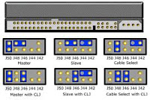](http://1.bp.blogspot.com/-4C7xW8-lf7A/UChTj4J55qI/AAAAAAAAAQ0/6mwLMGHcq8Q/s1600/jumper+settings.jpg)[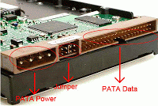](http://1.bp.blogspot.com/-zRKDDthoJ6A/UChTyzIEgsI/AAAAAAAAAQ8/p4meYtOAjhg/s1600/PATA-HDD-connector.gif)

#### Handling Precautions

* Disc drives are fragile. Do not drop or jar the drive. Handle the drive only by the edges or frame. Keep the drive in the protective anti-static container until you are ready to install it to minimize handling damage.
* Drive electronics are extremely sensitive to static electricity. While installing the drive, wear a wrist strap and cable connected to ground.
* Turn off the power to the host system during installation.
* Do not disassemble the drive. Doing so voids the warranty.
* Do not apply pressure or attach labels to the circuit board or to the top of the drive.

#### Setting Harddisk configuration PATA HDD

* Set the hard drive jumper setting (master/slave)
* Select type of configuration setup

### [http://2.bp.blogspot.com/-0BH4QhqJ5w0/UChUw1Fen3I/AAAAAAAAARE/i7at05zoAOQ/s320/install-sata-hard-drive1.gif](http://2.bp.blogspot.com/-0BH4QhqJ5w0/UChUw1Fen3I/AAAAAAAAARE/i7at05zoAOQ/s1600/install-sata-hard-drive1.gif)Installing SATA drives

***SATA hard drives*** - are the same size and shape as EIDE hard drives and are installed in exactly the same way with one big difference: one SATA port connects to one SATA hard drive, so there's no need to deal with the messy master and slave configuration scheme. It is not necessary to set any jumpers, terminators, or other settings on this drive for proper operation. The jumper block adjacent to the SATA interface connector is for factory use only.

### Attaching Cables and Mounting the Drive

Attach one end of the drive interface cable to the Serial ATA interface connector on your computer's motherboard or Serial ATA host adapter (see your computer manual for connector locations).

*Note: Serial ATA connectors are keyed to ensure correct orientation.*

### BIOS Configuration

Close your computer case and restart your computer. Your computer may automatically detect your new drive. If your computer does not automatically detect your new drive, follow the steps below.

1. Restart your computer. While the computer restarts, run the system setup program (sometimes called BIOS or CMOS setup). This is usually done by pressing a special key, such as DELETE, ESC, or F1 during the startup process.
2. Within the system setup program, instruct the system to auto detect your new drive.
3. Save the settings and exit the setup program. When your computer restarts, it should recognize your new drive. If your system still doesn't recognize your new drive, see the troubleshooting section on the back of this sheet.

*Note: Serial ATA is a new interface type. Some older systems may see the drive and classify it as a SCSI device if you are using a Serial ATA host adapter. This is normal even though this is not a SCSI disc drive. This does not affect drive performance or capacity.*

**Examples of Input and Output Devices**

***What is an Input Devices*** - An input device is any hardware component that allows you to enter data and instruction into a computer.

**Examples of Input Devices**

* Keyboard
* Mouse
* Image/Object scanner
* Microphone
* Joysticks, Game pads
* PC video camera
* Digital camera
* Bar code scanner
* Biometric scanner

|  |
| --- |
| [input-devices](http://2.bp.blogspot.com/-LPQ5pADo13o/UCe76UHVr2I/AAAAAAAAAPA/HAiBkaZXjXU/s1600/Input+Devices.jpg) |
| Input Devices |

***What is an Output Devices*** - An output device is any hardware component that conveys information to one or more people.

**Examples of Output Devices**

* Monitor
* Printer
* Speaker

[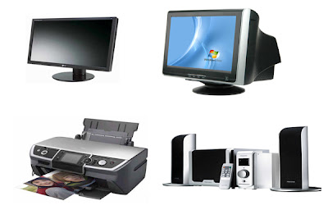](http://2.bp.blogspot.com/-zIu7fi_SW9M/UCe-awVqqcI/AAAAAAAAAPI/n5CvFcxjQ70/s1600/output+devices.jpg)

**Learning About BIOS Setup**

A ***ROM BIOS*** provides a built-in Setup program which allows the user to modify the basic system configuration and hardware parameters, Bios is a set of routines that affects how the computer transfer data between computer components, such as memory, disk, and the display adapter. The modified data will be stored in a battery-backed CMOS, so that the data will be retained even when the power is turned-off. In general, the information saved in the CMOS RAM will stay unchanged unless there is a configuration change in the system, such as hard drive replacement or a device is added. In this model we are using old type of BIOS version, looks will differ on some Machine model especially for the newer models.

**Learn BIOS Menus and Other Features**

***STANDARD CMOS FEATURES / MAIN*** - allows you to record some basic system hardware configuration.

[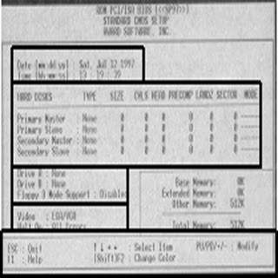](http://3.bp.blogspot.com/-3V0n9WVMATQ/UChQDoTEw0I/AAAAAAAAAQM/vKHvWQFx-Fo/s1600/1.jpg)

* Time and Date Setting: to set, highlight Date /Time.
* This field records the specifications for all non-SCSI hard disk drives installed to   your system. The onboard PCI IDE connectors provide Primary and Secondary Channels for connecting up to four IDE hard disk or IDE devices (CDROM’S, DVD ROM, DVD WRITER, CDWRITER’S, ZIP DRIVES). Use the Auto setting for detection during boot up.
* Drive A / Drive B (none)\* this field records the type of floppy drives installed in your system. The available options for drives A and B are 360KB, 5.25 in.; 1.2 MB, 5.25 in.; 720kb, 3.5 in.,1.44MB; 3.5 in., 2.88 MB, 3.5 in.; None. (Floppy 3 Mode Support (disabled)\* This is a Japanese standard floppy drive, no need to enable.)
* Video (EGA/VGA)\* Set this field to the type of video display card installed in you system. Options are EGA/VGA, CGA 40, CGA 80, and mono( for Hercules or MDA).
* Halt On (All Errors)\* This fields determines which types will cause the system to halt. Choose from either All Errors; No Errors; All, But Keyboard; All but Diskette; or All, But Disk/Key.
* Control keys with their respective functions, used to change the values of the CMOS SETUP.

**BIOS FEATURES**

[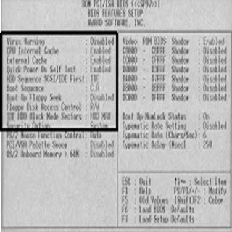](http://2.bp.blogspot.com/-PlNvy-_59Dw/UChQpnP77bI/AAAAAAAAAQU/m6Qcjy_w6DY/s1600/2.jpg)

* Virus warning (Disabled) This field protects the boot sector  and Partition table against accidental modifications. An attempt to write to them will cause the system to halt and display a warning message.
* HDD Sequence SCSI/IDE First (IDE) when using both SCSI and IDE harddisk drives, IDE is always the boot disk using drive letter C(default setting of IDE).
* BOOT SEQUENCE (C, A)\* This field determines where the system looks first for an Operating System. Options: C,A; A,CDROM,C; CDROM,C,A; D,A; E,A; F,A; C only; LS/ZIP, C; and A,C.
* IDE HDD Block Mode Sectors (HDD MAX) this field enhances hard disk performance by making multi-sector transfers instead of one sector per transfer. Most IDE drives, except for older version, can utilize this feature. Options: HDD MAX; Disabled.
* SECURITY OPTION (System, Setup) this field can be utilize when Password is set thru SUPERVISOR PASSWORD menu, Determines when the system prompts for the password.   System –password is supplied before booting up. Setup-    password is supplied when entering the Bios Setup.

**CHIPSET FEATURES**

[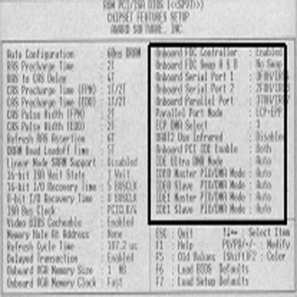](http://4.bp.blogspot.com/-1LkB0hirYTE/UChQzcEMbwI/AAAAAAAAAQc/HXTgjcf3MVk/s1600/3.jpg)

* Onboard FDC Controller (Enabled) - This field allows you to connect your floppy disk drives to the onboard floppy drive controller which make your FDD operational.
* Onboard Serial Port 1 or Communication Port 1 (com 1, COM A)\*\* 3F8H / IRQ4\* options 3F8H/IRQ4, 2F8H/IRQ3, 3E8H/IRQ4, 2E8H/IRQ10, Disabled for the onboard serial connector.
* Onboard Serial Port 2 or Communication Port 2 (com 2, COM B)\*\* 2F8H / IRQ3\* options 3F8H/IRQ4, 2F8H/IRQ3, 3E8H/IRQ4, 2E8H/IRQ10, Disabled for the onboard serial connector.
* Onboard Parallel Port or LPT port (378H) This field allows you to set the operation mode of the parallel port, Options:Normal –allows normal-speed operation but in one direction only.
* EPP (Enhance Parallel Port)-allows bi-directional parallel port operation at    maximum speed.
* ECP (Enhance Capability Port)- allows the parallel port to operate in bi-directional mode and at a speed faster than the maximum data transfer rate.
* ECP+EPP- allows normal speed operation in a two –way mode.
* UART2 Use Infrared (disabled)- When enabled, this field activates the onboard infrared feature and sets the second serial UART to support Infrared Module connector on motherboard.
* Onboard PCI IDE Enable (On-chip IDE CHANNEL 10, 11 / On-chip PRIMARY, SECONDARY IDE / Onboard IDE-1, IDE-2 Controller)\*\*
* Controls your IDE devices such as Harddisk drive, CDrom or CDwriter drive LS120 drives, Internal Zip Drives, DVD drives and DVD writer.
* IDE Ultra DMA Mode (Auto) – This sets the IDE UltraDMA to be active when using UDMA-capable IDE devices. The BIOS will automatically adjust or disable this setting for slower IDE devices so that AUTO or high settings will not cause problems for older IDE devices.
* IDE 0 Master/Slave PIO/DMA or UDMA Mode, IDE 1 Master/Slave
* PIO/DMA or UDMA Mode (Auto) -Each channel (0,1) has both a master and a slave making four IDE devices possible. Because each IDE device may have a different timing (0,1,2,3,4). The default setting is AUTO this will allow auto detection to ensure optional performance.

Inventory Checklist

Computer Name: \_\_\_\_\_\_\_\_\_\_\_\_\_\_\_\_\_\_\_\_\_\_

Identification Number: \_\_\_\_\_\_\_\_\_\_\_\_\_\_\_\_\_

Case Number of 3.5” bays \_\_\_\_\_5.25” bays \_\_\_\_\_

Manufacturer: \_\_\_\_\_\_\_\_\_\_\_\_\_\_\_\_\_\_

Motherboard Manufacturer: \_\_\_\_\_\_\_\_\_\_\_\_\_\_\_\_\_\_

Model:\_\_\_\_\_\_\_\_\_\_\_\_\_\_\_\_\_\_\_\_\_\_\_\_ Bus Speed\_\_\_\_\_\_\_\_\_ MHz

Form Factor \_\_\_\_\_\_\_AT \_\_\_\_\_\_\_ATX

Chipset Manufacturer:\_\_\_\_\_\_\_\_\_\_\_\_\_ Model: \_\_\_\_\_\_\_\_\_\_\_\_\_\_\_   
BIOS Manufacturer:\_\_\_\_\_\_\_\_\_\_\_\_\_\_\_ Version: \_\_\_\_\_\_\_\_\_\_\_\_\_\_\_

Does the CPU use a socket or a slot? \_\_\_\_\_\_\_\_

How many CPU socket/slots are there? \_\_\_\_\_\_\_   
How many ISA slots are there? \_\_\_\_\_\_\_\_   
How many PCI slots are there? \_\_\_\_\_\_\_\_   
How many EIDE connectors are there? \_\_\_\_\_\_\_   
How many floppy connectors are there? \_\_\_\_\_\_\_   
How many serial ports are there? \_\_\_\_\_   
How many parallel ports are there? \_\_\_\_\_   
Is there an AGP slot? \_\_\_\_\_\_\_\_   
How many USB ports are there? \_\_\_\_\_\_   
How many other ports or slots are there? \_\_\_\_\_\_\_   
What kind(s) are they? \_\_\_\_\_\_\_

CPU Manufacturer: \_\_\_\_\_\_\_\_\_\_\_\_\_\_

Model:\_\_\_\_\_\_\_\_\_\_\_\_\_\_\_\_\_\_\_   
Speed \_\_\_\_\_\_\_\_\_\_\_\_\_\_\_\_ MHz

Memory \_\_\_\_\_\_ 30-pin SIMMs \_\_\_\_\_\_ 72-pin SIMMs

\_\_\_\_\_\_ 168-pin DIMMs \_\_\_\_\_ 160 pin RIMMs

\_\_\_\_\_\_ 184-pin RIMMs \_\_\_\_\_\_ Others: \_\_\_\_\_\_\_\_\_\_\_

How many memory slots are there? \_\_\_\_\_\_\_\_\_

What is the fastest type of memory supported? \_\_\_\_\_\_   
What is the maximum memory supported? \_\_\_\_\_\_\_

Hard Drive Manufacturer: \_\_\_\_\_\_\_\_\_\_\_\_\_\_\_\_\_\_

Model: \_\_\_\_\_\_\_\_\_\_\_\_\_\_\_\_\_

Size \_\_\_\_\_\_\_ Cylinders \_\_\_\_\_\_\_\_\_ Heads \_\_\_\_\_\_\_\_\_ SPT \_\_\_\_\_\_\_

Interface Type \_\_\_\_\_\_\_\_ IDE \_\_\_\_\_\_\_\_ SCSI

CD-ROM Manufacturer: \_\_\_\_\_\_\_\_\_\_\_\_\_\_\_\_\_\_\_

Model:\_\_\_\_\_\_\_\_\_\_\_\_\_\_\_\_\_   
Speed: \_\_\_\_\_\_\_\_\_\_\_\_\_\_\_\_\_

Interface Type \_\_\_\_\_\_\_\_\_\_ IDE \_\_\_\_\_\_\_\_\_\_\_ SCSI\_\_\_\_\_\_\_\_\_

Floppy Disk Manufacturer: \_\_\_\_\_\_\_\_\_\_\_\_\_\_\_\_\_\_\_

Drive

Monitor Manufacturer: \_\_\_\_\_\_\_\_\_\_\_\_\_\_\_

Model Number: \_\_\_\_\_\_\_\_\_\_\_\_\_\_

Video Card Manufacturer: \_\_\_\_\_\_\_\_\_\_\_\_\_\_\_

Model: \_\_\_\_\_\_\_\_\_\_\_\_\_\_\_\_\_\_  
Memory \_\_\_\_\_\_\_\_MB   
ISA \_\_\_\_\_\_\_\_\_  
PCI \_\_\_\_\_\_\_\_\_  
On Board\_\_\_\_

Sound Card Manufacturer: \_\_\_\_\_\_\_\_\_\_

Model: \_\_\_\_\_\_\_\_\_\_\_\_\_\_\_   
ISA \_\_\_\_\_\_\_\_\_\_\_\_

PCI \_\_\_\_\_\_\_\_\_\_\_\_

On Board \_\_\_\_\_\_\_\_\_\_\_\_\_

Mouse Type \_\_\_\_\_\_\_\_\_\_ PS/2 \_\_\_\_\_\_\_\_\_\_ Serial \_\_\_\_\_\_\_\_\_\_\_\_\_\_\_ USB

Keyboard Connector \_\_\_\_\_\_ 5-pin DIN or \_\_\_\_ 6-pin mini DIN \_\_\_\_\_\_ USB (Make

sure it matches the connector on your Motherboard).

Power Supply AT \_­­­­\_\_\_\_\_\_\_\_\_

ATX \_\_\_\_\_\_\_\_\_

Other \_\_\_\_\_\_\_\_\_

Power Supply Wattage \_\_\_\_\_\_\_

|  |
| --- |
| **CHAPTER IV How to Build a Computer** |

Learning how to build your own computer from scratch is fun, plus can save you money. And besides, there's always a feeling of pride after putting something together yourself. Now after looking at a PC and seeing cables and wires all over the place, you may have doubts and not feel up to the task, but that's OK. Actually it's quite simple. This page and the following pages will show you how to install all of the major parts with plenty of pictures and explanations. so put your mind at ease and relax. But before getting started, let's look at some important tips.   
  
**Preparations:**

1. To build your own computer from scratch know what you want to do before buying parts. Do you want to just surf the net, check email, or perform word processing and make spreadsheets? Or is multimedia your thing? Will you want to upgrade? How many hard drives/DVD drives do you want? Your needs should determine what you spend. You don't need to purchase an expensive sound card, video card or fancy motherboard if all you're going to do is surf the net. Whereas if a person is a serious gamer he'll need these things. Compare prices and select parts wisely.
2. Also, make sure components are compatible. You don't want to order parts, only to find out after they arrive that the CPU and motherboard are not compatible. Again, do your homework!!!
3. After you have the parts, don't start building just yet. Always look at the computer manual first. Pay particular attention to the motherboard's layout. Look where connectors are located. Computer cases contain USB, Firewire, and speaker ports on the front of the case. Some have memory card slots. All of these plug into the motherboard so know where they go. The same holds true for thehard drive light, power button, and reset switch. Although certain things about building PCs are the same, motherboards have different features that vary by manufacturer and model.Familiarizing yourself with the manual makes building go much faster.
4. OK, now that you've browsed the manual, one more thing. Get rid of any static electricity you may have by using an anti-static wrist strap.If you don't have one, touch the metal part of the chassis (the case). Static electricity can damage the motherboard, so this is an important step.

**Chapter V Building your own PC**

|  |
| --- |
| **How To Install a Power Supply** |

To install a power supply is really quite easy. It fits in the top back of the case. First, orient the holes on the power supply to those on the case.

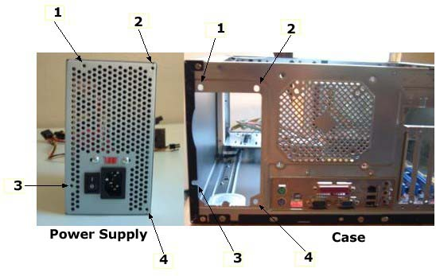

Then, place the unit in the space provided and slide it in until the screw holes are aligned.

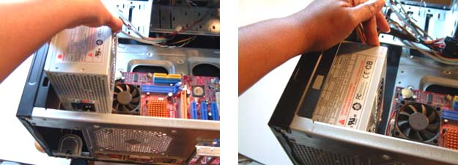

Secure it by screwing it in.

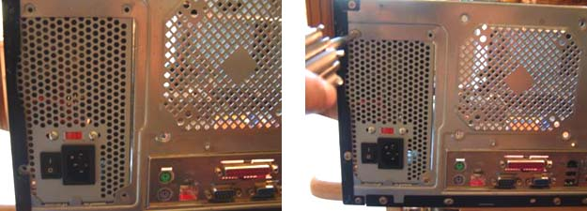

|  |
| --- |
| How To Install a Motherboard |

To install a motherboard, you will need several screws. Case screws go into the bottom of the case and are metal or plastic. I will be using the metal ones.

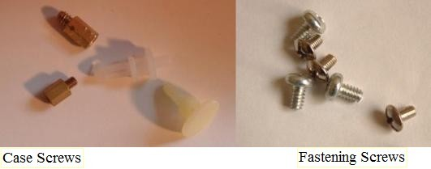

Look at your board and find the screw holes. Then look at the holes in the bottom of the case.

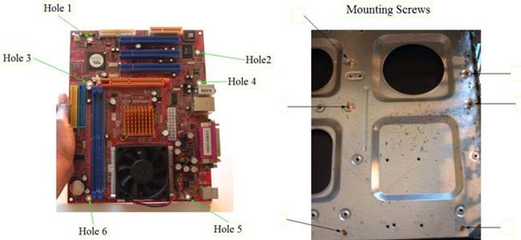

Match the holes on the motherboard to those in the case. You may have to hold the board slightly over the bottom of the case. Laying the board directly on the case may damage it.   
  
After the holes are matched, put in the case screws as shown on the right side of the image above. Next, place the motherboard on the screws. If done correctly, the ports on the motherboard will fit into the port holes on the back of the case.

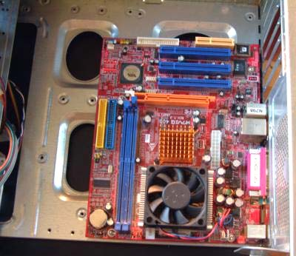  
  
Secure the board by putting in the fastening screws.

**Installing a Motherboard**

Here I'll outline for you the actual mounting of your motherboard in your computer case. I'm assuming that you've completed the above steps and are ready to install a motherboard in the computer case.

* If your computer is plugged in, unplug it. Make sure you have your antistatic wrist band on and [open the computer's case.](http://www.build-your-own-computer-tips.com/open-a-computer-case.html)

|  |  |
| --- | --- |
|  | H:\New folder\New folder\Installing a motherboard is easy_files\spacer.gif |

* Next, screw in the spacers that should have came with you case into the holes that you selected above. Some computers may also have snap-in spacers instead of the screw in spacers. The spacers look like this:
* Hold the motherboard just above the case to find which holes of the case line up with the holes in the mother board.

|  |  |  |
| --- | --- | --- |
| [H:\New folder\New folder\Installing a motherboard is easy_files\P1010181-small.jpg](http://www.build-your-own-computer-tips.com/images/P1010181.jpg) *(click any image to zoom in)* |  | [H:\New folder\New folder\Installing a motherboard is easy_files\P1010182-small.jpg](http://www.build-your-own-computer-tips.com/images/P1010182.jpg) |

* Once the spacers are securely in it's time to install your motherboard by **gently** laying it in the case onto the spacers. When the holes of the motherboard line up with the holes of the spacers, screw the motherboard in place with the screws provided with the case.

Do **not** over tighten these screws as they can crack and ruin your motherboard. If the screw's head looks too wide and it may disrupt the motherboards circuitry you can place a rubber buffer between the screw and the board.

|  |  |  |
| --- | --- | --- |
| [H:\New folder\New folder\Installing a motherboard is easy_files\P1010185-small.jpg](http://www.build-your-own-computer-tips.com/images/P1010185.jpg) |  | H:\New folder\New folder\Installing a motherboard is easy_files\spacermounted.jpg |

* Finally, the last step for installing a motherboard is to make some of the basic connections. Which include the case's on/off switch, case indicator lights, reset button, and speakers. The location of these connections are different in every computer, so check your motherboard's user manual.

Also [connect the computer power supply](http://www.build-your-own-computer-tips.com/install-a-power-supply.html) to the motherboard, usually two to three connections depending on your motherboard, and you are ready to do a preliminary test.

|  |  |  |
| --- | --- | --- |
| [H:\New folder\New folder\Installing a motherboard is easy_files\P1010193-small.jpg](http://www.build-your-own-computer-tips.com/images/P1010193.jpg) |  | [H:\New folder\New folder\Installing a motherboard is easy_files\P1010209-small.jpg](http://www.build-your-own-computer-tips.com/images/P1010209.jpg) |

**Testing a Motherboard**

Got everything completed above? Good! The finally step of installing a motherboard is to test it.

* Insert your video graphics card into the AGP slot of your mother board (more on this here(link)) and secure it to the computer case with a screw.
* Hook up your monitor, keyboard, and mouse; and plug the computer into a power outlet.

Your computer should beep and display the basic BIOS information on the screen. If this doesn't happened or your computer doesn't turn on, check all of the connections you made while installing your motherboard.

|  |
| --- |
| **How To Install a CPU** |

To install a CPU, first raise the lever on the socket. Simply pull the lever out a little bit, then lift up. You should see the socket move up.

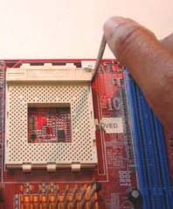

Now you're ready to put in the processor. The CPU pins have to be aligned with the socket holes. Look very carefully at the pin holes on the socket to see the arrangement. Turn the processor over and orient the pins to match the socket.   
  
\*NOTE: Keep in mind CPUs and sockets vary. Modern Intel processors don't have pins. I'm using an AMD CPU.

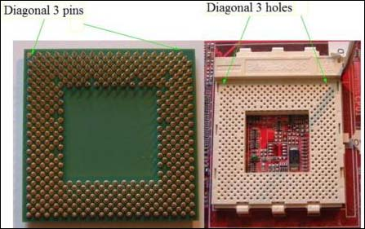

Next, turn the processor back over and place it in the socket. It should basically fall in by itself. To secure it, pull the lever down until it locks in place.

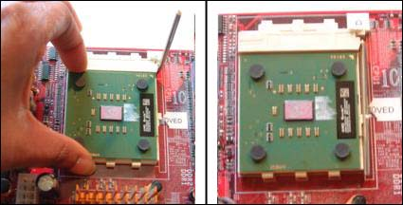

**Installing the CPU Fan and Heatsink:**  
Processors get hot and require a fan or some other kind of cooling. They come in a variety of types and install by different means. Some are easy. Others may take a little work. Always check the documentation. The one in this tutorial is your basic fan.   
  
If the fan and heatsink are not attached together, go ahead and attach them now.

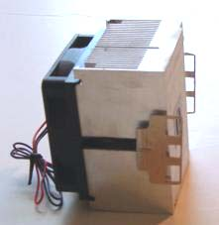

Apply a small amount of thermal grease on the processor or underneath the heat sink.

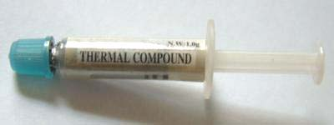

Place the fan/heatsink on top of the CPU. Make sure the fan's connector is next to the motherboard fan connector.

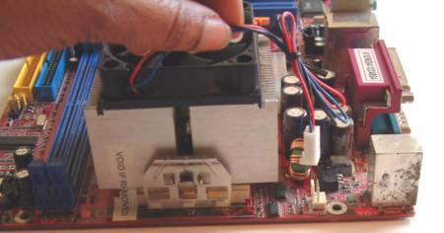

On one side of the heatsink, maneuver the heat sink arm until the notches on the socket lock through the holes. If done correctly, they'll click into place. This may take a little tinkering.   
  
Next, on the other side, take a pencil or other object and push down on the heatsink arm until the notches lock through the holes. Again, you should hear it click into place.

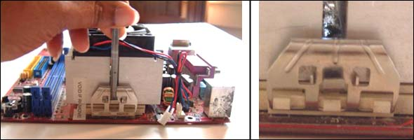

Now that it is secured, connect the fan to the motherboard.

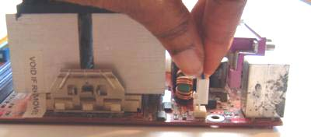

|  |
| --- |
| **How to Install Desktop Memory** |

One of the easiest things to do is install desktop memory. To put in a stick of RAM, look at the center of the slots and you will see a notch. On the ends of each slot you will see a small latch. Pull them down if they are not already.

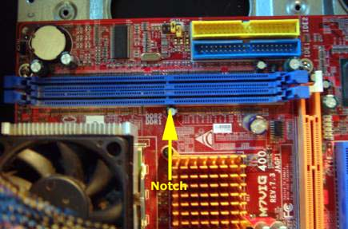

Next, look at the memory and notice the hole in the connector.

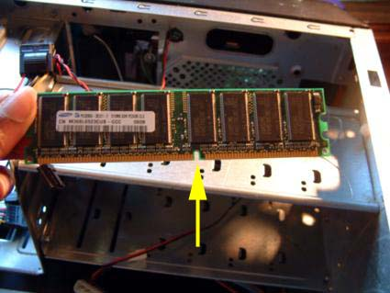

Place the ends of the RAM into the ends of the slot. Make sure the hole is over the notch. Push down on the ends of the memory until the latches on the slot attach themselves to the sides of the memory. You will hear a click when this happens.

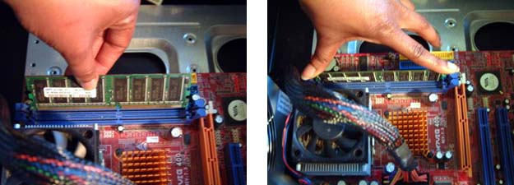

That's all there is to it! When handling memory, try not to touch the contacts on the bottom. If your system supports dual channel and you want to use it, check the documentation to see which slots to populate.

|  |
| --- |
| **How to Install a Hard Drive** |

Before we get started, it should be noted that while the most common hard drives used today are SATA, the system I'm using is IDE based. Besides having different types of connectors, the installment procedure is basically the same. SATA is discussed later.   
  
To start, look at the side of the hard drive. You should see some screw holes.   
  
**Note:** There are a variety of computer cases and many don't use screws to install drives. Check the case's specifications.   
  
Slide the drive into the drive bay so that the screw holes of the bay and drive are aligned. Then, insert the screws.

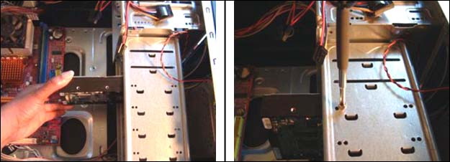

Now, find the IDE connectors on the motherboard. They are labeled IDE1 and IDE2, although many modern boards have only one IDE connector.

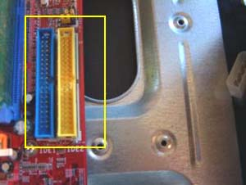

Next, look at the IDE cable. The blue end plugs into the motherboard. Notice there's a notch on each connector. This is to ensure that you connect it correctly. It only fits one way. If this is the primary hard drive for the system, connect the cable to IDE 1.

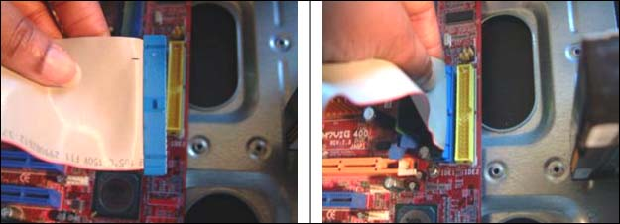

Now take the other end of the cable (black) and connect it to the 40-pin connector on the drive. Remember, the cable's notch makes it fit one way. Another way to tell if you're doing it correctly is to examine the cable. One side has a thin red stripe that runs the length of the cable. This red side is aligned with pin 1 on the drive.

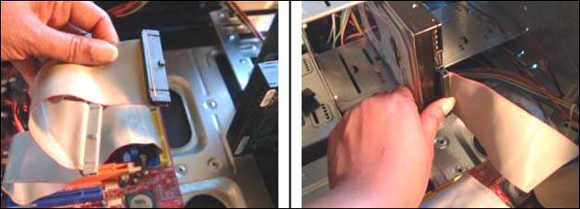

The last thing to attach is the power. Get a molex connector from the power supply, and insert it into the power connector. The yellow wire is always to the outside.

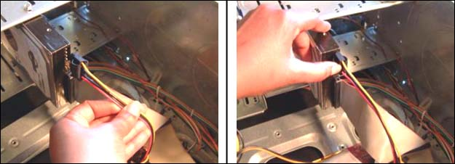

That's it! To install a second IDE drive, it must be configured to be the slave drive by using the jumpers located between the 40-pin and power connectors. The default setting is master. Which jumper to use is listed on top of the drive. Attach it to the middle cable connector.   
  
**Installing SATA Drives:**  
Installing SATA drives is just like installing IDE's except for one major difference. Since SATA cables support one drive, there is no need for a slave configuration if you want to put in a second drive. Just use another connector. Many motherboards come with several SATA connectors and are labeled SATA 1, SATA 2, etc.

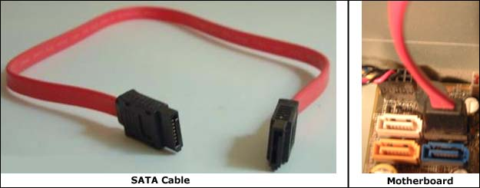

Plug one end of the cable into the motherboard and the other into the drive. Then attach the power. The cables fit one way. The boot drive's cable is inserted into SATA 1 on the motherboard.

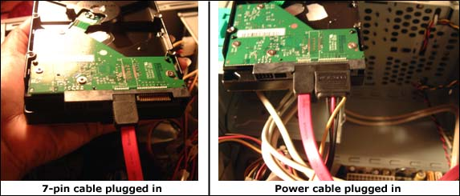

|  |
| --- |
| **How to Install a DVD Drive** |

Installing DVD drives is practically identical to installing hard drives. Like hard drives, they can be either IDE or SATA. I will be installing an IDE drive.   
  
On the front side of the case, punch out one or more of the drive plates, depending on how many you're installing. Locate the screw holes on the side of the drive. Then slide the drive into the bay through the front of the case until it is even with the case and the screw holes are aligned. Put in the screws.

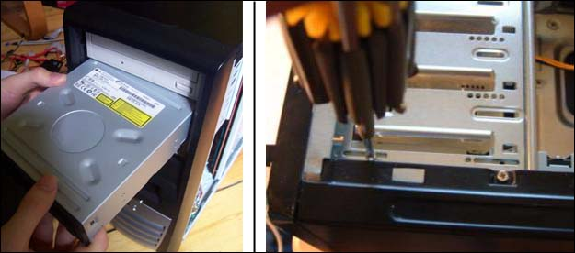

NOTE: I think it's worth mentioning again that cases are different and not all use screws, so check the cases' features. I'm using a standard case.   
  
As with the hard drive get your IDE cable and plug the blue end into the IDE2 motherboard connector. The cable's notch makes it fit one way.

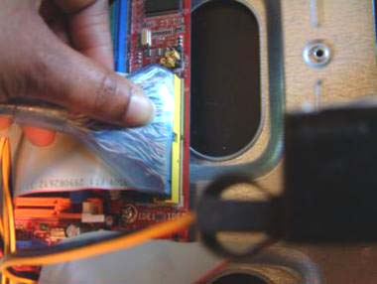

Plug the other end (black) into the 40-pin drive connector. Again, it fits one way.

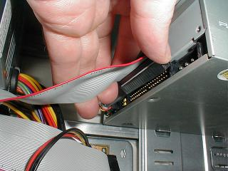

Last, connect the power. Get a molex cable from the power supply and insert it into the power connector. The yellow wire goes to the outside.

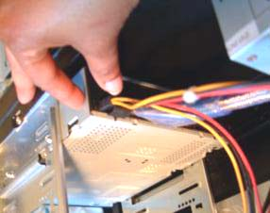

To install a second IDE drive, make sure it is configured as the slave drive by using the jumpers located between the 40-pin and power connectors. The default setting is master. Which jumper to use is listed just above the connectors. Slide it into another bay and attach it to the middle cable connector.   
  
**Installing SATA DVD Drives:**  
Like hard drives, installing SATA DVD drives is simple. SATA cables support one drive, so there is no need for a slave configuration if you want to put in a second one. Just use another connector. Many motherboards come with several SATA connectors and are labeled SATA 1, SATA 2, etc. Plug one end of the cable into the drive and the other into the board. Attach the power. The cables fit one way. If the system has a SATA hard drive, it will be connected to SATA 1 on the motherboard so you will need to use one of the other slots.

|  |
| --- |
| **Installing Expansion Cards and Connecting the Front Panel** |

PC expansion cards provide extra functionality and features than built-in components. Whether it's a video card, sound card, or network card, the procedure for installing them is basically the same. I'm going to install a PCI sound card.   
  
To begin, find a PCI slot (blue in the image below). Notice in each one there is a notch close to the right side of the slot. If you're looking from the other angle it will be on the left.

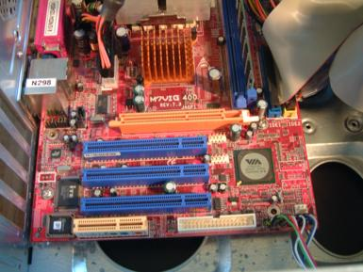

Next, look at the card and notice the gaps in the contacts.

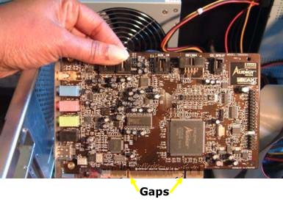

Now, arrange the card so the ports face outside the case. Place the card into the slot. One of the gaps in the contact should fit over the notch on the slot. Press down on the ends of the card until you hear it snap into place. Secure it by screwing the handle to the case.

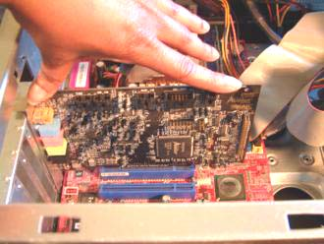

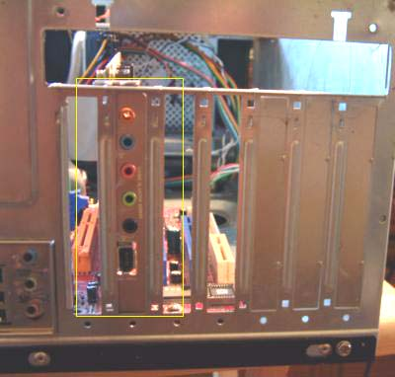

**Front Panel Connectors:**  
Front panel connectors allow things on the front of the case, such as the power button, reset switch, power LED, internal speakers, and hard drive LED to function. They are two rows of pins located right on the edge of the motherboard and are usually individually labeled. Connecting these is basically the final step in building a PC.

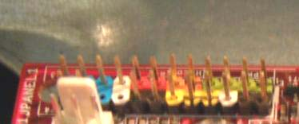

The wires that connect to these extend from the front inside of the case and are also labeled.

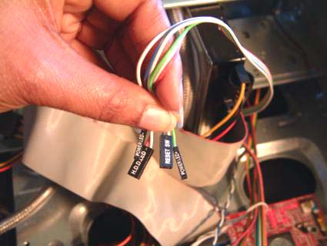

Since pin arrangement varies from board to board, it's best to check the motherboard manual for proper connection instructions.   
  
In addition to these, most cases contain front panel USB, Firewire, and audio connectors. Their motherboard pins are usually near the others.

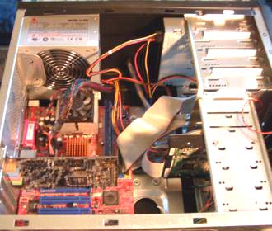  
Finished PC!

**CHAPTER VI BASIC TROUBLESHOOTING**

|  |
| --- |
| **Computer Troubleshooting** |

Troubleshooting computers can be a little frustrating and a little tricky. With so many parts and software installed, any number of things can go wrong. But when (not if) something happens, this is the best opportunity for you to learn-of course provided that you have a few basics under your belt. Nothing beats experience. The more you do it, the better you become, and the more your confidence grows. And the best part, you will save yourself a lot of money.   
  
There are many things that can go wrong with a computer. Here, I try to cover the basics to get you going in the right direction.   
  
Well let's start with an important tip: When troubleshooting computers always start with the simple stuff. By that I mean there's a tendency to assume that when something happens it's always due to a major problem, when all it could be is a loose cable or something else minor. I have been guilty of this myself. Check the easy things first!!!   
  
Now the real challenge is deciding whether a symptom is hardware or software related. A lot of times this comes through trial and error. Don't be afraid of misdiagnosing a problem. It's going to happen. Just keep at it.   
  
**Issues During POST**  
When you power on your system, the power supply sends a signal to the CPU, which receives instructions to go to the BIOS to start the boot process. Part of this process is the POST (Power On Self Test). Problems arising at this stage are almost always hardware. During the POST, devices are found and checked for errors. If everything is fine the motherboard speaker will usually sound a single, short beep and move on to loading the operating system. If something occurs you will hear some type of beep or see an error message on the screen. BIOS manufacturers have different beep codes so you will have to know which BIOS your system is using. Phoenix and AMI are the two primary makers. Award BIOS was bought out by Phoenix in 1998. You can find the type of BIOS you have by either turning on your computer (assuming of course it comes on) and looking at the top left of the screen, opening the case and looking at the BIOS chip, consulting the motherboard manufacturer or the company that built your computer.   
  
Whichever BIOS you have, if the beep code indicates a memory or video card problem the usual solution is to check to see if they are fully seated in their slots or to replace the part. If using built-in video then it could be the motherboard. If it's a CPU beep code your processor might be overheating. Some BIOS setups are set to shut the computer down if the processor is too hot. A malfunctioning processor fan can could be the culprit. Turn off the computer and remove the case door. Turn the computer back on and see if the fan is working or running slowly. If it's the fan, replace it. If not, remove the processor and see if there's any physical damage to it. Keep in mind that you will not always see physical damage on a bad CPU.   
  
If you don't hear a beep at all, more than likely it's a failing power supply or motherboard.   
  
**Devices Not Listed in BIOS**  
Immediately after the POST is performed information about your computer is listed on the screen, including your drives. If you don't see a drive listed, go back and make sure they are installed properly and that cables are firmly connected.

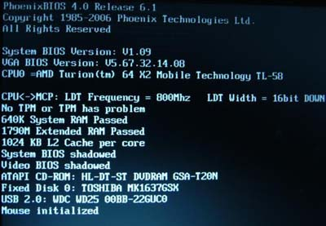

No Operating System Found or Similar Message:  
After the POST and listed information the BIOS checks the boot device for the master boot record (MBR), which tells where the operating system (OS) is. A drive set to boot with no operating system will produce an error, so make sure your system is set to boot from the right device. Go into CMOS and look under the BOOT menu to see if the proper boot order is listed. (Again, depending on the BIOS, there are various ways to enter CMOS. It's listed at the bottom of the screen soon after you turn on the computer. Most of the time it's by pressing DEL, F1, or F2). In many cases the DVD drive is first on the list followed by the hard drive(s). That's OK. If the DVD drive is empty, the BIOS skips it and starts looking at the hard drives. If there is a non-bootable DVD in the drive, remove it. Your boot drive should be the first option or second (If DVD drive is first). Once found, the OS begins to load.

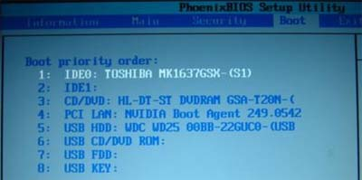

Another cause for this message is that the master boot record itself can become corrupted. There is a link to a quick tutorial on how to fix a damaged MBR with an XP or Vista CD located [**here**](http://www.slowpctips.com/windows-help/repairing-the-mbr/#_blank).   
  
**Computer is Slow**  
A computer that runs at a snail's pace is quite annoying, especially when you have a lot of work to get done. Fortunately, many of the common causes are easily fixable.   
  
A slow running computer is often due to viruses and spyware which are discussed below. Another cause can be programs running in the background. Many times when installing new software, by default they're designed to run when Windows starts. You can look in the tray at the bottom right of the screen to see all the installed software that's running. You can usually stop these from starting with Windows by either right-clicking on the program's icon in the tray and select its properties or options and choose not to have it begin at startup. Or open the entire program and go to the options/properties menu.   
  
Another way to prevent programs from running at startup is to run msconfig.   
  
To open msconfig in XP click start, run, type msconfig. In Vista click start, type msconfig in the "start search" text box right above the task bar (the program icon should appear in the white area above the text box), then either double click the icon or press enter. Go to the startup tab. There you will see the same programs that are in your tray. You have the choice of disabling them all (not wise, there is certain software that needs to run when Windows starts such as anti-virus) or individually selecting the ones you don't want to start by unchecking the box next to them. After making your selection(s) click apply. Your choices will go into effect the next time you start your computer.

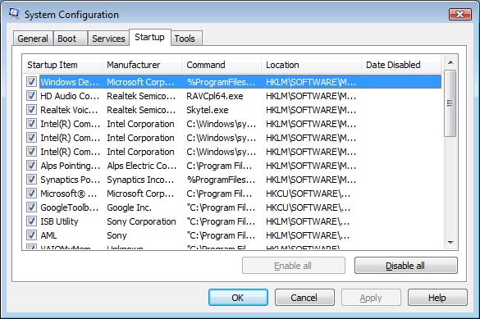

Another common reason for a slow computer is not having enough RAM. Installing more can often help the problem.   
  
Viruses/Spyware:  
Viruses and spyware can not only slow down your computer, they can render it unusable. Furthermore, certain types of viruses and spyware can transmit your personal information to the attackers. You should always have antivirus running on your system. If you are looking for a good free option, I recommend [**Avast**](http://www.avast.com#_blank).   
  
**Limited Hard Drive Space**  
After a long period of time, most of our hard drives contain data we no longer need or that is left over by software not completely uninstalled eventually leading to a messy drive. Given the size of modern hard drives, this is rarely an issue anymore. In any event, if you are a clean freak like me, you may want to periodically clean house. Windows built-in Disk Cleaner tool is a good way to get rid of unwanted files, although there's plenty of other software available too. And of course, you can always add an additional hard drive if you need more storage space.   
  
To open Disk Cleanup in XP or Vista click start -> Programs -> Accessories -> System Tools -> Disk Cleanup and follow the instructions.   
  
**Fragmented Hard Drive**  
When a hard drive is brand new and you begin installing software or saving data, Windows tries to keep all the individual files intact, resulting in them being read extremely fast. But after a while you start deleting things. Well, each time something is deleted, it leaves "gaps" in your drive. Then when another program is installed or data saved, individual files are broken up and placed in these gaps all over the drive. This is what is known as a fragmented hard drive. When opening a file or program, the operating system has to scan the entire drive to find parts of files and put them back together, reducing read time. This why it can seem like forever for a file to open.   
Defragmenting a hard drive is easy with Windows Disk Defragmenter. It scans your drive for split up files and reassembles them. To open In XP or Vista click -> Start -> Accessories -> System Tools -> Disk Defragmenter. Before using Disk Defragmenter I would suggest running Disk Cleanup first to eliminate unwanted data. As with Disk Cleanup, there are many other 3rd party defragmenting programs available.

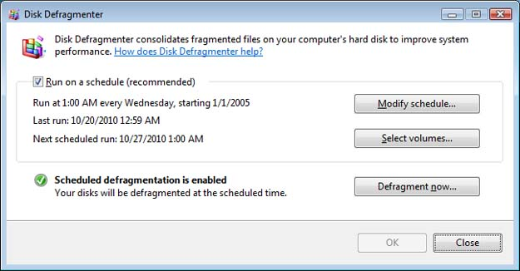

**Non-Working Devices/Device Not Recognized**  
If a device has stopped functioning or isn't recognized by Windows, remember to first check the simple things. Make sure cables and power are plugged in. With an internal component, turn off and unplug the machine. Remove the case door and make sure cables are firmly connected to the device and that add-on cards are seated in their slots. If all is OK, there may be a device driver issue. Device drivers are little pieces of software that allow hardware to work. Reinstall the device driver or download the latest version. Either go the manufacturer of the device or the company where you bought your computer. If still no success try uninstalling and reinstalling the device.   
  
If the above doesn't produce any results, it is probably the device itself.   
  
**Problems After Installing New Software or Device Driver**  
Of course you should first uninstall the software or driver. Or use System Restore to return your system to a previous working state. To open System System Restore in XP or Vista click Start -> Programs -> Accessories -> System Tools -> System Restore.

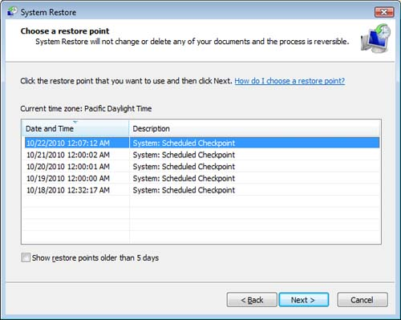

There are times when new programs might freeze up your system. In this case try to see if you can boot to Safe Mode and then perform a restore. Safe Mode only loads the very basic devices and drivers needed for your system. To get to Safe Mode restart your system. When it begins to boot, continuously press the F8 key. A menu should appear that looks similar to the one on the left. Choose Safe Mode and press enter. After Windows loads you should get the screen on the right with a black desktop. Start System Restore like described above.

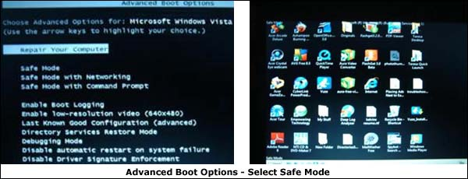

**No Power**  
The main culprit is usually the power supply unit (PSU). Make sure the power cord is securely plugged into the supply and the wall outlet. If so, you can buy a tester to see whether your PSU is putting out enough voltage.   
  
Another cause could be a malfunctioning device. Turn off the computer and disconnect all devices. Reinstall each device one by one, turning on the computer after each device. Should your system not come on after installing a particular component, replace it.   
  
If your system doesn't come on after reinstalling every device, you may have a motherboard or CPU problem.   
  
**Spontaneous Reboots**  
A computer that reboots often (while you're in Windows or other operating system) is another indication of a bad power supply. See the first couple of sentences under No Power above.   
  
**Time Keeps Changing**  
If you constantly have to set the time/date clock, that's the main symptom of a bad CMOS battery. Replace it. But just like any other battery it has to be the same size. Look at the number on your battery and buy one with the same number.   
**Chapter VII Learn BIOS Menus and Other Features**

**STANDARD CMOS FEATURES / MAIN** - allows you to record some basic system hardware configuration.

[](http://3.bp.blogspot.com/-3V0n9WVMATQ/UChQDoTEw0I/AAAAAAAAAQM/vKHvWQFx-Fo/s1600/1.jpg)

* Time and Date Setting: to set, highlight Date /Time.
* This field records the specifications for all non-SCSI hard disk drives installed to   your system. The onboard PCI IDE connectors provide Primary and Secondary Channels for connecting up to four IDE hard disk or IDE devices (CDROM’S, DVD ROM, DVD WRITER, CDWRITER’S, ZIP DRIVES). Use the Auto setting for detection during boot up.
* Drive A / Drive B (none)\* this field records the type of floppy drives installed in your system. The available options for drives A and B are 360KB, 5.25 in.; 1.2 MB, 5.25 in.; 720kb, 3.5 in.,1.44MB; 3.5 in., 2.88 MB, 3.5 in.; None. (Floppy 3 Mode Support (disabled)\* This is a Japanese standard floppy drive, no need to enable.)
* Video (EGA/VGA)\* Set this field to the type of video display card installed in you system. Options are EGA/VGA, CGA 40, CGA 80, and mono( for Hercules or MDA).
* Halt On (All Errors)\* This fields determines which types will cause the system to halt. Choose from either All Errors; No Errors; All, But Keyboard; All but Diskette; or All, But Disk/Key.
* Control keys with their respective functions, used to change the values of the CMOS SETUP.

**BIOS FEATURES**

[](http://2.bp.blogspot.com/-PlNvy-_59Dw/UChQpnP77bI/AAAAAAAAAQU/m6Qcjy_w6DY/s1600/2.jpg)

* Virus warning (Disabled) This field protects the boot sector  and Partition table against accidental modifications. An attempt to write to them will cause the system to halt and display a warning message.
* HDD Sequence SCSI/IDE First (IDE) when using both SCSI and IDE harddisk drives, IDE is always the boot disk using drive letter C(default setting of IDE).
* BOOT SEQUENCE (C, A)\* This field determines where the system looks first for an Operating System. Options: C,A; A,CDROM,C; CDROM,C,A; D,A; E,A; F,A; C only; LS/ZIP, C; and A,C.
* IDE HDD Block Mode Sectors (HDD MAX) this field enhances hard disk performance by making multi-sector transfers instead of one sector per transfer. Most IDE drives, except for older version, can utilize this feature. Options: HDD MAX; Disabled.
* SECURITY OPTION (System, Setup) this field can be utilize when Password is set thru SUPERVISOR PASSWORD menu, Determines when the system prompts for the password.   System –password is supplied before booting up. Setup-    password is supplied when entering the Bios Setup.

**CHIPSET FEATURES**

[](http://4.bp.blogspot.com/-1LkB0hirYTE/UChQzcEMbwI/AAAAAAAAAQc/HXTgjcf3MVk/s1600/3.jpg)

* Onboard FDC Controller (Enabled) - This field allows you to connect your floppy disk drives to the onboard floppy drive controller which make your FDD operational.
* Onboard Serial Port 1 or Communication Port 1 (com 1, COM A)\*\* 3F8H / IRQ4\* options 3F8H/IRQ4, 2F8H/IRQ3, 3E8H/IRQ4, 2E8H/IRQ10, Disabled for the onboard serial connector.
* Onboard Serial Port 2 or Communication Port 2 (com 2, COM B)\*\* 2F8H / IRQ3\* options 3F8H/IRQ4, 2F8H/IRQ3, 3E8H/IRQ4, 2E8H/IRQ10, Disabled for the onboard serial connector.
* Onboard Parallel Port or LPT port (378H) This field allows you to set the operation mode of the parallel port, Options:Normal –allows normal-speed operation but in one direction only.
* EPP (Enhance Parallel Port)-allows bi-directional parallel port operation at    maximum speed.
* ECP (Enhance Capability Port)- allows the parallel port to operate in bi-directional mode and at a speed faster than the maximum data transfer rate.
* ECP+EPP- allows normal speed operation in a two –way mode.
* UART2 Use Infrared (disabled)- When enabled, this field activates the onboard infrared feature and sets the second serial UART to support Infrared Module connector on motherboard.
* Onboard PCI IDE Enable (On-chip IDE CHANNEL 10, 11 / On-chip PRIMARY, SECONDARY IDE / Onboard IDE-1, IDE-2 Controller)\*\*
* Controls your IDE devices such as Harddisk drive, CDrom or CDwriter drive LS120 drives, Internal Zip Drives, DVD drives and DVD writer.
* IDE Ultra DMA Mode (Auto) – This sets the IDE UltraDMA to be active when using UDMA-capable IDE devices. The BIOS will automatically adjust or disable this setting for slower IDE devices so that AUTO or high settings will not cause problems for older IDE devices.
* IDE 0 Master/Slave PIO/DMA or UDMA Mode, IDE 1 Master/Slave
* PIO/DMA or UDMA Mode (Auto) -Each channel (0,1) has both a master and a slave making four IDE devices possible. Because each IDE device may have a different timing (0,1,2,3,4). The default setting is AUTO this will allow auto detection to ensure optional performance.

**Supervisor Password and User Password**

[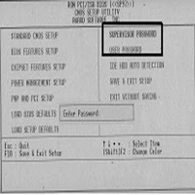](http://1.bp.blogspot.com/-85-si88pfJc/UChQ8Hvc4BI/AAAAAAAAAQk/hGZVip2Y6Iw/s1600/4.jpg)

These two options set the system passwords. “Supervisor Password” sets a password that will be used to protect the System and Setup Utility. “User Password” sets a password that will be used exclusively on system. It can be up to 8 Alphanumeric characters long.

**REMOVING PASSWORDS FROM SYSTEM and BIOS SETUP**

[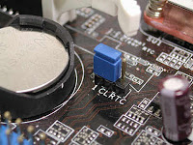](http://1.bp.blogspot.com/-1y-2lqCiZeE/UChRQtnKNYI/AAAAAAAAAQs/W8Sqm6YVFvA/s1600/jumper.jpg)

Locate a jumper setting labeled CLRCMOS; RTCCLR; JBAT; change the jumper position from 1-2 to 2-3 momentarily for 2 seconds, or refer to its manual for proper discharging of the [CMOS](http://en.wikipedia.org/wiki/CMOS).

**Computer System Error Beep Codes**

**Power On Self Test Beep Codes**

The computer POST (Power On Self Test) is the process of testing the computer system, insuring that it meets the necessary system requirements and that all hardware is working properly before starting the remainder of the boot process. If the computer passes the POST, the computer will have a single beep (with some computer BIOS manufacturers it may beep twice) as the computer starts and the computer will continue to start normally. However, if the computer fails the POST, the computer will either not beep at all or will generate a beep code, which tells the user the source of the problem.

Each time the computer boots up the computer must past the POST. Below is the common step a POST performs each time your computer starts.

1. Test the power supply to ensure that it is turned on and that it releases its reset signal.
2. CPU must exit the reset status mode and thereafter be able to execute instructions.
3. BIOS checksum must be valid, meaning that it must be readable.
4. CMOS checksum must be valid, meaning that it must be readable.
5. CPU must be able to read all forms of memory such as the memory controller, memory bus, and memory module.
6. The first 64KB of memory must be operational and have the capability to be read and written to and from, and capable of containing the POST code.
7. I/O bus / controller must be accessible.
8. I/O bus must be able to write / read from the video subsystem and be able to read all video RAM.

If the computer does not pass any of the above tests, your computer will receive an irregular POST. An irregular POST is a beep code that is different from the standard one or two beeps. This could be either no beep at all or a combination of different beeps indicating what is causing the computer not to past the POST.

**Example of a Computer Error Beep Codes**

|  |  |
| --- | --- |
| **Beep Code** | **Description of Problem** |
| No Beeps | Short, No power, Bad CPU/MB, Loose Peripherals |
| One Beep | Everything is normal and Computer POST is fine |
| Two Beeps | POST/CMOS Error |
| One Long Beep, One Short Beep | Motherboard Problem |
| One Long Beep, Two Short Beeps | Video Problem |
| One Long Beep, Three Short Beeps | Video Problem |
| Three Long Beeps | Keyboard Error |
| Repeated Long Beeps | Memory Error |
| Continuous Hi-Lo Beeps | CPU Overheating |

So as you can see if your computer doesn't start up and starts beeping away like a mime you can start the process of figuring out what is wrong by stopping for a second and listen to it. From a single beep which tells you everything is okay, to three long beeps which indicate a keyboard error to the siren like Hi-Lo beeps that tells you the CPU is overheating - listening to your computer is advisable!

**IBM Standard POST Error Beep Codes**

|  |  |
| --- | --- |
| **Beep Code** | **Description of Problem** |
| 1 short beep | Normal Post – system is ok |
| 1 short beeps | POST Error – error code shown on the screen |
| No beep | Power supply or system board problem |
| Continuous beep | Power supply, system board, or keyboard problem |
| Repeating short Beeps | Power supply or system board problem |
| 1 long, 1 short beep | System board problem |
| 1 long, 2 short beeps | Display adapter problem (MDA, CGA) |
| 1 long, 3 short beeps | Enhanced graphics adapter (EGA) |
| 3 long beeps | 3270 keyboard card |

**AMI versus Phoenix BIOS**

When an IBM compatible computer is first turned on, the hardware runs a Power On Self Test (POST). If errors are encountered during this POST test, they are usually displayed via an Audio Beep or in a form of a code number flashed across the screen. This list of audio beep codes will help you determine the location of your problem, and enable you to move on to the next step of resolving the issue.

**AMI BIOS Error Beep Codes**

|  |  |
| --- | --- |
| **Beep Code** | **Description of Problem** |
| 1 Short Beep | One beep is good! Everything is ok, that is if you see things on the screen. If you don’t see anything, check your monitor and video card first. Is everything connected? They seem fine; your motherboard has some bad chips on it. First reset the memory module and reboot. If it does the same thing, one of the memory chips on the circuit is bad, and you most likely need to get another memory module since these chips are soldered on. |
| 2 Short Beeps | Your computer has memory problems. First check video. If video is working, you’ll see an error message. If not, you have a parity error in your first 64k of memory. Fist, check your memory module. Reset them and reboot. If this doesn’t do it, the memory chips may be bad. You can try switching the first and second banks of memory chips. First banks are the memory banks that your CPU finds it first 64k of base memory in. You’ll need to consult your manual to see which bank is first. If all memory tests good, you probably need to change another motherboard. |
| 3 Short Beeps | Basically the same thing as 2 beeps. Follow that diagnosis above. |
| 4 Short Beeps | Basically the same thing as 2 beeps. Follow that diagnosis above. It could also be a bad timer. |
| 5 Short Beeps | Your motherboard is complaining. Try resetting the memory and rebooting. If that doesn’t help, you should consider another motherboard. You could probably get away with just replacing the CPU, but does not cost-effective. Its just time to upgrade! |
| 6 Short Beeps | the chip on your motherboard that controls your keyboard (A20 gate) isn’t working. First, try another keyboard. If it doesn’t help, reseat the chip that controls the keyboard, if it isn’t soldered in. If it still beeps, replace the chip if possible. Replace the motherboard if it soldered in. |
| 7 Short Beeps | Your CPU broke overnight. It’s no good. Either replace the CPU or buy another motherboard. |
| 8 Short Beeps | Your video card isn’t working. Make sure it is seated will in the bus. If it still beeps, either the whole card is bad or the memory on it is. Best bet is to install another video card. |
| 9 Short Beeps | Your BIOS is bad. Reseat or replace the BIOS. |
| 10 Short Beeps | Your problem lies deep inside the CMOS. All chips associated with the CMOS will likely have to be replaced. Your best bet is to get a new motherboard. |
| 11 Short Beeps | Your problem is in the Cache Memory chips on the motherboard. Reseat or replace these chips. |
| 1 Long 3 Short Beeps | You’ve probably just added memory to the motherboard since this is a conventional or extended memory failure. Generally a memory chip that is not seated properly causes this. Reseat the memory chips. |
| 1 Long 8 Short Beeps | Display / retrace test failed. Reseat the video card. |

**Phoenix BIOS Error Beep Codes**

These audio codes are little more detailed than the AMI codes. This BIOS emits three set of beeps. For example, 1 – pause – 3 – pause 3 – pause. This is a 1 – 3 – 3 combo and each set of beeps is separated by a brief pause. Listen to this sequence of sounds, count them, and reboot and count again if you have to.

|  |  |
| --- | --- |
| **Beep Code** | **Description of Problem** |
| 1 – 1 – 3 | Your computer can’t read the configuration info stored in the CMOS. Replace the motherboard. |
| 1 – 1 – 1 | Your BIOS needs to be replaced. |
| 1 – 2 – 1 | You have a bad timer chip on the motherboard, You need a new motherboard. |
| 1 - 2 – 2 | The motherboard is bad. |
| 1 – 2 – 3 | The motherboard is bad. |
| 1 – 3 – 1 | You need to replace the motherboard. |
| 1 – 3 – 3 | You’ll need to replace the motherboard |
| 1 – 3 – 4 | The motherboard is bad. |
| 1 – 4 – 1 | The motherboard is bad. |
| 1 – 4 – 2 | Some of your memory is bad |
| 2 - \_ - \_ | any combo of Beeps after two, means that some of your memory is bad, and unless you want to get real technical, you should probably have the guys in the lab coats test the memory for you. Take it to the shop. |
| 3 – 1 - \_ | One of the chips on your motherboard is defective. you’ll likely need to get another board. |
| 3 – 2 – 4 | One of the chips on your motherboard that checks the keyboard is defective. Motherboard needs replacement |
| 3 – 3 – 4 | Your computer can’t find the video card. |
| 3 – 4 - \_ | Your video card isn’t working. You'll need to replace it. |
| 4 – 2 –1 | There’s a bad chip on the motherboard. Motherboard needs replacement. |
| 4 – 2 – 2 | First check the keyboard for problems. If nothing, you have a bad motherboard. |
| 4 – 2 – 3 | Same as 4-2-2. |
| 4 – 2 – 4 | One of the cards is bad. Try detaching the cards one by one to isolate the problem and replace the bad one. The last possibility is to buy another Mainboard. |
| 4 – 3 – 1 | Replace motherboard. |
| 4 – 3 –2 | See 4-3-1 |
| 4 – 3 – 3 | See 4-3-1 |
| 4 – 3 – 4 | Time of the day clock failure. Try running the setup program that comes with the computer. Check the date and time. If that doesn’t work, replace the battery, if not the power supply, you may have to replace the motherboard, but that is rare. |
| 4 – 4 – 1 | your serial ports are acting up. Reseat, or replace, the I/O card. If the I/O card is on the motherboard itself, disable them with a jumper or on it’s BIOS setup and then add an I/O card. |
| 4 – 4 – 2 | See 4-4-1, but this time is your parallel port that’s acting up. |
| 4 – 4 – 3 | Your math coprcessor is having problems. Run a test program to double-check it. If it is indeed bad, disable it, or replace it. |
| Low 1 – 1 – 2 | Your motherboard is having problems |
| Low 1 – 1 – 3 | This is an extended CMOS RAM problem; check your motherboard battery, and motherboard. |

This Computer System Error [Beep Codes](http://www.computerhope.com/beep.htm) is very essential since this will be also given in the TESDA Computer Servicing Exam. I suggest that you must review this as well.

ave a 1 year warranty.   
  
Custom-built machines offer more flexibility. You are in complete control from the size and style of the case to the number of drives, the type of operating system, and the quality of the parts. You can choose what other software you want installed, and you have the option of building a system that's upgradeable.   
  
**Pre-Built (non Brand Name)**  
Although you're not hand picking the parts, pre-built systems come with a wide selection of features. Most online stores list all the specs, so you still need some tech knowledge to decide. They, too, come with the operating system installed and allow you to upgrade depending on what you buy.   
  
Whether buying a name brand, custom-built, or pre-built before opening your purse or wallet, the first thing to consider is, "What are my needs?" What do I want to use my computer for? Let's look at some.   
  
**Surfin' the net/Checking Email/Basic Word Processing**  
If this is all you ever plan on doing, a powerful machine with a fancy motherboard or graphics isn't necessary. Very good computers are available from $300-$500 that come with an AMD or Intel CPU, sufficient hard drive space (100-160 GB, sometimes more), 1 or more GB of memory, nice graphics, and a good sound card. In addition to new systems, many discounted computers fit this category. Multimedia/Multitasking: To do a whole lot with multimedia, such as burning CDs/DVDs, storing music, videos, and photos, or running multiple CPU and memory intense applications at the same time I would suggest a PC with:

* At least a 2.0+ GHZ AMD or Intel dual core CPU
* At least 2-4 GB of memory
* At least a 200-320 GB hard drive. If storing lots of videos I would say start with a 500 GB. At some point you may even consider buying an external hard drive for extra storage. Western Digital, Seagate, and Maxtor are three of the main hard drive manufacturers.
* If you're going to listen to music or watch videos on your PC, good sound and video quality are important. Some of the cheapest sound cards support surround sound, and many PCs come with built-in surround sound. But if you're not interested in surround sound, a 2.1 speaker system still provides good quality audio. A 2.1 setup requires two regular desktop speakers and a subwoofer for bass.
* If you do decide on surround sound, of course you will have to buy the appropriate speakers. However, if buying several speakers is not in your budget, there are sound cards by Creative Labs with X-Fi technology that provide virtual surround sound with only two speakers.
* For video, a PC with either ATI Radeon or NVIDIA graphics technology with a DVI, S-Video, or an HDMI port. Some come with all three. You can also buy a graphics card with these ports.
* If you strictly want a PC for media purposes only, you may think about a HTPC (Home Theater PC). HTPCs are regular PCs but are specifically built for the multi-media environemnt. The cases are designed to look like your entertainment system devices. But other differences include significant noise reduction (you don't want to hear fans and drives roaring when watching a show), ports to connect other devices such as iPods, and media software you may not find on the average PC such as Theatertek and Beyond TV to name a few. Some have a LCD display for movie or audio info.
* Gaming - For gaming you want a PC equipped with at least a 2.5 - 3.0 GHz dual or quad core processor, an SLI or Crossfire video card, 4 to 12 GB of memory, and 1 GB of video memory. Most top-notch gaming systems run anywhere from around $900 to over $1000.

When looking for a computer, you might consider an all in one PC. Rather than having a case, all in one PCs consist only of a monitor, keyboard, and mouse. All the ports, memory, drives-anything that goes in a typical computer case, is built into the monitor, and eliminates the need for a monitor cable and display power cable.   
  
Low-end systems (around $450 - $600) are not extremely powerful machines. Most use the Intel Atom CPU which runs at about 1.6 or 1.66 Ghz, support 1-2 GB of memory, have hard drive capacities from around 160 - 250 GB with 5400 RPM speed, and nice monitor size (around 18"). High-end machines come with dual core CPUs, large hard drives with 7200 RPM speeds, usually support up to 4GB of memory, have screen sizes from around 19 to 25 inches, Hi-Definition audio, and good graphics. Some support 64-bit operating systems. Both cheap and expensive systems possess other features such as multiple USB ports, memory card readers, wireless networking, & optical drive. Many now have touchscreens.   
  
A primary disadvantage is that on many systems upgrading is not an option.   
  
So, who would want to purchase an all-in-one-PC? If saving space is the goal, why not just buy a laptop? Well, the main consideration may come down to portability. Many people buy a laptop because they can take them anywhere. If you want to save space but don't have a need to carry your computer around, then an all-in-one-PC just might suit your needs.   
  
**Discount Computers**  
Looking for discount pcs or laptops? If so, buying a refurbished system is a good way to save some money. When you hear the word refurbished, the first thing that probably comes to your mind is junk, but that's not the case. They are usually new computers (or other products) that have been sent back for some reason and can no longer be sold as new again, so the price is reduced. For example, the case may be scratched, there could have been some damage during shipping, a defect in a part such as the hard drive or DVD drive. Or in some instances a product may be overstocked, and the price lowered to get rid of it. Many come with warranties.   
  
Some of these systems are often better than brand new machines because they go through extensive testing before being reshipped.   
  
So don't let the term refurbished scare you away. You might miss out on a top-notch computer at a bargain price!!!

**Barebone Systems**

After becoming familiar with all the components in a computer and your knowledge and confidence grow, you might at some point get the courage to want to build your own. If so, purchasing a barebone PC is a great way to save money. A barebone system is a partly assembled or unassembled computer and comes with the essential parts - usually the motherboard, memory, case, power supply, and CPU (sometimes you have to buy the processor fan). Some come with DVD drives and you have to buy the operating system, but it's still a good deal because you're not paying to have it built for you. And many of these systems are under $400.00. So you save costs while at the same time learn how to build your own PC.

**CHAPTER IX System Unit Disassembly Procedure**

This is one of the most important things to learn in taking the TESDA NC II Computer Servicing Exam. You need to learn the step by step procedure on how to open and disassemble a [system unit](http://en.wikipedia.org/wiki/Computer_case). There are various design of computer casing and before opening you need to check and see how you will start the system unit dis-assembly. Here we are going to use a mini-tower casing as our model, mini-tower casing design is the most easiest to disassemble, however that would depend on the brand and model.

* It's Not a Race, take a slow relaxed approach, discuss, question and research each component as it's removed.
* Fall back on your own knowledge, use the Internet, your books and resource material. It's impossible to retain all the information, so one of the most important computer skills you can learn is how to research and use your resources to find what you need.

**Questions to Think About or Discuss as you Disassemble**

* Should I document everything I do or everything I remove?
* Am I taking the best ESD precautions available to me right now?
* When you remove an expansion card what kind of card is it?
* When removing a drive, what kind of drive is it?
* When removing wires or cables, what are the cables for?
* Am I still taking proper ESD precautions and is my anti-static strap still hooked up?
* Look at the motherboard again when there's not so much in the way. Can you point out the CPU?

**Before You Begin**

* Have a pen and paper ready. Documentation is real important.
* Make sure you have the tools you need and they're all close by and handy.
* Be sure to have a container to keep the screws in.
* Make sure you have the resource material, drivers or software that you may need.
* If possible, enter the CMOS setup and record the information available.
* Disassembly is major surgery, do a full backup of the system.

**How to Remove the System Unit Cover**

[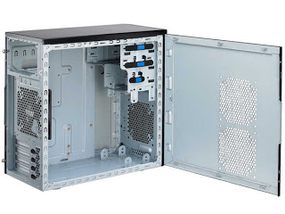](http://3.bp.blogspot.com/-PQ0tiKBoBMU/UChHufmhc7I/AAAAAAAAAPc/-esfwFgvzLA/s1600/mini-tower.jpg)

The standard way of removing mini-tower cases used to be to undo 4-6 screws on the back of the case, slide the cover back about an inch and lift it off. If there is no manual, then a little time taken for careful inspection may be in order. Here are some things to remember:

* Don't Force Anything. If it has to be forced, it will probably break. If there are no screws on the back of the case for the cover, check the plastic face-plate on the front. Some pry off to reveal screws or release levers (remember, careful inspection). If everything on the front has its own bezel around it (including the LEDs) then maybe the plastic front pops off (or maybe the case slides off the front).
* Make sure any screws removed are for the cover. You don't want to unscrew the power supply by accident and have it fall inside your computer. That's a bad thing.
* After the case is removed, place it in a safe place, where it won't get knocked of a table, kicked or stepped on and bent.

**How to Remove Adapter Cards**

[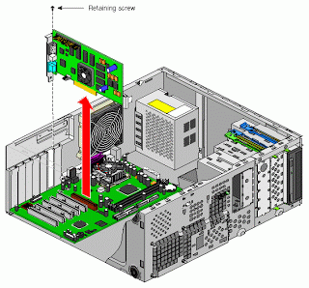](http://3.bp.blogspot.com/-pAzsRt13R_U/UChJNhiVBhI/AAAAAAAAAPk/Zl4RD0HHJis/s1600/removing+card.gif)

* Again, documentation is very important. Since some of the module cards have a specific configuration, like for example a 16-bit ISA card will probably work in any 16-bit ISA slot, but there may be a reason it's in that particular one. Document the type of card and which slot it comes from.
* Check the card for any cables or wires that might be attached and decide if it would be easier to remove them before or after you remove the card.
* Undo the screw that holds the card in place.
* Grab the card by its edges, front and back, and gently rock it lengthwise to release it. Do not wiggle it side to side as you can break the card, the slot, or the solder. Sometimes it helps to grasp the inside corner of the card with one hand and place a finger from the other hand under the associated port out the back of the computer to pry up the one end of the card.
* Once the card is removed, you may want to record any jumper settings you see, just in case one is accidentally dislodged. Try to store the card in an antistatic bag. If you don't plan on replacing the card then a cover should be installed over the slot opening.

**How to Remove Drives From System Unit Bay**

[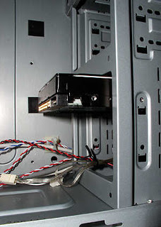](http://1.bp.blogspot.com/-zcKf_M_y2-4/UChLh3FmmgI/AAAAAAAAAPs/-oX_Y9DLEdk/s1600/hdd_in_lower.jpg)

* Removing drives is not that difficult. They usually have a power connector and a data cable attached from the device to a controller card or a connector on the motherboard. CD-ROMs may have an analog cable connected to the sound card.
* The power will be attached using one of two connectors, a large Molex connector or a smaller Berg connector for the floppy drive. The Molex connector may need to be wiggled slightly from side to side while applying gentle pressure outwards. The Berg connector may just pull straight out or it may have a small tab that has to be lifted with a tiny flat screwdriver.
* The data cables need to be documented. Remember the pin one rule. Know where each one goes before you pull it out and record its orientation (which side is the stripe on, where is pin 1?). Pull data cables gently and carefully.
* Can the entire drive bay be removed? Does the drive come out the back of the bay or does it slide out the front. If a bay is removable, you may have to remove some screws or unclip a lever then slide the bay back and off. If the bay is not removable, there should be access ports on the other side of the case that allow for access to those screws.

**How to Remove Memory Module**

[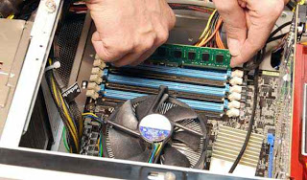](http://3.bp.blogspot.com/-5SMohfS4R40/UChMB3KNP4I/AAAAAAAAAP0/1AAdlE44jk8/s1600/removing+memory.jpg)

Memory modules are one of the chips that can be damaged by as little as 30 volts. Be careful of ESD and handle them only by the edges. SIMMs and DIMMs are removed differently:

* SIMM - gently push back the metal tabs holding the SIMM in the socket. Tilt the SIMM away from the tabs to about a 45% angle. It should now lift out. Put each SIMM in its own protective bag.
* DIMM- There are plastic tabs on the end of the DIMM socket. Push the tabs down and away from the socket. The DIMM should lift slightly. Now you can grab it by the edges and place it in a separate antistatic bag.

**How to Remove Internal Power Supply**

[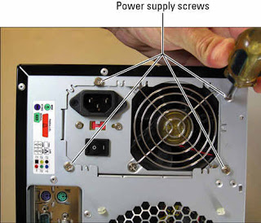](http://3.bp.blogspot.com/-DWzz-h9bwnc/UChMgibp-dI/AAAAAAAAAP8/mcIsReD7akU/s1600/power+supply.jpg)

* Make sure it's unplugged.
* All power connectors should be removed, including the connection to the motherboard and any auxiliary fans. Watch the little plastic tabs on ATX connectors (you'ld rather not break them). AT power supplies have a two piece power connector that may be labeled P-8 and P-9. Make note of the orientation. The black wires should be in the middle, black to black.
* Remove the connection to the remote power switch at the front of the case. Orientation of the colored wires at this switch is critical. Make sure you document well, and during re-assembly plug the computer into a fused surge protector before turning it on (this could save your motherboard and components from melting if you've reconnected improperly). If you're putting the same power supply back, it's better to remove the entire switch and leave the connectors intact. The remote switch on an ATX form factor attaches to the motherboard.
* Remove the four screws at the back of the case and gently slide the power supply out of the case. While removing these screws, hold onto the power supply. You don't want it falling into the case.

**How to Remove Mother Board**

[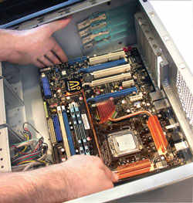](http://1.bp.blogspot.com/-8dzH_08-HlE/UChN-Er8KII/AAAAAAAAAQE/ID4hrH_ia2g/s1600/mother+board.jpg)

* Document and remove all wire attachments to the motherboard. (Some of these have Pin 1 designations also.)
* Most cases have a removable panel that the motherboard is attached to. By removing a couple of screws the panel can be taken off and you can gain much better access to the motherboard. Again, a little investigation can save a lot of trouble.
* There is usually 2 or 3 screws holding down newer motherboards. Make sure you've got the right ones and remove them.
* Motherboards sit on plastic or brass standoffs that keep the traces and solder from touching.

### CHAPTER X Operating System Familiarization

TESDA NC II Computer Servicing also requires the computer technicians to familiarize all types of operating system especially windows operating system. Here you can learn various types of operating system from first generation windows version up to the earlier time, and of course other well known operating system. In this example we are using Windows 2000 server, OS installation may differ in every version, however, sequence will be almost the same.  
  
***Operating System*** - (commonly abbreviated to either OS or O/S) is an interface between hardware and user; an OS is responsible for the management and coordination of activities and the sharing of the resources of the computer. The operating system acts as a host for computing applications that are run on the machine. As a host, one of the purposes of an operating system is to handle the details of the operation of the hardware.

### List of Windows Operating System Version.

* Windows 3.0 is the third major release of Microsoft Windows, and was released on 22 May 1990. It became the first widely successful version of Windows.
* Windows 3.1x is a series of [operating system](http://en.wikipedia.org/wiki/Operating_system) produced by Microsoft for use on personal computers. The series began with Windows 3.1, which was vended first during March 1992 as a successor to Windows 3.0.
* Windows 95 is a consumer-oriented graphical user interface-based operating system. It was released on August 24, 1995 by Microsoft.During development it was referred to as Windows 4.0 or by the internal code-name Windows Chicago.
* Windows 98 (code-named Memphis) is a graphical operating system released on 25 June 1998 by Microsoft and the successor to Windows 95.
* Windows 98 Second Edition (often shortened to SE) is an updated release of Windows 98, released on 5 May 1999. It includes fixes for many minor issues, improved USB support, and the replacement of Internet Explorer 4.0 with the significantly faster and less error-prone Internet Explorer 5.0.
* Windows Millennium Edition, or Windows Me is a hybrid 16-bit/32-bit graphical operating system released on 14 September 2000 by Microsoft. It was originally codenamed Millennium.
* Windows 2000 is a line of operating systems produced by Microsoft for use on business desktops, notebook computers, and servers. Released on February 17, 2000,it was the successor to Windows NT 4.0, and is the final release of Microsoft Windows to display the "Windows NT" designation.
* Windows XP is a line of operating systems produced by Microsoft for use on personal computers, including home and business desktops, notebook computers, and media centers. The name "XP" is short for "experience". Windows XP is the successor to both Windows 2000 Professional and Windows Me, and is the first consumer-oriented operating system produced by Microsoft to be built on the Windows NT kernel and architecture.
* And currently, the latest Windows 7, Windows 8 which will be release by this coming October 2012, and of course Windows 2008 server version.

### Other Well Known Operating System

* Mac OS is the trademarked name for a series of graphical user interface-based operating systems developed by Apple Inc. (formerly Apple Computer, Inc.) for their Macintosh line of computer systems. The Macintosh user experience is credited with popularizing the graphical user interface. The original form of what Apple would later name the "Mac OS" was the integral and unnamed system software first introduced in 1984 with the original Macintosh, usually referred to simply as the System software.
* Edubuntu has been developed in collaboration with teachers and technologists in multiple countries. Edubuntu is built on top of the Ubuntu base, incorporates the LTSP thin client architecture and several education-specific applications, and is aimed at users aged 6 to 18.

### Software Applications Examples

***Application software*** - is a computer program that functions and is operated by means of a computer, with the purpose of supporting or improving the software user's work. In other words, it is the subclass of computer software that employs the capabilities of a computer directly and thoroughly to a task that the user wishes. Typical examples of 'software applications' are word processors, spreadsheets, media players and database applications.

**Examples:**

* Spreadsheets
* Word processors
* Presentations
* Graphics editing
* Desktop publishing

### Well Known Utility Software

***Utility software*** - (Known as serviece program, service routine, tool, or utility routine) is computer software designed to help manage and tune the computer hardware, operating system or application software by performing a single task or a small range of tasks. Some utility software has been integrated into most major operating systems.

#### Disk Storage Software Utility

* Disk defragmenters can detect computer files whose contents are stored on the hard disk in disjointed fragments, and move the fragments together to increase efficiency.
* Disk checkers can scan the contents of a hard disk to find files or areas that are corrupted in some way, or were not correctly saved, and eliminate them for a more efficiently operating hard drive.
* Disk cleaners can find files that are unnecessary to computer operation, or take up considerable amounts of space. Disk cleaner helps the user to decide what to delete when their hard disk is full.
* Disk partitioners can divide an individual drive into multiple logical drives, each with its own filesystem which can be mounted by the operating system and treated as an individual drive.
* Backup utilities can make a copy of all information stored on a disk, and restore either the entire disk (e.g. in an event of disk failure) or selected files (e.g. in an event of accidental deletion).
* Disk compression utilities can transparently compress/uncompress the contents of a disk, increasing the capacity of the disk.
* File managers provide a convenient method of performing routine data management tasks, such as deleting, renaming, cataloging, uncataloging, moving, copying, merging, generating and modifying data sets.
* Archive utilities output a stream or a single file when provided with a directory or a set of files. Archive utilities, unlike archive suites, usually do not include compression or encryption capabilities. Some archive utilities may even have a separate un-archive utility for the reverse operation.
* System profilers provide detailed information about the software installed and hardware attached to the computer.
* Anti-virus utilities scan for computer viruses.
* Text and Hex/ Editors directly modify the text or data of a file. These files could be data or an actual program.
* Data compression utilities output a shorter stream or a smaller file when provided with a stream or file.
* Cryptographic utilities encrypt and decrypt streams and files.
* Launcher applications provide a convenient access point for application software.
* Registry cleaners clean and optimize the Windows registry by removing old registry keys that are no longer in use.
* Network managers check the computer's network, log events and check data transfer.

#### Device Driver Utility Software

***Device driver or software driver*** - is a computer program allowing higher-level computer programs to interact with a hardware device. A driver typically communicates with the device through the computer bus or communications subsystem to which the hardware is connected. When a calling program invokes a routine in the driver, the driver issues commands to the device. Once the device sends data back to the driver, the driver may invoke routines in the original calling program. Drivers are hardware-dependent and operating-system-specific. They usually provide the interrupt handling required for any necessary asynchronous time-dependent hardware interface.

**Preparing Hard disk for OS Installation**

Here you will learn how to prepare your hard disk drive for operating system (OS) Installation. You must understand the process since this very essential when taking up TESDA NC II Computer Servicing Exam.  
***Partitioning*** - A procedure were the size of the harddisk is is being divided into several parts or space in preparation for formatting. Is a process of dividing the harddisk into regions called partition. Each partition occupies a group of adjacent cylinders. Partition allows you to organize a harddisk into segments or space in preparation for formatting  
***FDISK*** - is the process of creating partitions into harddisk. Before you install your operating system, you must first create a primary partition on the hard disc (disc 1) in your computer, and then format the partition

**Creating Partition**

**Using FDISK for Windows ME and Windows 98**

This process will need Windows ME/98 installation Disk or DOS bootable operating system diskette or CD. Once you run the bootable disk it will normally arrive to a:\> prompt. Normally when creating this kind of bootable disk it has the following tools needed. The fdisk.exe format.com. Once you are now on the command prompt just type in FDISK then it will now move on the process of creating partition. Just follow the steps below.

* Creating [DOS partition](http://en.wikipedia.org/wiki/Disk_partitioning) or Logical DOS Drive - Choose this option if you need to create a partition on your computer hard drive.
* Set active partition - If you have created multiple partitions on your hard drive choose this option to specify which partition you wish to set as active. When choosing option 2 to set the active partition, you will see a listing of the current partitions. Choose the number representing the partition you wish to set as active, the default is one.
* Delete partition or Logical DOS Drive - This option is used if you need to delete partition(s) from the computer's hard disc drive.
* Display partition information - Use this option to look at the current fixed disc drive partition information. If you have multiple drives you will need to choose option 5 before being able to display the other hard drive information.
* Display partition information - Use this option to look at the current fixed disc drive partition information. If you have multiple drives you will need to choose option 5 before being able to display the other hard drive information.

**How to Delete Partitions of Windows ME/98**

* Delete Logical DOS Drive(s) in the Extended DOS Partition - This option would be used first if you have Extended DOS partitions that you wish to delete.
* Delete Non-DOS Partition - This option is usually used for partitions that have either been created by third party applications, such as a DDO, or by other operating systems, such as IBM Warp, Unix, and others.
* Delete Primary DOS partition - Use this option to delete your main primary partition. However, if you currently have any Extended / Logical DOS partitions, you must delete these partitions before you will be allowed to delete the Primary DOS partition.
* Delete Extended DOS partition - If you have your computer partitioned into more than one drive, use this option to delete the Extended DOS partition(s). You must delete the Logical DOS Drive(s) before you can delete the Extended DOS partition.

**Windows 2000 Installation Guide**

* Now insert the Windows 2000 Professional CD and reboot your computer. The first menu will now appear, it will say "Press any key to boot from CD...." at this point press the space bar on the computer.
* Windows will start to install. This may take some time as Windows copies file in preparation to install.
* Now press "ENTER" to start the Install. . Windows will start to install. This may take some time as Windows copies file in preparation to install.
* Now the user Agreement, read and Press "F8" to continue, if you disagree press "ESC", setup will then exit.
* Now select the Windows 2000 installation and press "R" to repair. Now the user Agreement, read and Press "F8" to continue, if you disagree press "ESC", setup will then exit.
* Setup will now examine the Drives..and then copy files to the installation folder.
* Next setup will initialize the Windows 2000 configuration.
* Once done setup will be required to reboot, make sure you have to.
* Windows install will start again.Once done setup will be required to reboot.
* Once done setup will be required to reboot, make sure you have to floppies in the drives, and press "ENTER" to speed things up.
* Next setup will initialize the Windows 2000 configuration.
* Regional settings should be correct as of last install, click "NEXT" to continue.And now you get to wait again, be patient the "Installing Devices" part of the install can take forever.
* Now input your Product Key, this is 25 characters long and can be found in the Windows 2000 packaging or on the side or back of your machine. Click next to continue. If you get any errors then double check what you have inputted and make sure you have used the correct letters and numbers.
* If your computer is on a network then click on "YES...." and input the workgroup name, otherwise leave at "NO..." and click "NEXT". More components will now install.And finally click on "FINISH" to complete the Windows 2000 install.
* The computer will now reboot y. Due to the Windows 2000 CD being in drive, the following message will appear "Press any key to boot from CD", do not press anything, just wait for the message to pass.
* You will now arrive at the login screen, login into system as you did before and test system. With any luck all should be OK.

**Verifying Device Drivers**

* Right click to My Computer Icon in the desktop and select properties (left click).
* Select hardware tab (left click).
* Left click on device manager button.
* On device manager window, check for any warning (! Exclamation point, ? question mark, X mark on any icon) the following warning prompt you to check the device or it’s driver.

**CHAPTER XI NETWORKING**

### Learn the Basic Networking and Topology

***Computer Communications*** - A process in which two or more computers or devices transfer’s data, instructions, and information. For successful communications you need the following:

* ***A sending device*** - Initiates an instruction to transmit data, instructions, information
* ***A communications device*** - Connects the sending device to a communications channel
* ***A communication channel*** - Transmission media on which the data, instructions, or information
* ***A communications device*** - Connects the sending device to a communications channel
* A receiving device - Accepts the transmission of data, instruction of information

### Uses of computer communication

* ***Internet*** - A worldwide collection of networks that links millions of businesses, government agencies, educations, and individual
* ***Web*** - Worldwide collection of electronic documents on the internet that users access through Web browser.
* ***E-Mail*** - Or Electronic mail, is type of mail message that is sent through the network.
* ***Instant messaging*** - A Real-time internet communication service that notifies you when one or more people are online,then allows you to exchange messages, pictures, files, audio and video.
* ***Chat rooms*** - A Real-time typed in conversation that takes place on a computer connected to a network, that also allows you to exchange messages, pictures, files, audio and video.
* ***Newsgroup*** - Online areas in which user’s have written discussion about a particular subject.
* ***Internet telephony*** - A conversation takes place over the internet using a telephone connected to a desktop computer.
* ***FTP*** - Internet standard that permits or allows user to upload or download files.
* ***Web Folder*** - Known as HTTP server, allows users publish documents and other files.
* ***Video conferencing*** - Realtime meeting over two person, use the internet to transmit audio and video signal.
* ***Fax Machine or Computer fax/modem*** - Transmits and receives documents over the phone line.

### Network Communications Standard

Data is processed in one of two ways: Analog or Digital. A computer, by contrast, is Digital Which means it can process data in two discrete states: Positive (ON or 1) Non-Positive (OFF or 0). The 1 and 0 represent the two digits used by the binary number system, this system is at the heart of digital computing.

***Computer Network*** - A collection of computers and devices connected together via communications devices and transmission media.

### Classifications of Network

|  |
| --- |
| [http://4.bp.blogspot.com/-PS4czUQ4kDI/UChWiR5hHYI/AAAAAAAAARM/zoZYFnaYZkw/s200/local.gif](http://4.bp.blogspot.com/-PS4czUQ4kDI/UChWiR5hHYI/AAAAAAAAARM/zoZYFnaYZkw/s1600/local.gif) |
| Local Area Network |

***LAN (Local Area Network)***  - A network that connects computers and devices in a limited geographical area such as home, school computer laboratory, office building, or closely positioned group of building. Each computer or device on the network is called a Node.

|  |
| --- |
| [http://3.bp.blogspot.com/-Y6tW5MMmtiQ/UChXCieEPlI/AAAAAAAAARU/m_7Go5US26Y/s200/wireless-network-1a.jpg](http://3.bp.blogspot.com/-Y6tW5MMmtiQ/UChXCieEPlI/AAAAAAAAARU/m_7Go5US26Y/s1600/wireless-network-1a.jpg) |
| Wireless LAN |

***WLAN (wireless LAN)*** - Is a LAN that uses no physical wires. Computers and devices that access a wireless LAN must have a built-in wireless capability, or the appropriate wireless network card, PC card, or Flash card. Wireless LAN communicates with wired LAN for access to its resources.

|  |
| --- |
| [http://3.bp.blogspot.com/-d37ifcOx66U/UChYCj92aEI/AAAAAAAAARc/o7ZeRqUPXzk/s200/man.jpg](http://3.bp.blogspot.com/-d37ifcOx66U/UChYCj92aEI/AAAAAAAAARc/o7ZeRqUPXzk/s1600/man.jpg) |
| MAN Netwok |

***MAN (Metropolitan Area Network)*** - Is a high speed network that connects local area networks in a metropolitan area such as city or town.

|  |
| --- |
| [http://2.bp.blogspot.com/-LWbBvH-I5QQ/UChYVvG624I/AAAAAAAAARk/ZT649tSKkYE/s200/WAN.jpg](http://2.bp.blogspot.com/-LWbBvH-I5QQ/UChYVvG624I/AAAAAAAAARk/ZT649tSKkYE/s1600/WAN.jpg) |
| WAN Network |

***WAN (Wide area network)*** - Is a network that covers a large geographic area (such as a city, country, or the world) using a communications channel that combines many types of media such as telephone lines, cables and radio waves. The internet is the worlds largest WAN.

### Network Architectures

***Network Architecture*** - Is the design of computers, devices and media in a network.

|  |
| --- |
| [http://1.bp.blogspot.com/-VqsfKechx3I/UChY-Wfc_cI/AAAAAAAAARs/sN7Os0ZqNoo/s200/clntserv.gif](http://1.bp.blogspot.com/-VqsfKechx3I/UChY-Wfc_cI/AAAAAAAAARs/sN7Os0ZqNoo/s1600/clntserv.gif) |
| Client Server Network |

***Client/Server Network*** - Server of Host computer, a centralized storage of the area for programs, data and information, also controls access to the hardware.

* File Servers
* Domain Controller
* Internet proxy server
* Print server

[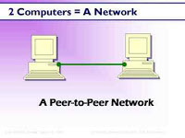](http://2.bp.blogspot.com/-xGZOG4zJnHo/UChaKSyN83I/AAAAAAAAAR8/FqiSUpMegHw/s1600/pic004.jpg)

***Peer-to-peer network*** - Each computer is called peer, A simple and an inexpensive network that typically connects fewer that 10 peers.

* Cross-over network - Connect two computer using cross over utp cable. This type of connection does not require a network hub or a network switch.
* Null modem cable - A null modem cable connects to two standard serial ports for networking two computers together. Null modem cables enable direct data transfer with a minimum of setup required. A null modem cable differs from ordinary serial cables the same way as Ethernet crossover cables differ from ordinary Ethernet cables. Null modem cables reverse the transmit and receive lines on end to enable direct two-way communication. A null modem cable for PCs ordinarily follows the RS-232 standard and uses the same serial ports as RS-232 cables. An RS-232 null modem cable transfers data at the rate of 115 Kbps. The fastest null modem cable, based on RS-422, supports up to 450 Kbps.

[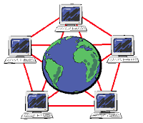](http://4.bp.blogspot.com/--FyRrKy0uwQ/UChcDLJyJVI/AAAAAAAAASE/9z-D-_g37zA/s1600/p2p.png)

***Internet Peer-to-peer network (P2P)*** - Another type of peer-to-peer, called P2P, describes an internet network on which users access each other’s network harddisk and exchange files directly into the internet.

### Network Topology

***Network Topology*** - Is the physical [topology](http://en.wikipedia.org/wiki/Network_topology) of a network refers to the configuration of cables, computers, and other peripherals. Physical topology should not be confused with logical topology which is the method used to pass information between workstations. The following sections discuss the physical topologies used in networks and other related topics.

### Main Types Physical Topologies

* Linear Bus Topology
* Star Topology
* Star-Wired Ring Topology
* Tree Topology

[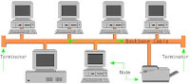](http://3.bp.blogspot.com/-CbWaxKPzZjY/UChcrhxy-PI/AAAAAAAAASM/Ni2bpUBvY7U/s1600/linear.jpg)

***Linear Bus Topology*** - A linear bus topology consists of a main run of cable with a terminator at each end All nodes (file server, workstations, and peripherals) are connected to the linear cable. Ethernet and LocalTalk networks use a linear bus topology.

#### Advantages of a Linear Bus Topology

* Easy to connect a computer or peripheral to a linear bus.
* Requires less cable length than a star topology.

#### Disadvantages of a Linear Bus Topology

* Entire network shuts down if there is a break in the main cable.
* Terminators are required at both ends of the backbone cable.
* Difficult to identify the problem if the entire network shuts down.
* Not meant to be used as a stand-alone solution in a large building.

[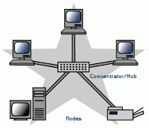](http://1.bp.blogspot.com/-ZEcet5qSMik/UChc_5E4f2I/AAAAAAAAASU/Sb6EsDQll4I/s1600/star.gif)

***Star Topology*** - A star topology is designed with each node (file server, workstations, and peripherals) connected directly to a central network hub or concentrator.Data on a star network passes through the hub or concentrator before continuing to its destination. The hub or concentrator manages and controls all functions of the network. It also acts as a repeater for the data flow. This configuration is common with twisted pair cable; however, it can also be used with coaxial cable or fiber optic cable.

#### Advantages of a Star Topology

* Easy to install and wire.
* No disruptions to the network then connecting or removing devices.
* Easy to detect faults and to remove parts.

#### Disadvantages of a Star Topology

* Requires more cable length than a linear topology.
* If the hub or concentrator fails, nodes attached are disabled.
* More expensive than linear bus topologies because of the cost of the concentrators.
* The protocols used with star configurations are usually Ethernet or LocalTalk. Token Ring uses a similar topology, called the star-wired ring.

***Star-Wired Ring*** - A star-wired ring topology may appear (externally) to be the same as a star topology. Internally, the MAU (multistation access unit) of a star-wired ring contains wiring that allows information to pass from one device to another in a circle or ring. The Token Ring protocol uses a star-wired ring topology.

[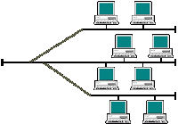](http://1.bp.blogspot.com/-buVqXRHLrOs/UChdYi9z7RI/AAAAAAAAASc/aUUWcVYu-R4/s1600/tree_topology.gif)

***Tree Topology*** - A tree topology combines characteristics of linear bus and star topologies. It consists of groups of star-configured workstations connected to a linear bus backbone cable (See fig. 4). Tree topologies allow for the expansion of an existing network, and enable schools to configure a network to meet their needs.

#### Advantages of a Tree Topology

* Point-to-point wiring for individual segments.
* Supported by several hardware and software vendors.

#### Disadvantages of a Tree Topology

* Overall length of each segment is limited by the type of cabling used.
* If the backbone line breaks, the entire segment goes down.
* More difficult to configure and wire than other topologies.  
  ***5-4-3 Rule*** - A consideration in setting up a tree topology using Ethernet protocol is the 5-4-3 rule. One aspect of the Ethernet protocol requires that a signal sent out on the network cable reach every part of the network within a specified length of time. Each concentrator or repeater that a signal goes through adds a small amount of time. This leads to the rule that between any two nodes on the network there can only be a maximum of 5 segments, connected through 4 repeaters/concentrators. In addition, only 3 of the segments may be populated (trunk) segments if they are made of coaxial cable. A populated segment is one which has one or more nodes attached to it . In Figure 4, the 5-4-3 rule is adhered to. The furthest two nodes on the network have 4 segments and 3 repeaters/concentrators between them. This rule does not apply to other network protocols or Ethernet networks where all fiber optic cabling or a combination of a fiber backbone with UTP cabling is used. If there is a combination of fiber optic backbone and UTP cabling, the rule is simply translated to 7-6-5 rule.

### Considerations When Choosing a Topology

* ***Money*** - A linear bus network may be the least expensive way to install a network; you do not have to purchase concentrators.
* ***Length of cable needed*** - The linear bus network uses shorter lengths of cable.
* ***Future growth*** - With a star topology, expanding a network is easily done by adding another concentrator.
* ***Cable type*** - The most common cable in schools is unshielded twisted pair, which is most often used with star topologies.

### OSI Layer Model

The Open System Interconnection (OSI) reference model describes how information from a software application in one computer moves through a network medium to a software application in another computer. The OSI reference model is a conceptual model composed of seven layers, each specifying particular network functions. The model was developed by the International Organization for Standardization (ISO) in 1984, and it is now considered the primary architectural model for intercomputer communications. The OSI model divides the tasks involved with moving information between networked computers into seven smaller, more manageable task groups. A task or group of tasks is then assigned to each of the seven OSI layers. Each layer is reasonably self-contained so that the tasks assigned to each layer can be implemented independently. This enables the solutions offered by one layer to be updated without adversely affecting the other layers. The following list details the seven layers of the Open System Interconnection (OSI) reference model.

[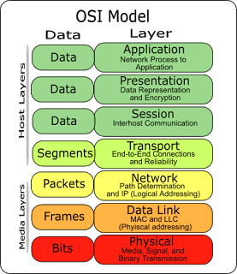](http://4.bp.blogspot.com/-9OFLF52VRgA/UChdzjQbjcI/AAAAAAAAASk/iyYXcfKI9pU/s1600/osi.png)

***NETWORK PROTOCOL*** - A protocol is a set of rules that governs the communications between computers on a network. These rules include guidelines that regulate the following characteristics of a network: access method, allowed physical topologies, types of cabling, and speed of data transfer.

***Ethernet*** - The Ethernet protocol is by far the most widely used. Ethernet uses an access method called CSMA/CD (Carrier Sense Multiple Access/Collision Detection). This is a system where each computer listens to the cable before sending anything through the network. If the network is clear, the computer will transmit. If some other node is already transmitting on the cable, the computer will wait and try again when the line is clear. Sometimes, two computers attempt to transmit at the same instant. When this happens a collision occurs. Each computer then backs off and waits a random amount of time before attempting to retransmit. With this access method, it is normal to have collisions. However, the delay caused by collisions and retransmitting is very small and does not normally effect the speed of transmission on the network.

The Ethernet protocol allows for linear bus, star, or tree topologies. Data can be transmitted over wireless access points, twisted pair, coaxial, or fiber optic cable at a speed of 10 Mbps up to 1000 Mbps.

***Fast Ethernet*** - To allow for an increased speed of transmission, the Ethernet protocol has developed a new standard that supports 100 Mbps. This is commonly called Fast Ethernet. Fast Ethernet requires the use of different, more expensive network concentrators/hubs and network interface cards. In addition, category 5 twisted pair or fiber optic cable is necessary. Fast Ethernet is becoming common in schools that have been recently wired.

***Gigabit Ethernet*** - The most recent development in the Ethernet standard is a protocol that has a transmission speed of 1 Gbps. Gigabit Ethernet is primarily used for backbones on a network at this time. In the future, it will probably be used for workstation and server connections also. It can be used with both fiber optic cabling and copper. The 1000BaseTX, the copper cable used for Gigabit Ethernet, is expected to become the formal standard in 1999.

***FDDI*** - Fiber Distributed Data Interface (FDDI) is a network protocol that is used primarily to interconnect two or more local area networks, often over large distances. The access method used by FDDI involves token-passing. FDDI uses a dual ring physical topology. Transmission normally occurs on one of the rings; however, if a break occurs, the system keeps information moving by automatically using portions of the second ring to create a new complete ring. A major advantage of FDDI is speed. It operates over fiber optic cable at 100 Mbps.

### Types of Network Devices

[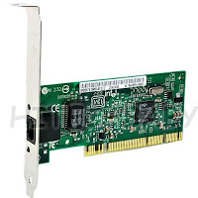](http://2.bp.blogspot.com/-Q2KMLUIxZRo/UChfHVwzBfI/AAAAAAAAASs/QG6Skvnewlg/s1600/nic+card.jpg)

***Network card, network adapter, network interface controller (NIC), network interface card, or LAN adapter*** - is a computer hardware component designed to allow computers to communicate over a computer network. It is both an OSI layer 1 (physical layer) and layer 2 (data link layer) device, as it provides physical access to a networking medium and provides a low-level addressing system through the use of MAC addresses. It allows users to connect to each other either by using cables or wirelessly.

[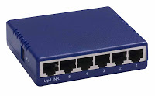](http://1.bp.blogspot.com/-d8_H-j-QidU/UChfYN2de_I/AAAAAAAAAS0/CsNDT3zEXKs/s1600/hub.jpg)

***Network HUB*** - Ethernet hubs vary in the speed (network data rate or bandwidth) they support. Some years ago, Ethernet hubs offered only 10 Mbps rated speeds. Newer types of hubs offer 100 Mbps Ethernet. Some support both 10 Mbps and 100 Mbps (so-called dual-speed or 10/100 hubs). The number of ports an Ethernet hub supports also varies. Four- and five-port Ethernet hubs are most common in home networks, but eight- and 16-port hubs can be found in some home and small office environments. Older Ethernet hubs were relatively large in size and sometimes noisy as they contained built in fans for cooling the unit. Newer devices are much smaller, designed for mobility, and noiseless. Ethernet hubs operate as Layer 2 devices in the OSI model, the same as network switches.

[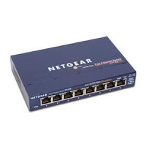](http://2.bp.blogspot.com/-PhY-n-z11Yw/UChftWGjCSI/AAAAAAAAAS8/J2GEgl1YzGI/s1600/switch.jpg)

***Network Switch***

* Network switches appear nearly identical to network hubs, operate at layer two (Data Link Layer) of the OSI model.
* Network switches generally contains more intelligence than a hub. Unlike hubs, network switches are capable of inspecting data packets as they are received, It determining the source and destination device of each packet, and forwarding them appropriately. By delivering messages only to the connected device intended, a network switch conserves network bandwidth and offers generally better performance than a hub.
* Ethernet network switches support either 10/100 Mbps Fast Ethernet or Gigabit Ethernet (10/100/1000) standards.

### Difference Between a Hub and a Switch

* A switch is effectively a higher-performance alternative to a hub.
* Hubs operate using a broadcast model and switches operate using a virtual circuit model.
* When four computers are connected to a hub, for example, and two of those computers communicate with each other, hubs simply pass through all network traffic to each of the four computers.
* Switches, on the other hand, are capable of determining the destination of each individual traffic element (such as an Ethernet frame) and selectively forwarding data to the one computer that actually needs it. By generating less network traffic in delivering messages, a switch performs better than a hub on busy networks.

***Routers***

[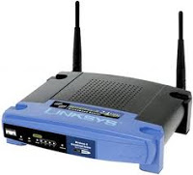](http://1.bp.blogspot.com/-TybJWa8ir-E/UChggoZXv3I/AAAAAAAAATE/gWCAVuC6m_k/s1600/router.jpg)

* Are physical devices that join multiple wired or wireless networks together. Technically, a wired or wireless router is a Layer 3 gateway, meaning that the wired/wireless router connects networks (as gateways do), and that the router operates at the network layer of the OSI model.
* Home networkers often use an Internet Protocol (IP) wired or wireless router, IP being the most common OSI network layer protocol.
* An IP router such as a DSL or cable modem broadband router joins the home's local area network (LAN) to the wide-area network (WAN) of the Internet.
* By maintaining configuration information in a piece of storage called the routing table, wired or wireless routers also have the ability to filter traffic, either incoming or outgoing, based on the IP addresses of senders and receivers.
* Some routers allow the home networker to update the routing table from a Web browser interface. Broadband routers combine the functions of a router with those of a network switch and a firewall in a single unit.

***RJ45 (Registered Jack 45)***

[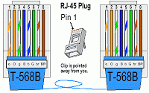](http://2.bp.blogspot.com/-3P41aQZJ9QQ/UChhO820ClI/AAAAAAAAATM/G0MH7hqm4h0/s1600/wpid-rj45_cable_568b.gif)

* A standard type of connector for network cables. RJ45 connectors are most commonly seen with Ethernet cables and networks.
* RJ45 connectors feature eight pins to which the wire strands of a cable interface electrically. Standard pinouts define the arrangement of the individual wires needed when attaching connectors to a cable.
* Several other kinds of connectors closely resemble RJ45 and can be easily confused for each other. The RJ-11 connectors used with telephone cables, for example, are only slightly smaller (narrower) than RJ-45 connectors.

[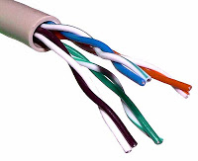](http://2.bp.blogspot.com/-fWnIRIh5F9c/UChhraLDj8I/AAAAAAAAATU/3CuYgwX4hMM/s1600/UTP_cable.jpg)

***CAT5 UTP (Unshielded Twisted Pair) Cable*** - The quality of UTP may vary from telephone-grade wire to extremely high-speed cable. The cable has four pairs of wires inside the jacket. Each pair is twisted with a different number of twists per inch to help eliminate interference from adjacent pairs and other electrical devices. The tighter the twisting, the higher the supported transmission rate and the greater the cost per foot. The EIA/TIA (Electronic Industry Association/Telecommunication Industry Association) has established standards of UTP and rated five categories of wire.

### Network Cabling

[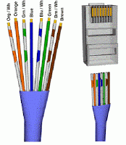](http://2.bp.blogspot.com/-0-E28dHWMqU/UChiJMJKAXI/AAAAAAAAATc/Q6Jy-kRkCP0/s1600/Cat5-Rj45.gif)

Here is what the internals of the cable look like,Internal Cable Structure and Color Coding Inside the cable, there are 8 color coded wires. These wires are twisted into 4 pairs of wires, each pair has a common color theme. One wire in the pair being a solid or primarily solid colored wire and the other being a primarily white wire with a colored stripe (Sometimes cables won't have any color on the striped wire, the only way to tell which is which is to check which wire it is twisted around). Examples of the naming schemes used are: Orange (alternatively Orange/White) for the solid colored wire and White/Orange for the striped cable. The twists are extremely important. They are there to counteract noise and interference. It is important to wire according to a standard to get proper performance from the cable. The TIA/EIA-568-A specifies two wiring standards for an 8-position modular connector such as RJ45. The two wiring standards, T568A and T568B vary only in the arrangement of the colored pairs. Tom writes to say "...sources suggest using T568A cabling since T568B is the AT&T standard, but the US Government specifies T568A since it matches USOC cabling for pairs 1 & 2, which allows it to work for 1/2 line phones...". Your choice might be determined by the need to match existing wiring, jacks or personal preference, but you should maintain consistency. I've shown both below for straight through cabling and just T568B for cross over cabling.

[](http://2.bp.blogspot.com/-3P41aQZJ9QQ/UChhO820ClI/AAAAAAAAATM/G0MH7hqm4h0/s1600/wpid-rj45_cable_568b.gif)

***About RJ45 Plugs and Jacks*** - The RJ45 plug is an 8-position modular connector that looks like a large phone plug. For braided/stranded wires, the connector has sharp pointed contacts that actually pierce the wire. For solid wires, the connector has fingers which cut through the insulation and make contact with the wire by grasping it from both sides. The connector is the weak point in an ethernet cable, choosing the wrong one will often cause grief later. If you just walk into a computer store, it's nearly impossible to tell what type of plug it is. You may be able to determine what type it is by crimping one without a cable. RJ45 jacks come in a variety styles intended for several different mounting options. The choice is one of requirements and preference. RJ45 jacks are designed to work only with solid cable. Most jacks come labeled with color codes for either T568A, T568B or both. Make sure you end up with the correct one.

### Ethernet Cable Pin Outs

There are two basic cable pin outs. A straight through cable, which is used to connect to a hub or switch, and a cross over cable used to operate in a peer-to-peer fashion without a hub/switch. Generally all fixed wiring should be run as straight through. Some Ethernet interfaces can cross and un-cross a cable automatically as needed, a handy feature.

|  |
| --- |
| [http://2.bp.blogspot.com/-ldjYJlEElTs/UChjLJ6uarI/AAAAAAAAATk/LgLS59sL_AY/s400/code.gif](http://2.bp.blogspot.com/-ldjYJlEElTs/UChjLJ6uarI/AAAAAAAAATk/LgLS59sL_AY/s1600/code.gif) |
| Standard Straight Through Wiring |

|  |
| --- |
| [http://4.bp.blogspot.com/-55WWpOiUgJE/UChj3vP1RII/AAAAAAAAATs/oAnB2yH4gb8/s320/cat5_pin_assgmt_crossover.gif](http://4.bp.blogspot.com/-55WWpOiUgJE/UChj3vP1RII/AAAAAAAAATs/oAnB2yH4gb8/s1600/cat5_pin_assgmt_crossover.gif) |
| R4Cross Over Cable Configuration |

### How to wire Ethernet Patch Cables

1. Strip off about 2 inches of the cable sheath.
2. Untwist the pairs - don't untwist them beyond what you have exposed, the more untwisted cable you have the worse the problems you can run into.
3. Align the colored wires according to the diagrams above.
4. Trim all the wires to the same length, about 1/2" to 3/4" left exposed from the sheath.
5. Insert the wires into the RJ45 plug - make sure each wire is fully inserted to the front of the RJ45 plug and in the correct order. The sheath of the cable should extend into the RJ45 plug by about 1/2" and will be held in place by the crimp.
6. Crimp the RJ45 plug with the crimper tool.
7. Verify the wires ended up the right order and that the wires extend to the front of the RJ45 plug and make good contact with the metal contacts in the RJ45 plug
8. Cut the cable to length - make sure it is more than long enough for your needs.
9. Repeat the above steps for the second RJ45 plug.

### How to wire fixed Ethernet Cables

1. Run the full length of cable in place, from endpoint to endpoint, making sure to leave excess.
2. At one end, cut the wire to length leaving enough length to work, but not too much excess.
3. Strip off about 2 inches of the cable sheath.
4. Align each of the colored wires according to the layout of the jack.
5. Use the punch down tool to insert each wire into the jack.
6. Repeat the above steps for the second RJ45 jack. If a cable tester is available, use it to verify the proper connectivity of the cable. That should be it, if your cable doesn't turn out, look closely at each end and see if you can find the problem. Often a wire ended up in the wrong place or one of the wires is making no contact or poor contact. Also double check the color coding to verify it is correct. If you see a mistake or problem, cut the end off and start again. A cable tester is invaluable at identifying and highlighting these issues.When sizing cables remember that an end to end connection should not extend more than 100m (~328ft). Try to minimize the cable length, the longer the cable becomes, the more it may affect performance. This is usually noticeable as a gradual decrease in speed and increase in latency.

***CAT5 Cable*** - is an Ethernet network cable standard defined by the Electronic Industries Association and Telecommunications Industry Association (commonly known as EIA/TIA). CAT5 is the fifth generation of twisted pair Ethernet technology and the most popular of all twisted pair cables in use today.CAT5 cable contains four pairs of copper wire. It supports Fast Ethernet speeds (up to 100 Mbps). As with all other types of twisted pair EIA/TIA cabling, CAT5 cable runs are limited to a maximum recommended run length of 100m (328 feet). Although CAT5 cable usually contains four pairs of copper wire, Fast Ethernet communications only utilize two pairs. A newer specification for CAT5 cable - CAT5 enhanced (CAT5e) - supports networking at Gigabit Ethernet[ speeds (up to 1000 Mbps) over short distances by utilizing all four wire pairs, and it is backward-compatible with ordinary CAT5.Twisted pair cable like CAT5 comes in two main varieties, solid and stranded. Solid CAT5 cable supports longer length runs and works best in fixed wiring configurations like office buildings. Stranded CAT5 cable, on the other hand, is more pliable and better suited for shorter-distance, movable cabling such as on-the-fly patch cabling. Though newer cable technologies like CAT6 and CAT7 are in development, CAT5 / CAT5e Ethernet cable remains the popular choice for most wired local area networks (LANs), because Ethernet gear is both affordable and supports high speeds.

***CAT6 Cable*** - is an Ethernet cable standard defined by the Electronic Industries Association and Telecommunications Industry Association (commonly known as EIA/TIA). CAT6 is the sixth generation of twisted pair Ethernet cabling. CAT6 cable contains four pairs of copper wire like the previous generation CAT5. Unlike CAT5, however, CAT6 fully utilizes all four pairs. CAT6 supports Gigabit Ethernet speeds up to 1 gigabit per second (Gbps) and supports communications at more than twice the speed of CAT5e, the other popular standard for Gigabit Ethernet cabling. An enhanced version of CAT6 called CAT6a supports up to 10 Gbps speeds.As with all other types of twisted pair EIA/TIA cabling, individual CAT6 cable runs are limited to a maximum recommended length of 100m (328 feet). Printing along the length of the cable sheath identifies it as CAT6.

[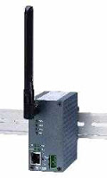](http://1.bp.blogspot.com/-SCjBhbxwFP4/UChk7wav8lI/AAAAAAAAAT0/iOAvO4oreFQ/s1600/Industrial_wireless_access_point.JPG)

***Wireless access points (APs or WAPs)*** - are specially configured nodes on wireless local area networks (WLANs). Access points act as a central transmitter and receiver of WLAN radio signals. Access points used in home or small business networks are generally small, dedicated hardware devices featuring a built-in network adapter, antenna, and radio transmitter. Access points support Wi-Fi wireless communication standards. Although very small WLANs can function without access points in so-called "ad hoc" or peer-to-peer mode, access points support "infrastructure" mode. This mode bridges WLANs with a wired Ethernet LAN and also scales the network to support more clients. Older and base model access points allowed a maximum of only 10 or 20 clients; many newer access points support up to 255 clients.

### Basic Internet Connection Procedure

***Installing Phone Filters*** - You must install the included Phone Line Filters on every device (phones, fax machine, satellite receivers etc.) that is connected to the same line as your new DSL.

### How to Installing DSL Modem

[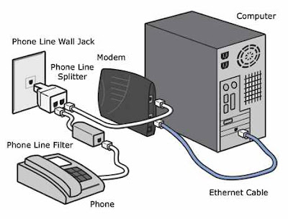](http://2.bp.blogspot.com/-Qt0657PgXdo/UChlnXSqhkI/AAAAAAAAAT8/Q9zkZkTZp7s/s1600/dsl_modem_setup_html_m43c3651e.png)

* Plug the included Phone Line Splitter into your Wall Jack. If you are going to be using another device (phone, fax machine, satellite receiver etc.) plug-in one of your Phone Line filters into the Splitter and then plug your phone into the filter. On the other side of the splitter hookup your DSL modem directly with the supplied phone cable. Be sure to plug it into the LINE or DSL port on the back of your modem.
* Make sure your computer is turned off.
* Take the supplied Ethernet cable and plug it into the LAN or ETHERNET port on the back of the modem. Plug the other end of the cable into the Ethernet port on the computer.
* Plug the supplied power cord into the modem and then into an available plug nearby. Once you plug-in the power supply, the modem will turn on automatically. If there is a switch on the back of the modem make sure to flip it to the ON position.
* Once the READY, SYNC/PPPoE or LINE light on the front of the modem stops blinking, turn your computer on and you will be ready to surf the internet.

RJ 45Crimping Procedure

[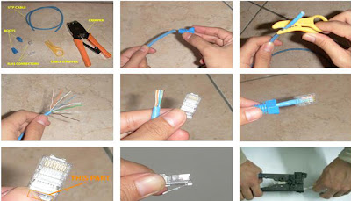](http://2.bp.blogspot.com/-LDyyLOyy5JY/UChpPVG8dYI/AAAAAAAAAUU/Fu2B_opj--I/s1600/crimpt2.jpg)